Ana Lyvia Tabosa da Silva

Ex-ante LCA of a hydrometallurgical route using weak acid for recycling of REEs from EOL HDD’s NdFeB permanent magnet

Master’s thesis in Circular Economy

Leiden, July 2021

Supervisors: Benjamin Sprecher and Shoshan Abrahami

Leiden University

Delft University of Technology

Faculty of Science

Institute of Environmental Sciences at Leiden University (CML)

Department of Industrial Ecology

**Abstract**

The rare-earth elements (REEs) are Europe’s most critical raw-materials group due to the high supply dependency on the Chinese REEs near-monopoly. The NdFeB permanent magnet in EOL hard disk drivers (HDDs) is an actual source of REEs. However, REEs recycling routes are still under development. Hydrometallurgical routes are attractive because they are versatile, but concerns arise regarding their chemical consumption and the implication to the environment. An ex-ante environmental analysis supports the launch and consolidation of the route in an environmentally sound manner. This work aims to identify the environmental hotspots of a theoretical hydrometallurgical recycling route for REEs, which uses acetic acid for leaching and oxalic acid for precipitation. The route also allows chemical recycling through a loop within it. The ultimate goal is to draw recommendations toward improving the environmental profile of the technology before it gets implemented. The evaluation is carried using the Life Cycle Assessment (LCA) methodology according to a dedicated framework for ex-ante analysis, including upscaling. The analysis highlights as hotspots the oxalic acid in the precipitation stage and the direct dust emissions and its treatment in the fragmentation of HDDs. Moreover, results indicate that acetic acid regeneration within the system is more burdensome than use the chemical produced from raw materials. The premature assessment also indicates that the environmental profile of the emerging technology is potentially inferior to the established primary production. A limitation of the model arises from the economic allocation for multifunctional processes due to the approach developed to stipulate the price of some co-products. Overall, the uncertainties carried with the ex-ante LCA prevent any assertive declaration regarding the recycling route’s environmental performance. However, the exercise contributes to the problem-solution space. It gives directions to the next steps: better data collection for the RE recovery phase, less dust production in the fragmentation phase, other means for precipitation of REEs, and variation in the leaching solid-liquid ratio.

Keywords: NdFeB permanent magnet, REEs, recycling, hydrometallurgy, weak acid, ex-ante LCA.

**Acknowledgment**

Arrive at the end of this Master’s degree journey was not simple, starting with flights from my small hometown in Northeast Brazil until my first destination, central Norway. Jokes apart, I must acknowledge all involved in this adventure: Heaven, family, friends, and professors. Finally, I close this cycle with a loaded bag: science, knowledge, friendship, strength, self-confidence, gratitude, and... “wanting more.”

I want to thank my heavenly Father and Mother for bringing me up here. During the easy and hard times, they are there, lighting the way. All honor and glory to them, always!

Thank you to my parents and brother for all your love and support. My family is my gold mine. I love you!

Thank you to my Brazilian professors, Monica Carvalho and José Mauricio Gurgel, for being part of this endeavor.

Thank you to my hometown friends for prayers and good wishes. A particular thanks to the friends I made in Trondheim, especially those from St. Olav Cathedral and Father Paul Opata that always made the church our home away from home. This was priceless!

Gratitude to the CIRCLE people, especially to the friends Desireé and Jared. The warm reception and delicious food in the freezing Norwegian weather will never be forgotten! While in the Dutch land, my big thanks go to the CML Ph.D. candidate Brenda Xicotencatl. The great discussions and support throughout the thesis project brought me here. I appreciated all knowledge shared!

I should like to leave with the words of 2 Timothy 4:7-8 “I have fought the good fight, I have finished the race, I have kept the faith. Now there is in store for me the crown of righteousness, which the Lord, the righteous Judge, will award to me on that day—and not only to me, but also to all who have longed for his appearing.” I am looking forward to what is to come, and I am enthusiastic about applying the knowledge gathered and experience to make our society a better place to live. Here I go!

Table of Content

List of figures ix

List of tables x

List of abbreviations and acronyms xi

Executive summary xii

1 Introduction 1

1.1 Research objective and research question 6

1.2 Case study description 8

1.3 Outline of report 10

2 Literature review 11

2.1 Recycling methods for REEs 11

2.1.1 Hydrometallurgy for REEs recovery 16

2.2 Ex-ante Life Cycle Assessment (LCA) 20

3 Methodology 26

3.1 Projected technology scenario definition 26

3.1.1 Plant’s processes’ operations and installations 28

3.2 LCA 32

3.2.1 Oxalic acid production 32

3.2.2 Primary production 32

3.2.3 Recycling route 34

3.2.3.1 Goal definition 34

3.2.3.2 Scope, function, and functional unit definition 35

3.2.3.3 Inventory Analysis 36

3.2.3.3.1 System boundaries 36

3.2.3.3.2 Data 39

3.2.3.3.3 Multifunctionality and allocation 40

3.2.3.4 Impact Assessment 42

3.2.3.4.1 Classification, characterization, and normalization 42

3.2.3.5 Interpretation 44

4 Results 45

4.1 Characterization results 45

4.2 Normalization results 46

4.3 Completeness check 47

4.4 Consistency check 48

4.5 Contribution analysis 48

4.6 Sensitivity test 54

4.7 Comparative analysis 56

5 Discussion of results 60

6 Conclusions and recommendations 65

7 Suggestion for future research 67

8 References 68

Appendix A 76

Appendix B 88

Appendix C 89

Appendix D 99

Appendix E 109

List of figures

Figure 1.1 Raw materials supply strategy 2

Figure 1.2 Hydrometallurgical recycling route for REE recovery applied to this work 8

Figure 2.1 TRL level on the top vs. MRL on the bottom 21

Figure 2.2 Framework for determining TRL, MRL, data collection, and challenges for ex-ante LCA 22

Figure 2.3 Ex-ante LCA framework for upscaling of emerging technologies 24

Figure 3.1 Hydrometallurgical recycling route for REE recovery 28

Figure 3.2 Plant’s footprint 30

Figure 3.3 Product system’s flowchart 39

Figure 4.1 Normalized environmental profile of product system 47

Figure 4.2 Contribution analysis of foreground processes 49

Figure 4.3 Contribution analysis of RE recovery unit process. 50

Figure 4.4 Contribution analysis of Leaching unit process 51

Figure 4.5 Contribution analysis of Fragmentation unit process 53

Figure 4.6 Sensitivity analysis, comparing environmental performance of sensitivity cases vs. original system 55

Figure 4.7 Sensitivity analysis, alternative price approaches 56

Figure 4.8 Comparing environmental performance, per impact category, of primary production of REO vs. recovery of REO from EOL HDDs NdFeB magnets 58

Figure 4.9 Incumbent technology vs. emerging technology original system and its sensitivity variations 59

List of tables

Table 2.1 Advantages and disadvantages of processes for recovery of NdFeB magnet 12

Table 2.2 Comparison between pyrometallurgy and hydrometallurgy 15

Table 2.3 Comparison between precipitation and solvent extraction 17

Table 3.1 List of projected plant’s equipment 29

Table 3.2 Environmental profile of the primary production product system 34

Table 4.1 Environmental profile of the product system 45

Table 4.2 Most upstream process and environmental flow contributing to the RE recovery unit process 52

Table 4.3 Consistency check, primary production vs. recycling. 57

List of abbreviations and acronyms

|  |  |
| --- | --- |
| REEs | Rare-earth elements |
| IUPAC | International Union of Pure and Applied Chemistry |
| LREEs | Light rare earth elements |
| HREEs | Heavy rare earth elements |
| Nd | Neodymium |
| NdFeB | Neodymium Iron Boron permanent magnet |
| HDDs | Hard disk drivers |
| SDGs | Sustainable Development Goals |
| EOL | End-of-life |
| R&D | Research and development projects |
| LCA | Life Cycle Assessment |
| SWOT | Strengths-Weaknesses-Opportunities-and-Threats |
| WP | work packaging |
| RE | Rare-earth |
| ISO | International Organization for Standardization |
| TRL | Technology readiness level |
| MRL | Manufacturing readiness level |
| EARTO | European Association of Research and Technology |
| MFA | Material Flow Analysis |
| REO | Rare-earth oxide |
| WEEE | Waste electrical and electronic equipment |
| LCI | Life Cycle Inventory |
| LCIA  LCIAM | Life Cycle Impact Assessment  Life Cycle Impact Assessment Method |
| ILCD | International Reference Life Cycle Data System |
| Fr | France |
| RER | Europe |
| GLO | Global |
| PCs | Computers |
| PEF | Product Environmental Footprint |
| CFs | Characterization factors |
| ADP | Abiotic Depletion Potential |
| NFs  IAM  SSPs  CML  P204 | Normalization factors  Integrated Assessment Models  Shared Socioeconomic Pathways  Institute of Environmental Sciences at Leiden University  Dioctyl phosphate |

Executive summary

The rare-earth elements (REEs) are Europe’s most critical raw-materials group. Their fundamental applicability in green technologies such as electric vehicles and wind turbines is critical to attaining a low-carbon future. The largest REEs deposit is in China, the global leader of the supply chain. Although the resource is not naturally scarce, the Chinese near-monopoly poses a threat in the European demand-supply dynamic.

The NdFeB permanent magnet is the most common industrial application of Nd, a REE. They are used in computer and laptop’s hard disk drivers (HDDs), electric motors, wind turbines, and electric vehicles. Computer and laptops have a shorter lifespan than the other applications, being part of today’s REEs urban mine. Industrial recycling of REEs is not established yet. Industry and academia are working to introduce an economical and environmentally viable route. The VALOMAG project wants to investigate the environmental burdens due to the implementation of a hydrometallurgical recycling route using weak acid at an industrial scale. This thesis reports on that. The Life Cycle Assessment (LCA) methodology was applied at a theoretical hydrometallurgical route using acetic acid for leaching and oxalic acid for precipitation. The route also allows chemical recycling through a loop within it. The LCA was applied ex-ante, so the emerging technology was upscaled considering the potential future scenario in which it will be ready for an industrial implementation (in 2030). Afterward, its environmental performance was compared to the established primary production route for REEs. The objective was to identify the potential environmental hotspots of the emerging technology to draw recommendations contributing to the problem-solution space and, ultimately, launch the technology in an environmentally sound manner when compared to primary production.

The LCA results are not a prediction of the technology’s environmental profile. The ex-ante nature of the analysis brings more uncertainty than usual. Due to that, results should be considered in a reserved way. The route’s hotspots were caught in the fragmentation and RE recovery steps. The RE recovery highly contributes to all impact categories. The oxalic acid used in the precipitation of REEs is the major contributor. Precipitation using oxalic acid also allows the regeneration of acetic acid. Nonetheless, the analysis showed that for the studied route, the chemical regeneration causes more environmental harm than good due to the use of oxalic acid as a precursor in acetic acid regeneration.

Additionally, in impact categories such as freshwater ecotoxicity, freshwater eutrophication, human health carcinogenic effects, and human health non-carcinogenic effects, the fragmentation quarrels to the major contribution. The direct emission of the dust generated in the shredding of HDDs and its treatment are pointed out to offset the contribution of this unit process to these impact categories.

In comparison with primary production, the environmental performance of the recycling route was inferior. However, any declaration is still premature due to the uncertainties inherent to ex-ante LCAs, which entails low robustness to the results. A particular one regards the approach to stipulate the price of compound goods produced in the route, which allocates more burden to the system than it is supposed.

For the RE recovery unit process, it can be recommended better data collection, investigation of a substitute chemical for oxalic acid, its regeneration, or a change of precipitation technique. For the fragmentation step, it can be recommended to redesign the process to turn it less harsh, generating less dust. A recommendation to improve the modeling lies in an alternative approach to stipulate the price of compound goods coproduced in the route, which are non-commercialized yet. For that, it is essential to define the function of these products well. In the future, it can be suggested to investigate a change in the leaching solid-liquid ratio to understand the implications to the system’s environmental profile considering the route’s throughput.

An assertive declaration about the recycling route’s environmental performance is still premature. The ex-ante LCA has no means to provide it. However, the findings of this work stimulate critical thinking about the new technology’s environmental performance, broadening the research perspective and paving the way towards a truly sustainable resource efficiency practice for REEs recycling soon.

# Introduction

The so-called rare-earth elements (REEs) are classified by the International Union of Pure and Applied Chemistry (IUPAC) as a group of 17 chemically similar metallic elements. Their group is constituted of 15 lanthanides, plus scandium and yttrium. Recently REEs are receiving increasing attention due to their critical role in the low-carbon, green future (Binnemans et al., 2013). Amongst their application they are found in permanent magnets, lamp phosphors, catalysts, and rechargeable batteries. Even though being abundant on the Earth's crust, concerns surrounding REEs supply exists. In its first list of critical raw materials, the European Commission classified REEs as the most critical raw materials group, with the highest supply risk (European Commission, 2011a). The up-to-date version of the list still bringing REEs as critical raw material for Europe, having China as the supplier of 98% of EU's REEs demand (European Commission, 2020).

Usually, the REEs concentration in an ore is not high enough to justify direct mining exclusively. In this sense, REEs are "hitchhikers" metals, meaning that they are mined as "by-products" of others, more concentrated metals in ore, the "attractors." Today, there are two major supply chains producing REEs globally, the Chinese and the Australian (Zakotnik & Tudor, 2015). The deposit of Bayan Obo in China is the largest worldwide, followed by Mount Weld's deposit in Australia (Marx et al., 2018). This fact poses a threat to the supply of REEs to Europe and any region that does not hold REEs deposits. Indeed, this became evident in 2011, when the Chinese government limited the exportation of REEs, which led to price spikes. The Chinese virtual monopoly over REEs production, having 50% of worldwide mineral reserves and 86% market share (Sprecher et al., 2014), can be a source of supply-demand disruption leading to constraints in green technology deployment (Nlebedim & King, 2018).

Facing this challenge, Binnemans et al. (2013) proposed an approach to overcome the REEs supply issues (Figure 1.1). The outlook is based on a comprehensive raw materials policy, including commodity recycling and alternative commodities development that could potentially substitute critical rare earths with less critical metals. For the latter, the fact that the physical properties offered by permanent magnets have a crucial role in the functionality of most low-carbon technologies, makes the substitution for less critical metals not a reality yet (Kapustka et al., 2020).

Figure 1.1 Raw materials supply strategy, a comprehensive approach. Source: Binnemans et al. (2013).

REEs are divided into two groups according to their atomic weight: light and heavy. The light rare earth elements (LREEs) include lanthanum through gadolinium (atomic numbers 57 through 64). The heavy rare earth elements (HREEs) include terbium through lutetium (atomic numbers 65 through 71) plus Yttrium, although its light atomic number (Van Gosen et al., 2017). Neodymium (Nd) is a REE that has an atomic weight of 60, belonging to the LREEs category. Its primary application in the industry is in permanent magnets. Neodymium alloys are used in magnets, and the most common is Neodymium Iron Boron (NdFeB). NdFeB magnets present high-density electromagnetic energy, one of the strongest currently available in the market (Wulf et al., 2017). The optimized magnetic properties are attractive to green technologies' performance while reducing weight, which justify the intensive growth of research on this topic lately (Bonfante et al., 2021). Spotted applications of NdFeB include wind turbines, electric motors, electric cars, computer hard disk drivers (HDDs), and electric bikes.

Alloys of NdFeB contain mostly Nd and Praseodymium (Pr) with some other small quantity of Dysprosium (Dy), Terbium (Tb), and Gadolinium (Gd) which varies according to the specific application they will encounter (Amato et al., 2019). In 2012, Alonso et al. (2012) estimated that in the following 25 years, the demand for Neodymium and Dysprosium would rise more than 700% and 2600%, respectively, if needs in automotive and wind applications would need to cope with the stabilization of atmospheric CO2 concentration of 450 ppm. In this sense, the recycling of NdFeB magnets is strategic.

Furthermore, recycling of these magnets can assure resource efficiency and lower environmental burdens caused by primary mining. Bonfante et al. (2021) emphasize that raw material production for permanent magnets involves significant social and environmental impacts due to heavy chemicals and the generation of radioactive co-products such as Thorium and Uranium. The authors performed a holistic overview to evaluate NdFeB magnets production's sustainability considering the Sustainable Development Goals (SDGs). They alert that this production activity's impact must be managed appropriately to achieve the SDGs (Bonfante et al., 2021). Amongst the negative impacts that primary production brings, are groundwater contamination, damage to humans, fauna, and flora. Zakotnik & Tudor (2015) mentioned that environmental damages from REEs mining caused an increased incidence of congenital disabilities and leukemia in the exposed community. From the resource efficiency perspective, recycling of NdFeB magnets offers not only saves on Nd extraction but also on the "attractor" metal and other metals which are forced mined in circumstances of Nd mining (Binnemans et al., 2013). Moreover, Nd's recycling from end-of-life (EOL) scrap is one way to close the material loop, contributing to circular economy (Binnemans et al., 2013). Thus, Nd recycling from magnets has many potential benefits. However, industrial permanent magnet recycling activities have not been established yet. All available technologies are still on a laboratory or pilot scale. There are no business models from an economic point of view (Amato et al., 2019). Amato et al. (2019) listed the patents on Nd recovery existing up to their publication date; the authors found only three registered.

Different technological approaches have been developed in research and development projects (R&D) for Nd recovery: hydrometallurgical, pyrometallurgical, and electrochemical technologies (Firdaus et al., 2016). As it is in development stage, there is no consensus on which technology is the best. In this way, investigation is important for seeing-through the options, enabling improvement. Binnemans et al. (2013), Elwert et al. (2017), and Jin et al. (2018) say that the hydrometallurgical route is the most promising because it is flexible regarding the chemical waste composition it generates, and it can treat metallic and oxidized feed of NdFeB waste removing impurities.

From the environmental performance point of view, different recycling technologies had been analyzed in the literature (Amato et al., 2019; Jin et al., 2018; Jin, Song, et al., 2018; Karal et al., 2021; Schulze et al., 2018; Schulze, Weidema, et al., 2018; Sprecher et al., 2014). The use of the Life Cycle Assessment (LCA) methodology was predominant in this task. Indeed, LCA is well acknowledged in literature for quantification of environmental impacts and exposure of high burden contributors throughout the life cycle of a product. The application of LCA at an early stage of emerging technology development is called ex-ante LCA (Tsoy et al., 2020). The advantage of assessing technology's environmental profile in its R&D stage is to guide decision-makers to launch an environmentally competitive technology at relatively low costs (Tsoy et al., 2020). Additionally, it can help consolidate permanent magnet recycling as a truly sustainable and environmentally friendly resource efficiency practice. This need has been addressed by Bonfante et al. (2021) in their Strengths-Weaknesses-Opportunities-and-Threats (SWOT) analysis, which indicated the negative environmental impacts of permanent magnet production as a threat to achieve the SDGs goals.

The recently published paper of Karal et al. (2021) evaluated the environmental impacts of a hydrometallurgical route using strong acid (sulfuric acid) for permanent magnet recycling. Their results indicate that electricity consumption and the use of sulfuric acid highly contribute to the environmental burdens (Karal et al., 2021). Environmental analysis is part of R&D projects to develop strategic ways for recycling of permanent magnets. First, in the EXTRADE project, which ended in 2019, and second in the ongoing VALOMAG project. The latter is part of the "eit- raw materials" initiative funded by the European Union. It aims at enabling the dismantling of EOL applications for the extraction and recycling of permanent magnets in short loop processes (VALOMAG, 2021).

The VALOMAG project involves the partnership of academic institutions, industry, and public institutions such as The French Geological Survey, Centre of Recherches Métallurgiques asbl, French Alternative Energies and Atomic Energy Commission, Kolektor Group Vondenje in upravljanje druzb d.o.o., Leiden University, Delft University of Technology, and SUEZ Groupe SAS. Leiden University and Delft University of Technology have the co-leadership to conduct the work packaging (WP) 05, “Process Integration and Life Cycle Assessment”. The VALOMAG project encourages involvement of master’s students to promote knowledge in the area. In this context, this master thesis will provide inputs on the environmental impacts of a hydrometallurgical recycling route using weak acid for recovery of REEs from EOL NdFeB permanent magnets. This will contribute to promote environmentally friendly closing loops activities in REEs production soon.

## Research objective and research question

Lately, concerns with the environmental sustainability of novel technologies are growing (Tsoy et al., 2020). Society’s pressure regarding reducing the environment’s degradation motivates decision-makers to preliminary assess emerging technologies’ environmental performance. The clarification of potential environmental impacts during the R&D stage allows reorienting the technology development to achieve optimum environmental performance. The recent work of Karal et al. (2021), which conducted an ex-ante LCA on a strong acid hydrometallurgical route for NdFeB magnet recycling, indicates further investigation in changing of acid type for leaching.

The VALOMAG project is developing a hydrometallurgical recycling route using weak acid for leaching. The recycling route is being built upon the previous one developed in the EXTRADE project (Beylot et al., 2020). The innovation in the latter is patented by BRGM, one of the VALOMAG’s partners, under the reference WO2017207947 and includes weak acid for leaching. For the new route, VALOMAG wants to investigate its environmental performance to launch the technology in an environmentally sound manner when it gets ready for large-scale implementation in the future.

This research aims to reveal probable environmental impacts due to the industrial scale implementation of a hydrometallurgical recycling route for REEs from EOL HDDs using weak acid through an ex-ante LCA. The ultimate goal of ex-ante LCAs is to evaluate the novel technology's environmental burdens on an industrial scale before it gets into this scale. The results of this work will be an input to VALOMAG, creating insights about the recycling route's environmentally damaging contributors. This study's intended audience is the stakeholders involved in the VALOMAG project and the scientific community in general.

The main research question is, therefore, “What leads toward improvements on the environmental performance of a weak acid hydrometallurgical recycling route for REEs from EOL NdFeB permanent magnet?”

As discussed throughout this thesis, it will be necessary to build a conceptual industrial-scale hydrometallurgical recycling chain to answer the research question. The chain is designed based on literature, inputs from the experiments carried out during the EXTRADE project, and inputs from the VALOMAG project. Moreover, experts are consulted so the designed route can be deemed as feasible as possible. The chain’s future processing capacity is based on the flow of EOL HDDs at the time which the technology is expected to operate. The environmental investigation is carried out using the LCA methodology according to the norms 14040, and 14044 of the International Organization for Standardization (ISO) (ISO, 2006a; ISO, 2006b) adapted to ex-ante analysis. The ex-ante LCA framework proposed by Tsoy et al. (2020) is used.

## Case study description

The recycling route analyzed in this work is not a representation of an actual lab or pilot experiment under development. Instead, it is a hybrid of processes found in literature and process developed during the EXTRADE and VALOMAG projects. The hydrometallurgical chain’s processes are shown in Figure 1.2:

Figure 1.2 Hydrometallurgical recycling route for REE recovery applied to this work. Source: author’s image.

The color in the flowchart indicates the three macro sections of the route: pretreatment, metal extraction, and metal recovery and purification. All processes in the pretreatment section derived from the pilot-scale experiments carried in the VALOMAG project. The processes of the other sections are derived from literature, including the EXTRADE project (Beylot et al., 2020). It was not possible to use the complete chain as it is for the VALOMG project because a new patent is in progress for the metal extraction and metal recovery and purification phases; thus, disclosure of details for publication is not possible yet.

The route is designed to recover REEs from NdFeB permanent magnets from EOL HDDs. In the pretreatment phase, the income of demagnetized HDDs is dissembled, reduced in size, and the pieces sorted. The material containing magnets stays in the chain, having their size reduced to the order of millimeters, so they enter the following phase, metal extraction. In the metal extraction phase, the magnetic powder is leached with acetic acid (weak acid), and the solid-liquid suspension is filtered to remove the unreacted materials. The filtrate solution containing various metal dissolved is forwarded to the metal recovery and purification phase. In the latter, precipitation of REEs with oxalic acid associated with a heating treatment allows the recovery of RE oxides.

## Outline of report

This section presents the structure of this work. Firstly, literature on the recycling techniques for REEs recycling will be reviewed, followed by literature on ex-ante LCA to provide the necessary background to the reader.

Regarding the recycling techniques, it starts with presenting the state-of-art routes for recycling REEs from EOL NdFeB permanent magnets. Afterward, the focus is given to the hydrometallurgical route, purposing this work. The hydrometallurgy steps are explained in detail.

Regarding the ex-ante LCA, it starts with differentiating the ex-ante LCA from normal (ex-post) LCA and follows with the challenges of using the ex-post LCA framework in an ex-ante analysis. Concerning this, the upscaling of the emerging technology is discussed as a particular step for ex-ante LCAs. The section ends by reviewing the ex-ante LCA framework developed by Tsoy et al. (2020), which offers guidelines for upscaling. The author’s framework comprises three main steps: projected technology scenario definition; preparation of a projected LCA flowchart; and projected data estimation.

Secondly, the methodology part will describe the LCA based on the ISO 14040 (ISO, 2006a) and 14044 (ISO, 2006b) frameworks for comparative analysis. It is important to note that the ISO frameworks are designed for traditional LCA (ex-post). However, it will be used together with the framework proposed by Tsoy et al. (2020), which complements ISO’s frameworks for ex-ante LCAs. Therefore, the methodology part comprises (in this order) the projected scaled-up system for the hydrometallurgical technology proposed in this work; the LCA of rare earths oxides (REO) primary production in China; and the LCA of the projected recycling route.

After that, the results of the LCA will be discussed, and recommendations toward a greener route drawn. Suggestions for future research will follow the conclusion and recommendation section. In this way, this work contributes to stakeholders in the field and to social acceptance of REEs projects with efforts made towards greener production systems.

# Literature review

## Recycling methods for REEs

Recycling of Neodymium magnets is sought as an essential step toward supply security and development of modern and clean technologies. However, recycling itself will not meet the entire demand in a growing market, mainly due to some applications' significant demand growth and their long lifespan. Overall, the recycling chain for permanent magnets can comprise several steps: collection of EOL devices, depollution for removal of hazardous components, sorting for magnet containing devices, dismantling for separation of recyclates (permanent magnet), demagnetization, fragmentation, shredding, milling (to obtain the desired size), roasting (for complete conversion of metal to metal oxide), separation and purification (metallurgical processes) and finally recovery of REEs oxides/ salts (Beylot et al., 2020; Swain & Mishra, 2019).

Several metallurgical processing options have been developed to recovery REEs from NdFeB magnet material. The most commonly studied state-of art routes are hydrogen decrepitation, hydrometallurgy, pyrometallurgy, and resintering of scrap magnets and magnetic powder (Tunsu, 2018). Each route presents advantages and disadvantages and may apply only to specific feeds, or routes need to be combined to recover REEs properly. For example, resitering is only applicable to clean, non-oxidized NdFeB powder feed; gas-solid pyrometallurgy and electroslag refining of feeds with more than one REE needs to be complemented with hydrometallurgy for recovery of individualized REE. Tunsu (2018) summarized the most common routes, their advantages, and disadvantages in Table 2.1:

Table 2.1 Advantages and disadvantages of the most common state-of-art processes for recovery of NdFeB magnet. Source: Tunsu (2018).

|  |  |  |  |
| --- | --- | --- | --- |
| **Method type** | **Example and description** | **Advantages** | **Disadvantages** |
| Direct use | Reuse of magnets in new products. | Cheapest option  Does not require chemicals | Requires adequate collection and dismantling  Intact separation of magnets is needed  Labor- and cost-intensive for small products  Cannot be applied to production waste/broken magnets  Further processing of the powder is required |
| Hydrogen decrepitation | The magnets absorb hydrogen and expand in volume, breaking into coarse granules/powder | Efficient for products containing small magnets  Cost-effective preparation method | Further processing of the powder is required  Not suited for mixed feeds, oxidized magnets, and magnets with large differences in composition |
| Hydrometallurgy | The magnets are dissolved in a solution (leaching), followed by separation of ions using precipitation/ solvent extraction or their combination | Can separate all metals with very high purity  Applicable to all types of waste  Can handle large variations in composition/impurities  Similar to virgin mining of REEs | Requires pretreatment (separation of magnets from products)  Reagent-intensive  Generation of secondary wastes  Large number of separation stages needed for high product purity |
| Pyrometallurgy | Gassolid and solidliquid interactions (chlorination, carbonylation), which lead to products with different volatilities  Selective extraction of Nd in molten Mg  Molten salt extraction (MgCl2)  Flux or slag processes using molten fluorides  Glass slag method (molten B2O3) | Applicable to magnets and swarf  Can handle variations in composition  Molten metal extraction can produce REEs in metallic state  Allows production of alloys | Energy-intensive (high temperatures required)  Uses chlorine gas/AlCl3 (corrosive)  Glass slag/electroslag refining generates solid wastes  Some methods, e.g., direct smelting and liquid metal extraction, cannot be applied to oxidized streams |
| Resintering of scrap magnets and magnetic powder | Blending and milling powder with extra REEs, followed by magnetic alignment, isostatic pressing, and sintering. | Fewer process steps  Lower cost  Lower environmental footprint than hydrometallurgy | Requires clean, nonoxidized powder |

Amongst the processes mentioned above, hydrometallurgy appears as the most versatile. It can recover individual REE with high purity from heterogeneous composition feeds, containing or not large amounts of impurity, allowing REEs compounds in different chemical forms (Gergorić, 2018). When compared to pyrometallurgy, hydrometallurgy contrasts by generating less gaseous pollution, being easier to perform, and consuming less energy, although consuming higher amounts of chemicals generating wastewater that needs proper treatment to avoid environmental problems (Gergorić, 2018; Tunsu et al., 2015). Another property that makes hydrometallurgical routes interesting is the selective dissolution, allowing relevant metals to be targeted, leaving behind the rest (Jha et al., 2016). Swain & Mishra (2019) listed the advantages of hydrometallurgical process over pyrometallurgical processes, given in Table 2.2:

Table 2.2 Comparison between pyrometallurgy and hydrometallurgy. Source: Swain & Mishra (2019).

|  |  |
| --- | --- |
| **Pyrometallurgy** | **Hydrometallurgy** |
| Applicable to only high-grade ores | Applicable to both high and low grade ores |
| Oxidized alloys are difficult to be processed in some of the treatments like direct melting and liquid metal extraction | Both oxidized and non-oxidized alloys could be processed |
| Requires high energy | Requires less energy |
| The end products need additional processing to obtain pure REEs (ex. Electro slag refining) | No need of additional processing |
| Cause air pollution | Less air pollution |
| Leaching is difficult. | Leaching is easier |

The choice for a possible treatment method depends on the nature of the EOL stream to be processed along with its chemical complexity and REEs content (Tunsu et al., 2015). In this context, pyrometallurgy is preferred in the processing of high-grade ores, which compensates for the process's high energy requirements. Moreover, pyrometallurgy is more appropriated to treat greater amounts of materials (Tunsu et al., 2015). Hydrometallurgy, for instance, is preferred to treat lower-grade ores from complex and contaminated streams, resulting in high product purity (Tunsu et al., 2015).

For the sake of consistence with the goal of this work, this literature review will focus from now on hydrometallurgy only.

### Hydrometallurgy for REEs recovery

Hydrometallurgical treatment and REEs recovery from Nd magnets involve two major steps: leaching and precipitation or solvent extraction (Tunsu, 2018). Literature has reported other methods for the latter phase, such as ion-exchange (Tunsu et al., 2015), and electrowinning (Ambaye et al., 2020).

Leaching is a dissolution process, which the main goal is to completely transfer REEs into the aqueous solution. There are two leaching modalities, selective and non-selective leaching. Non-selective leaching promotes the total leaching of metals in solution, whereas selective leaching allows for targeted leaching, avoiding the dissolution of unwanted metal, particularly iron (Fe) (Erust et al., 2021; Tunsu, 2018). Usually, co-leaching of Fe and other elements (B, Co, and Ni) poses a threat to further purification, making selective leaching preferable (Gergorić, 2018). Selective leaching can be strategically reached using the Pourbaix diagram, which describes the relative stability of chemical species present in the same aqueous environment, the leaching solution.

There have been reported in literature several leaching solutions used for NdFeB magnet recovery. Leaching solutions can be grouped into inorganic acids (strong) and organic acids (weak). The use of inorganic acids is commonly reported and is shown to be very efficient. Solutions of H2SO4, HCL, HF, and HNO3 and mixes of them are mostly used (Gergorić, 2018; Jha et al., 2016). On the other hand, the use of organic acids for leaching of Neodymium magnets has been poorly investigated, although solutions of citric acid and acetic acid could be appropriated since they form soluble complexes with REEs (Erust et al., 2021; Gergorić, 2018). Other organic acids such as glycolic, maleic, and ascorbic were studied by Gergorić (2018). Formic, oxalic acid, and lactic acid have been reported in the literature too (Erust et al., 2021; Tunsu, 2018).

The environmental consequences of using strong acids in leaching are reported in Gergorić (2018). Reclaiming from the introduction section, some of the environmental concerns of strong acid leachates are potential soil acidification and the release of poisonous gases such as H2, NOx, and SO2. Conversely, organic acids can potentially mitigate these consequences due to their lower acidities, releasing less poisonous gases, and being easier to degrade (Erust et al., 2021). Indeed, this is the inspiration for this thesis' research question.

Regardless of the approach, the next step in a hydrometallurgical route is to separate REEs from the leachate, producing solid compounds that can be reused. Amongst the most common methods found in the literature for the separation of REEs from leachates are precipitation and solvent extraction. The decision upon which method to apply varies according to desired product purity, type of impurities and amounts in the leachate, and the desired chemical form of product (individualized REE compounds or mixed) (Tunsu, 2018). Table 2.3 summarizes the advantages and disadvantages of the two common methods. The information was given by Tunsu (2018):

Table 2.3 Comparison between precipitation and solvent extraction. Source: Tunsu (2018).

|  |  |  |
| --- | --- | --- |
| **Method** | **Advantages** | **Disadvantages** |
| Precipitation | Simplest technique  Cheapest option  Need for simple equipment (precipitation tank, filters)  Easy to optimize and control  Lower amounts of secondary waste (no need for scrubbing/ stripping steps)  Generally good product purity for chemically simple solutions  Ability to process large volumes of feed in a short time  Final product is obtained in solid form | Leads to mixed REE compounds if more than one REE is present in solution  Lower product purity compared to solvent extraction  Less selective (problematic for solutions with high amounts/high number of impurities)  Coprecipitation issues  Washing of the precipitates is still needed (wastewater)  Nonregenerative (precipitation agent cannot be reused) |
| Solvent extraction | Allows for individual REE separation  Very high product purity  High selectivity  Can handle chemically complex feeds  Ability to tailor/ develop extractants to enhance separation  Automated continuous process, easy to scale up (mixer- settlers, columns)  Can process large feed volumes  The organic solvents can be reused | Large requirement for chemicals (extractants, diluents, scrubbing, and stripping reagents)  Large amounts of secondary waste generated, especially for high product purity (need for large number of scrubbing/stripping/regeneration steps)  Some solvents (particularly noncommercial ones) can be very expensive  Regeneration and reuse of the organic solvents is needed  Need for more complex and more expensive equipment  Optimization/control of the process is more complex than precipitation  Sensitive to solid impurities in the feed (crud or third-phase formation)  The final product is a solution that requires additional processing to obtain solid compounds (e.g., precipitation) |

Precipitation is acknowledged as the cheapest alternative because it uses less expensive chemicals and simpler apparatus. Usually, it results in a high recovery rate, but with lower purity when compared to solvent extraction. Chemicals that can be used for precipitation are sodium hydroxide, oxalic acid, or ammonium oxalate (Tunsu et al., 2015). Usually, oxalic acid is used, resulting in oxalates insoluble in water and diluted acids, easily separated through filtration, and calcinated at high temperatures to obtain REEs oxides (Tunsu, 2018). In case the REEs are preferred in the metallic form, hydrogen reduction at a high temperature can be used (Tunsu et al., 2015).

The use of hydrometallurgy is appropriate for separating REEs from iron and other metallic impurities (Abrahami et al., 2015). Nonetheless, the increasing low grade of EOL feed entails adaptation and refining in this recycling technology (Peelman et al., 2015). The use of microwave-assisted leaching is a novel and promising technique that reduces time and chemical consumption (Jha et al., 2016). Other industry practices, such as bioleaching, appear as favorable for low grade and difficult to leach secondary resources (Peelman et al., 2015). Ambaye et al. (2020) and Swain & Mishra (2019) mention other REEs recovery and separation techniques such as biosorption, siderophores, carbon-based material, molten slag extraction, glass slag method, electro cycling, liquid membrane extraction, and supercritical fluid extraction. All in all, it is possible to see that science and industry are trying to figure out feasible methods to recover REEs, mostly including economic and environmentally friendly approaches.

## Ex-ante Life Cycle Assessment (LCA)

The LCA methodology has been used since the late 1960s to evaluate products and services' environmental performance (Villares et al., 2017). LCA is a quantitative tool widely acknowledged by academia and industry for measuring environmental impacts and disclosuring of environmental hot spots of a product system. LCA's default application is in ongoing systems, in which process maturity is observed and data collection is relatively easy (Moni et al., 2020). Nonetheless, its application is not limited and has been used for environmental assessment of emerging technologies too. The advantage here resides in the early identification of burdens before market penetration. This entails improvement at low-cost facilitating launching the novel technology as environmentally friendly as the incumbent one (Cucurachi et al., 2018). This type of forward-looking LCA application is classified as ex-ante LCA (Cucurachi et al., 2018; Tsoy et al., 2020). As the analysis to be carried out in this work applies to an emerging technology to recover EOL NdFeB magnets, an ex-ante LCA must be carried out.

Literature has pointed out a range of methodology variations for performing an ex-ante LCA (Cucurachi et al., 2018; Moni et al., 2020; Tsoy et al., 2020). The challenges tailored by the initial level of information and the starting configuration of the new technology is mainly regarded to the intrinsic need for an intricate network of interlinked processes to constitute the background and foreground data processes of the LCA system. However, this challenge is an opportunity to improve technology design aspects such as functionality and understand the implications of different choices on the technology's anticipated environmental performance (Cucurachi et al., 2018). This avoids technology disruption, environmental burdens, regrettable investments, and even anticipates changes in environmental regulations (Cucurachi et al., 2018). Villares et al. (2017) pointed out that ex-ante LCA suits the evaluation of research proposals or design concepts, mainly contributing to early-stage studies' viability on closing material loops and desirable transitions to the circular economy.

Emerging technologies are classified according to their technology readiness level (TRL) and manufacturing readiness level (MRL), which both define the level of technological maturity (Buyle et al., 2019). TRL is a scale focusing on the technology's functional readiness, and MRL is a scale focusing on the maturity of components or subsystems for manufacturing of the technology. Technology readiness is a prerequisite for manufacturing readiness, and together they evaluate the development stage of a technology (Moni et al., 2020). Tsoy et al. (2020) reported the connection of both concepts given by The European Association of Research and Technology (EARTO) as shown in Figure 2.1:

Figure 2.1 TRL level on the top vs. MRL on the bottom. Source: Tsoy et al. (2020).

For ex-ante LCA, an appropriate comprehension of the state in which the novel technology development encounters is essential. As mentioned above, data on emerging technologies are not as robust as data on established technologies. Compared with traditional ex-post LCA, this difference allows the general LCA framework to be maintained. However, rudimental ex-ante data requests the implementation of particular phases and steps such as the definition of the novel technology's intended application, its functional unit, system boundary, estimation for the projection of the technology, related data, etc. (Thonemann et al., 2020). All having partial or full uncertainties, which are more deepen in ex-ante than in ex-post LCAs (Villares et al., 2017).

Moni et al. (2020) summarized in a table a framework for determining the TRL, MRL, and corresponding methods for data collection, contributions, and challenges for an ex-ante LCA implementation on a level-wise TRL basis (Figure 2.2). According to their framework, the emerging hydrometallurgical recycling route to be studied here fits within TRL4-TRL6. Part of the route had been tested in lab scale experiments during in the EXTRADE project and part had been tested in pilot scale experiments within the VALOMAG project. Therefore, the LCA methodological challenges will mainly concern to data and model uncertainties. Besides that, the LCA results can support decision for more environmentally benign process alternatives choices.

Figure 2.2 Framework for determining TRL, MRL, data collection, and challenges for ex-ante LCA. Source: Moni et al. (2020).

The ultimate goal of ex-ante LCAs is to evaluate the novel technology's environmental burdens on an industrial scale before it gets into this scale. The assessment of a low TRL (lab-scale and pilot-scale) is usually not representative of industrial scale, which may generate significantly reduced impacts due to the use of different equipment, processes efficiency, generation of by-product, and waste recycling loops (Villares et al., 2017). In order to compare the environmental burdens of the novel technology with the incumbent technology, an upscale simulation of the emerging technology must be made (Tsoy et al., 2020).

Upscaling is a particular step of ex-ante LCAs. The projected industrial scale can be achieved using the framework developed by Tsoy et al. (2020), which offers guidelines for scaling up. The framework comprises three main steps: (1) projected technology scenario definition; (2) preparation of a projected LCA flowchart; and (3) projected data estimation. It is important to note for comparison reasons, however, that projecting today's emerging technology in the future when it will be ready for industrial scale may require a projection of the incumbent technology in the same timeframe, depending on the timeframe considered. In this sense, background data should also reflect the reality in the future (Cucurachi et al., 2018). Therefore, ex-ante LCAs requires more alertness and collaborative communication among LCA practitioners and technology experts.

In the first phase of the framework by Tsoy et al. (2020), projected technology scenario definition, a hypothetical upscaled scenario is developed. In this way, the context development for the specific technology is important: demand projections, review of regulations and incentives, and technology evolvement can provide the expected projection into the future. Additionally, expert consultation is necessary (Villares et al., 2017). Geographical and temporal conditions should be specified, as well as processes operations and installation conditions. The hypothetical upscaled appearance should be sketched in a process flow diagram (Tsoy et al., 2020).

In the second phase of the framework, preparation of a projected LCA flowchart, the installations will be grouped in unit processes and functions. Functional unit, reference flow, and systems boundaries should be defined (Tsoy et al., 2020).

In the third phase of the framework, projected data estimation, the unit processes in the LCA flowchart will have their data estimated by data estimation methods. These methods include process simulation software, the use of proxy, and manual calculations. This step is performed together with the second phase (Tsoy et al., 2020). Tsoy et al. (2020) have included the framework in a decision tree, expanding on the steps that should be taken. This is illustrated in Figure 2.3:

Figure 2.3 Ex-ante LCA recommendation framework for upscaling of emerging technologies. Source: Tsoy et al. (2020).

The results of ex-ante LCAs are not a provision of future impacts. However, it serves as a source for insights on technology’s design processes that are advantageous to change to improve the environmental performance of a novel technology (Villares et al., 2017). The LCA results cannot have a predictive characteristic due to the higher degree of uncertainty caused by inherently approximations and assumptions in all phases. Ex-ante LCA implementation and interpretation require extra vigilance. Main problems may arise from struggles in defining goal and scope at such ex-ante stage, low quality and lack of data, generating uncertainty and suspicious potential environmental impacts, which prevent an accurate level of confidence in data interpretation (Villares et al., 2017). Additionally, the scaling up step may intensify uncertainties, imprecisions, and variabilities (Villares et al., 2017). Nonetheless, this does not hinder the explorative value it proposes, which can be cumulatively added and corrected throughout time by future research (Villares et al., 2017). Finally, neither ex-ante nor ex-post LCA results are absolute, and “their outcome is useful in a relative sense in spite of the uncertainties” (Villares et al., 2017, p.1619). Thus, the value of ex-ante LCAs relies on the strategic questions and suggestions it offers, contributing to the problem-solution space. It provides anticipated meaning without waiting until all the information is available involving alertness, engagement, and risk-taking due to the forward-looking nature (Villares et al., 2017).

# Methodology

## Projected technology scenario definition

The process of analyzing the environmental burdens of an emerging technology requires that such analysis uses the projected industrial scaled version of it, as in the framework of Tsoy et al. (2020). A fair comparison could only be made between the new technology and the incumbent one through this technique.

A scenario development reflects modes of thinking about the future, and it relies on the resources available for predicting conditions. Additionally, scenario modeling can be of a forecasting or backcasting nature. This varies according to the future's explorative character: possible, probable, and/or preferable (Börjeson et al., 2006). The future configuration can be explored upon the question, "How would be the recycling plant according to the projected waste stream of HDDs in the future?" According to Börjeson et al. (2006), this type of question asks how the future will look if a likely situation unfolds. Such investigation claims the elaboration of a predictive scenario. For this case study, the year 2030 and onwards will be "the future." About ten years from now, this period is an interval considered feasible because usually emerging technologies take around five to ten years to penetrate the market.

Predictive scenarios are helpful to work out foreseen challenges. It allows to plan and adapt to expected situations. In the case of this project, ultimately, the scenario will provide decision-makers awareness about the environmental problems likely to occurs in the case of technology development. In this way, better environmental performance can be designed and achieved for the new technology before its implementation.

Thus, the basis for the plant's industrial-scale will derive from the foreseen availability of EOL HDDs stream in 2030 for Europe. The forecast of this flow, especially of the REEs content, has been studied through the Material Flow Analysis (MFA) methodology by some authors (Guyonnet et al., 2016; Rademaker et al., 2013; Schulze & Buchert, 2016).

Rademaker et al. (2013) and Guyonnet et al. (2016) transparently studied the flow of REEs from EOL NdFeB permanent magnets in Europe up to 2030. Both studies concluded on the same outlook: by 2030, it should be possible to supply approximately 10% of the Nd demand in Europe by recycling NdFeB magnets from EOL HDDs, electric vehicles, and wind turbines. This is equivalent to the supply of nearly 100 tons of Nd per year.

Among the MFA studies on REEs reported in the literature, the work of Schulze & Buchert, (2016) was not used for cross-reference because, in their estimations, the authors accounted for NdFeB magnets manufacturing scrap in a global context. This accounting is not relevant for upscaling the proposed route since it is envisaged to treat only EOL NdFeB magnets (from European waste stream of HDDs). Moreover, the future plant will be envisioned as the European hub for hydrometallurgical recycling of REEs. The plant's location will be in France within a waste treatment center, allowing industrial symbiosis, thereby closing more loops and promoting a circular economy.

The work of Rademaker et al. (2013) provides, individually, the estimates of REEs from each type of EOL device considered in their work, both in the global and European dimensions. They assume that NdFeB magnets in HDDs are composed purely of Nd. Dy and Pr were not included in the composition because Dy is used when the magnet is expected to operate in a hot environment, which is not the case for HDDs, and Pr consists of a cost-effective Nd replacement without significant performance penalties, which they did not consider applicable for HDDs (Rademaker et al., 2013). Thus, their study provides the amount of REEs from EOL HDDs available for recycling, in Europe, in 2030, in terms of Nd (oxide). Their finding will be considered as the production capacity that the scaled facility should handle in 2030, 70 tons of Nd oxide.

It is important to highlight that Rademaker et al. (2013) did not present the REEs forecasts in terms of the element's metallic form (Nd2) but, as said in terms of the rare-earth oxide (REO) content (Nd2O3). They support this choice arguing that the REO is a common form of trading REEs in the commodity market (Rademaker et al., 2013). However, acknowledging that Nd enters this work's recycling route in its metallic form, their estimation for Nd oxide will be corrected to the metallic form through the weight percentage difference of both.

Having determined the annual capacity intake of the plant, its temporal, geographical, and activity's scope, the plant's processes operations, and installation conditions will be discussed in the following section. In the end, the plant's hypothetical upscaled appearance will be depicted as suggested in the framework of Tsoy et al. (2020).

### Plant’s processes’ operations and installations

Recalling from section 1.2, the processes constituting the hydrometallurgical recycling route to be upscaled are as in Figure 3.1:

Figure 3.1 Hydrometallurgical recycling route for REE recovery. Source: author’s image.

A similar recycling route for recovering base and precious metals from various waste electrical and electronic equipment (WEEE) residues was developed in the HYDROWEEE project, completed in 2017 (De Michelis & Kopacek, 2018). Indeed, during the second phase of the project, an industrial-scale plant for the route was built, proving the route of being technical, economic, operational, social, and environmental viable (Innocenzi et al., 2017; Rocchetti et al., 2013). The basis of the metal extraction and metal recovery and purification phases of their route matches with the design envisaged for these phases in the industrial-scale plant in 2030. In this sense, the plant’s infrastructure for the last two phases of the route will take HYDROWEEE as a proxy.

On another note, one could ask to what extent it is feasible to consider a hydrometallurgy process' technology from 2017 as still applicable to the 2030 year and later. Concerning this, the historical development of hydrometallurgy, in general, and its application for REEs separation, shows that this extractive metallurgy technique's evolution presents incremental innovations rather than radical ones (Habashi, 2005; Kronholm et al., 2013). Incremental process innovation is a cumulative process that builds on existing knowledge and resources. Thus, maintaining this trend, it is acceptable that the HYDROWEEE plant's configuration is representative for the future, assuming that technological advances of science and engineering will be implemented without radical innovations, avoiding disruption of the underlying core design concepts and links of the hydrometallurgical process for metals.

Regarding the plant's industrial-scale infrastructure for the first phase of the recycling route (pretreatment), it will be envisaged as a linear upscaling of the infrastructure developed for the pretreatment pilot-scale experiment during the VALOMAG project. Envisaging the future plant's installations with this hybrid approach, its list of equipment can be approximated by Table 3.1:

Table 3.1 List of projected plant’s equipment. Source: Adapted from De Michelis & Kopacek (2018) and internal VALOMAG report for pretreatment of HDDs.

|  |
| --- |
| **List of projected plant’s equipment** |
| Autogenous mill |
| Screener |
| Magnetic separator |
| Conveyor belts |
| Agitated chemical reactors |
| Filter presses |
| Pneumatic pumps |
| Scrubber |
| Boiler for hot water generation (for temperature control of jacketed reactors); |
| Rotary screw compressor (to supply compressed air need for operating valves, pneumatic pumps and dewatering of cakes) |
| Centrifugal pumps |
| Automatic pneumatic valves |
| Manual valves |
| Electrical and PLC panels |
| Pipes in polypropylene |

All the units above should be connected through connecting elements and use appropriated actuators and measurement devices. The equipment operates under the aspiration of a scrubber to minimize the emission of vapors and dust.

The installation’s footprint is depicted below to provide a view of the plant’s configuration. For that, a mix of HYDROWEEE’s floorplan and the sequence of processes of VALOMAG’s pretreatment phase are combined as shown in Figure 3.2:

Figure 3.2 Plant’s footprint. Source: De Michelis & Kopacek (2018) for metal extraction, and metal recovery and purification sections.

Additionally, the plant's installation is envisaged within a material recycling center, allowing industrial symbiosis for more closing loop activities as the recycling of other economic outflows such as the coarse size materials from the classification step, the non-magnetic material from the magnetic separation step, and the cake from the filtration 1 step.

The plant's operational units are settled to run a continuous process. A batch of 2,58E+05 kg of HDDs entering the pretreatment step takes about 17 hours to be finished. The pretreatment phase lasts about 3 hours, the metal extraction about 9 hours, and metal recovery and purification about 5 hours. In appendix A is described the plant's processes operation description, together with its inputs and outputs for the envisaged intake capacity in 2030.

Following the upscaling framework of Tsoy et al. (2020), the next step is preparing the projected LCA flowchart. For better comprehension, this is integrated into the next section, in which the LCA framework considerations are detailed.

## LCA

Before starting reporting on the LCA framework for the industrial-scale system of the hydrometallurgical recycling route, some clarifications are made regarding the LCI modeling for oxalic acid production and the LCA of the incumbent technology, which will be used for the comparative analysis.

### Oxalic acid production

In the metal recovery and purification phase, REEs will be recovered through precipitation. The chemical reagent used to precipitate the REO in the pregnant leachate solution is oxalic acid. The ecoinvent database does not have a modeled process for oxalic acid production. However, Wang et al. (2020) constructed the inventory data for having it as a background process and made it available. The LCI data provided corresponds to the oxalic acid production process in China. Moreover, they emphasize in the report that their model is suitable for any other LCA study about REEs. The authors were contacted by email to clarify the production process of oxalic acid and kindly provided the necessary help to reproduce their model with a high similarity to the one reported in their paper.

The LCI for the oxalic acid production, reproduced here, according to Wang et al. (2020)’s model, can be found in appendix B.

### Primary production

As stressed in the literature review section, to evaluate the emerging technology's environmental performance, a comparison with an alternative technology's environmental impacts must be made. In the case of emerging technologies, the ex-ante LCA framework's rationale suggests that this comparison needs to be with the incumbent technology. In this regard, the primary production of REO will be taken as the incumbent technology.

The bulk of primary REO production in the world comes from China. Thus, their production route will be considered. The environmental impacts of such activity were addressed in the work of Sprecher et al. (2014). The authors calculated the environmental impacts of the Chinese NdFeB permanent magnet primary production, including REO production from virgin ore. As this project aims to calculate the environmental impacts of REO recovery from EOL NdFeB magnets, the LCA performed by Sprecher et al. (2014) needs to be arbitrarily suppressed up to the production of primary REO for the sake of compatibility and consistent LCA comparison. The authors kindly provided the necessary data to do so.

The needed adjustments to the original LCA of Sprecher et al. (2014) to mitigate the modeling differences between their system and the one to be developed in this work are:

1. The original product system and functional unit were changed to accommodate the comparison with the new technology. In this case, the original system is kept up to the Nd oxide primary production, reducing the system boundary of the original analysis, leaving out all processes referred to the industrial manufacturing of NdFeB permanent magnets from Nd oxide. Consequently, the functional unit needs to change from producing "1 kg of neodymium (NdFeB) permanent magnets in China" to produce 1 kg of primary REO in China through a commercial established virgin production route;
2. The background system will be adapted to reflect Nd oxides' primary production in the same scope as the new technology. Having both product systems with common background is recommended by European Commission (2010) and Xicotencatl et al. (2021) (manuscript in preparation). This avoids severe uneven impacts from any possible commonly used dataset.
3. The Life Cycle Impact Assessment (LCIA) approach adopted in the original work is changed to the International Reference Life Cycle Data System (ILCD) 2.0 2018 midpoint to be consistent with the LCIA method in the LCA of the new technology (more detail on this will come on later sections). The work in preparation of Xicotencatl et al. (2021) alerts for this need. Furthermore, European Commission (2010) suggests that the systems to be compared, besides using the same LCIA method they should report on similar impact categories. In this sense, some categories will be added compared to the original work, and others excluded. The environmental profile of the primary production will comprise the following impact categories: Climate change, (Stratospheric) Ozone depletion, Human toxicity (cancer effects and non-cancer effects), (Ground-level) Photochemical ozone formation, Acidification (land and water), Eutrophication (land and water), and Ecotoxicity. More detail about impact categories choice will be discussed in later sections.

The “new” environmental profile for the primary REO production in China, after implementing changes i), ii) and iii) is shown in Table 3.2

Table 3.2 Environmental profile of the primary production product system. FU: 1kg of primary Nd oxide in China. Adapted from Sprecher et al. (2014).

|  |  |
| --- | --- |
| **Impact category** | **Value** |
| *Indicator results* |  |
| Climate change | 3,42E+01 kg CO2eq |
| Freshwater and terrestrial acidification | 4,87E-01 mol H+ eq |
| Freshwater ecotoxicity | 2,37E+01 CTU |
| Freshwater eutrophication | 5,44E-03 kg P eq |
| Marine eutrophication | 1,16E-01 kg N eq |
| Terrestrial eutrophication | 1,32E+00 mol N eq |
| Human health carcinogenic effects | 3,21E-07 CTUh |
| Human health non-carcinogenic effects | 2,83E-06 CTUh |
| Ozone layer depletion | 9,33E-06 kg CFC-11 |
| Photochemical ozone creation | 3,46E-01 kg NMVOC- |

Later, these category indicator results will be compared with the corresponding results for the new upscaled technology.

### Recycling route

#### Goal definition

This ex-ante analysis aims to determine the probable environmental impacts of the projected industrial-scale plant for comparison with incumbent technology's impacts. Ultimately, the analysis aims to determine the recycling route's environmental hot spots, so a more environmentally benign route can be designed. This study's intended audience is the stakeholders involved in the VALOMAG project and the scientific community in general.

#### Scope, function, and functional unit definition

The projected scaled-up plant is thought as a plausible way to enlarge and implement the technology to meet the expected demand in 2030 and onwards. The detailed coverage for each unit process is envisaged as complete and straightforward as possible, accounting for technosphere and environmental flows that are estimated based on extrapolations of the pilot-scale experiments for the pretreatment phase and literature and expert consultation for the rest of the phases. Therefore, the industrial-scale product system is a hybrid, made up of upscaled empirical data and theoretical data from the literature.

This work adopts the ILCD LCIA approach, particularly the ILCD 2.0 2018 at midpoint and the set of impact categories to be covered are Climate change, (Stratospheric) Ozone depletion, Human toxicity (cancer effects and non-cancer effects), (Ground-level) Photochemical ozone formation, Acidification (land and water), Eutrophication (land and water), and Ecotoxicity. A discussion around the chosen LCIA method and impact categories will follow in section 3.2.3.4.1.

Normalization is applied concerning an EU-27 citizen's footprint (in 2010). A discussion about normalization will follow in section 3.2.3.4.1.

The geographical scope in which the industrial-scale plant will operate is in France, being the European plant hub for weak acid hydrometallurgical recycling of REEs from HDDs. France is chosen because this is the country where a VALOMAG partner is developing a weak acid hydrometallurgical recycling route.

The LCA modeling is performed with Activity-Browser, software built on top of Brightway2 (Steubing et al., 2020). The LCI database used is the ecoinvent’s one in its version 3.6. Regional priority for ecoinvent processes is in the following order: France (FR)> Europe (RER)> Global average (GLO).

The technological scope envisaged for the new plant is the current modal technology for hydrometallurgy applied to recover metals from e-waste, already incorporated in the former HYDROWEEE plant.

The temporal scope envisioned for the new plant is in 2030 and onward, as discussed in section 3.1. Therefore, this analysis's temporal scope is of ex-ante nature, having processes projected in 2030. The ecoinvent LCI datasets modeling foreground and background processes are chosen as contemporary as possible, ultimately falling approximately between 1992-2014.

The industrial-scale system's function is to recover REO from EOL NdFeB magnets derived from EOL HDDs e-waste.

The functional unit can be determined as: the recovery of 1 kg of REO from EOL HDDs' NdFeB magnets separated from e-waste at the plant's gate.

The system's reference flow is the recovery of 1 kg of REO from EOL HDDs' NdFeB magnets separated from e-waste at the plant's gate through a hydrometallurgical route using weak acid.

#### Inventory Analysis

Refer to appendix A for the life cycle inventory data and modeling, and appendix B for the complete life cycle inventory list.

##### System boundaries

* Economy- environment system boundary

The analysis of the product system is said to be from cradle to gate. The cradle is the EOL HDDs, disposed by its consumers. The burdens resulting from the HDDs manufacturing and use phase are disregarded in this study because they are out of the scope of the VALOMAG project. Thus, the fabrication of HDDs will not be considered as the origin of the material flow entering the product system or the use phase of HDDs, which must be highly variable and challenging to model.

When disposed, e-waste needs to be collected, sorted, and dismantled before recycling. From those steps, only dismantling is included within the product system boundaries. The reason is the limited timeframe to complete this project. Therefore, the analysis starts with burdenless EOL HDDs coming into the product system already removed from EOL computers (PCs) and laptops.

The environmental system boundary lies outside the product system boundary. Therefore, the inputs representing the extraction of resources are placed outside the system boundary. However, the foreground processes bring these inputs within the product system. This happens when foreground processes link to background processes necessary to model the function of the unit processes inside the system boundary. On the other side, the emissions to the environment system are modeled as gases and material dust into the air and hazardous waste to incineration.

The within system’s boundaries are organized according to the unit processes, namely fragmentation, classification, magnetic separation, grinding, leaching, filtration 1, RE recovery, filtration 2, and calcination.

* Cut-offs

The product system presents a cut-off in the flow of non-fragmented HDDs in the fragmentation unit process. This is indicated in the flowchart (next section).

The outflow of non-fragmented HDDs is “cut-off” because they will be inserted back into the product system in the next run of the recycling chain, making up to the number of HDDs needed to compose a batch. This flow corresponds to approximately 10% of the inflow of HDDs into the process (from experimental data). As the inflow of HDDs is assumed to be burdenless, “cutting-off” the outflow of non-fragmented HDDs does not constitute a serious issue to the total environmental impact of the product system.

* Flowchart

The flow chart that represents the product system is depicted in Figure 3.3. The non-dashed boxes represent the foreground unit processes, and the grey arrows represent the background unit processes. Not all background processes are depicted, only those important to the system. In this way, the flowchart looks less cluttered. Refer to appendix B for the complete list of the background processes modeled in the unit processes.

For each foreground unit process, the functional flow is indicated by a “F.” The multifunctional processes are differentiated with a “M.” The letters “G” and “W” classify the flows as good or waste, respectively. The latter classification is based on the economic value of the flow. A positive value categorizes it as a good, the opposite as a waste. Finally, the product system’s reference flow is indicated.

Besides the reference flow, some other flows cross the system boundary. Those are economic flows not followed to system boundary. Most of them result from “multi-output” unit processes, which are appropriately allocated, as discussed in a later section. These outputs follow other valorization pathways (outside the product system), which are out of the scope of this study. Finally, there are other crossing flows in the flowchart, but not classified as “good.” Those are the “filtrate solution” (output of unit process eight), which is treated as hazardous waste, and the residual dust (outputs of unit process one, three, and four), which is treated as fly ash and scrubber sludge.

Figure 3.3 Product system’s flowchart. Source: author’s image.

##### Data

Regarding the foreground processes’ data, for all processes in the pretreatment phase, excepting the grinding unit process, data derives from the pilot-scale experiments carried in the VALOMAG project. The values are linear upscaled according to the size of the batch necessary to process the flow of EOL HDDs in 2030. In addition, data for the grinding process is sourced in literature, also having inputs from experts. It is acknowledged that data from pretreatment experiments are not pointing values, due to measurement uncertainties they may vary slightly. However, such variations are overlooked in this work, and data are incorporated as averages.

For the leaching and filtration 1 unit process, data are sourced in literature and personal communication with experts. Moreover, the stoichiometric coefficients of the leaching reaction are used for mass balance.

For all unit processes of the metal recovery and purification phase, data are sourced in literature and from expert consultation. Additionally, for the RE recovery unit process, the stoichiometric coefficients of the precipitation reaction are used for mass balance.

Data for electricity consumption is sourced in literature and incorporated as averages.

* Data gaps

The composition of the magnetic powder coming out of the griding unit process is approximated by the composition reported in Menad & Seron (2016). The authors did not report all chemical components of the powder adding up to 100% but to 96,5%. In this sense, to hold the mass balance, the remaining 3,5% of the composition is assumed as “other,” which chemical nature is unknown.

In the leaching and precipitation (RE recovery) unit processes, the chemical reactions for all elements of the magnetic powder are not known in this work. Only the reactions for the Nd content of the powder. Thus, approximation through mass balance is used for the rest of the components of the powder. Notably, this approximation results in a difference of 1% between the mass of input and output in the RE recovery unit process, which is small enough to be acceptable.

##### Multifunctionality and allocation

In this project, multifunctionality is in foreground processes with more than one functional flow, namely classification, magnetic separation, filtration 1, and RE recovery unit processes.

Economic allocation is applied to allocate part of the non-functional flows and emissions of such processes to the reference flow of the product system. Economic allocation is relevant in this work because of the value placed by society on metals and REEs due to their wide application, critical role in technology performance, and in the green future, as commented in the introduction section. Moreover, the risk of REEs supply-demand disruption and price spikes resulting from the Chinese near-monopoly is the driver to strive the route.

A particular challenge for the economic allocation concerns the price of compound goods co-produced in the product system, such as cake, filtrate solution 1, and solid-liquid suspension. Those are not commercialized yet, and their price is stipulated. This is common to ex-ante analysis. The approach used here is that the price is proportional to the individual price of their elemental composition (refer to appendix B for calculation). The elemental composition is approximated as the ratio between the element’s mass over the good’s mass.

Another option to address multifunctionally in the system is through mass allocation. However, this is not considered the first option for two reasons: revenue generation is the route driver, and the co-products involve light, heavy metals, and chemical reagents. So, weight diversity can provide unfair allocation. Indeed, Santero & Hendry (2016) report that the white paper of PE International, for the harmonization of LCA methodologies for metals, recommends economic allocation over mass allocation for a situation like in this work. Therefore, economic allocation appears as a proper first choice. The allocation factors yielding from the economic approach are in appendix B.

Avoiding allocation through the system expansion technique is not possible for this work. This is due to the unique way in which the co-products are produced in the route, which makes the LCI database lacks independent alternative production routes to represent the co-products.

Lastly, it is important to remember that the product system's function is defined as the "recovery of REO from EOL NdFeB magnets derived from EOL HDDs e-waste." In this regard, the inflow of EOL HDDs in the system is considered a good (burdenless) due to its positive economic value and not a waste. A particular dataset from the ecoinvent database "electronics scrap, Recycled Content cut-off" is used for that. In this sense, any multifunctionality in the fragmentation unit process due to the inflow of waste and outflow of goods is avoided.

#### Impact Assessment

##### Classification, characterization, and normalization

* Classification

In the Life Cycle Impact Assessment (LCIA), emissions and resources consumed in the product system are grouped to measure the impacts caused on the environment. This process is called classification. Clustering of emission and resource use into an impact category is done through an indicator. Indicators allow various emission and resource use to be represented into a single unit by using characterization factors. These factors reflect pressures per unit of emission or resource consumed according to the indicator. LCIA models establish these links.

The European Commission recommends LCIA models, characterization factors, indicators, and units for calculating the environmental impacts of a product system in Europe through the recommendation 2013/179/EU (European Commission, 2013). Table E.1 in appendix E lists the recommended elements. The ILCD 2.0 2018 midpoint LCIA approach agrees with the recommendation. For this reason, it is the assessment chosen to investigate the environmental impacts of this work’s product system.

Regarding the chosen impact categories, they are according to Santero & Hendry (2016). The authors report that the harmonization of LCA methodologies for metals by PE International claims that at least five impact categories should be considered: Climate change, Stratospheric ozone depletion, Ground-level photochemical ozone formation, Acidification (land and water), and Eutrophication (land and water). More impact categories may be added upon the study's product and goal, regardless of their recommendations. More three categories are relevant in REO production: Ecotoxicity, Human toxicity (cancer effects), and Human toxicity (non-cancer effects) (Pell et al., 2019). Therefore, those impact categories are also considered for reporting in this work.

Overall, LCIA impact categories' indicators, characterization models, and factors have two approaches to work with, midpoint and endpoint. Impact categories evaluated under the endpoint method provide indicators at the level of the areas of protection (or close to them), representing thus an environmental issue to be concerned due to the damage (endpoint) approach. On the other hand, impact categories evaluated under the midpoint method provide environmental damage indicators at a level of cause-effect, between emissions/resources use and the endpoint level.

In this work, the midpoint approach is adopted. This choice is based on the analysis' goal, which lies in revealing the environmental hot spots of an emerging recycling route for REEs to ultimately suggest potential paths toward improving environmental performance. This claims to assess the impacts at a level of cause-effect and not so much at an endpoint damage level. Additionally, endpoint models are not sufficiently mature to be straightly recommended by ILCD (European Commission, 2011b). Indeed, Guinée et al. (2002) emphasize that endpoint models are still under development, and for that, are not comprehensive and have high uncertainty levels.

* Characterization

Characterization of a product system consists of generating impact category indicator results by multiplying the classified environmental interventions by their corresponding CFs, according to the characterization model. Then, gathering the impact category results determines the environmental profile of the system.

The characterized impact results are the basis to compare the environmental performance of the recycling route vs. the primary production and to understand the contribution of individual unit processes to the category indicator result. In section 4 are the environmental profile of the product system, the contribution analysis, and the comparative analysis outcomes.

* Normalization

Normalization is applied to compare the different categories among themselves. This informs about remarkable peculiarities or inconsistencies in the product system when comparing impact categories.

Normalization is applied related to the 2010 EU-27 population person equivalent as a reference. Therefore, recognizing the magnitude of the impacts in the European context. In this way, the reference system is consistent with the analysis's geographical scope. The normalization factors (NFs) representing the 2010 EU-27 population person equivalent's impacts are provided by ILCD (Sala et al., 2015) and found in Table E.2 in appendix E.

The choice for using European NFs is an attempt to avoid over-or underestimation effects on the normalized impact categories' indicator results due to a mismatch with the ILCD’s LCIA methods. In this way, local effects modeled into the impact categories' CFs of the ILCD 2.0 2018 midpoint method are expected to align better with the NFs of the 2010 EU-27 population person equivalent. However, it is important to note that applying normalization may increase the uncertainty of the whole assessment given the complexity to determine the NFs together with inconsistency and lack of data (Sala et al., 2015). Uncertainty and approximation are inherent to NFs calculations, as it also depends on other uncertain and approximated information, such as LCIAM's CFs.

#### Interpretation

The LCA interpretation phase comprises a qualitative interpretation of the analysis and a quantitative interpretation of the results. The qualitative interpretation involves a completeness check and a consistency check. The quantitative interpretation is based on the results of a contribution analysis, a sensitivity analysis, and a comparative analysis.

* Completeness check

This check evaluates all relevant information, data available (and its completeness) used in the analysis. In this study, the completeness check is performed by confronting the product system’s outcome with similar studies in the literature.

* Consistency check

This check aims at determining whether the assumptions, methods, and data were consistent with the goal and scope. In this study, the consistency check is performed revisiting the modeling choices and confirming that they are related to Europe and metals, agreeing with the goal and scope of the analysis.

* Contribution analysis

This analysis aims at identifying the processes that are environmental hot spots by calculating their overall contribution in terms of percentage (of a total category indicator result). In this study, the contribution analysis is performed by impact categories considering their characterization indicator results. In this way, uncovering the route's higher contributive process (es) lights opportunities for redesigning the recycling route improving its environmental profile.

* Sensitivity analysis

This analysis aims to check the sensitivity of the analysis results to a change in the model. In this study, sensitivity tests are proposed on an alternative way for dealing with multifunctionality due to the assumptions made in the economic allocation; on alternative price approaches for the economic allocation; and on an alternative way to model the oxalic acid input into the system and its modeling.

* Comparative analysis

This analysis aims to present the environmental impacts of two alternative products for comparison. In this study, the comparison is between the incumbent technology for REO production (primary production in China) and the emerging technology (the recycling route). The comparison does not intend to provide an assertive declaration about which technology is the best but instead generating information to the problem-solution space.

# Results

## Characterization results

The complete set of category indicator results (the environmental profile) of the product system is shown in Table 4.1.

Table 4.1 Environmental profile of the product system. FU: 1 kg of REO from EOL HDDs’ NdFeB magnets separated from e-waste at the plant’s gate. Source: author’s table.

|  |  |
| --- | --- |
| **Impact category** | **Value** |
| *Indicator results* |  |
| Climate change | 7,87E+01 kg CO2eq |
| Freshwater and terrestrial acidification | 7,67E-01 mol H+ eq |
| Freshwater ecotoxicity | 3,17E+01 CTU |
| Freshwater eutrophication | 1,45E-02 kg P eq |
| Marine eutrophication | 2,29E-01 kg N eq |
| Terrestrial eutrophication | 2,61E+00 mol N eq |
| Human health carcinogenic effects | 5,20E-07 CTUh |
| Human health non-carcinogenic effects | 5,31E-06 CTUh |
| Ozone layer depletion | 8,05E-06 kg CFC-11 |
| Photochemical ozone creation | 6,43E-01 kg NMVOC- |
| *Economic outflows not followed to system boundary* |  |
| Basket of coarse size fractions | 2,01E+05 kg |
| Basket of non-magnetic materials | 2,95E+03 kg |
| Cake | 4,55E+03 kg |

## Normalization results

The normalized indicator results for the impact categories are depicted in Figure 4.1:

Figure 4.1 Normalized environmental profile of product system, reference system EU-27 population person equivalent (measurement unit, year). FU: 1 kg of REO from EOL HDDs’ NdFeB magnets separated from e-waste at the plant’s gate. Source: author’s image.

## Completeness check

The modeling of the projected industrial-scale system is endeavored to be as complete as possible besides the low technology readiness level and the non-actual implementation of the recycling route of this work. To the best of the author's knowledge, the unit processes include all relevant interventions reported in the literature and by experts. Satisfactory data quality is assured by sourcing it from peer-reviewed literature and expert consultation. For data not found by these means, mass balance assures completeness. The final system condition is compared with similar studies in literature and deemed representative.

The cut-off flow of non-fragmented HDDs, addressed in section 3.2.3.3.1 , does not affect the system's completeness because this flow will be inserted back into the recycling chain in the next run (the process is envisioned as continuous).

## Consistency check

As mentioned before in this report, the projected upscaled product system is a hybrid. Most data for the pretreatment phase of the route derives from pilot experiments carried in the VALOMAG project. In contrast, for the rest of the phases, data derives from literature and expert consultation. Therefore, for the pretreatment phase, the detailed report about the process delivers accurate data. Whereas, for the rest of the phases, no similar accuracy is found in the literature. Due to this fact, data manipulation has assumptions based on literature, and it is carefully handled to consistently hold the mass balance, conciliating inputs and outputs among unit processes and observing the goal and scope of the analysis. Overall, the assumptions made and the difference in data quality are not a severe problem for consistency.

The LCIA method and impact categories are chosen consistently with the goal and scope of the analysis. Modeling choices recommended for Europe and metals are prioritized.

## Contribution analysis

The contribution of the foreground processes is accessed to identify the major (s) environmentally burdensome per impact category. Then, for that (those) chain's unit process (es), a contribution analysis aims to identify the upstream process that most contributes to the burden. Additionally, the environmental flows' contribution to each impact category is in appendix D.

Figure 4.2 illustrates the normalized contribution analysis of the route's foreground unit processes, per impact category. Normalization is related to the impact category indicator result.

Figure 4.2 Contribution analysis of foreground processes. FU: 1 kg of REO from EOL HDDs’ NdFeB magnets separated from e-waste at the plant’s gate. Source: author’s image.

From the figure above, it is possible to conclude that the RE recovery unit process highly contributes to all impact categories. It quarrels with the fragmentation unit process in categories such as freshwater ecotoxicity, human health carcinogenic effects, and human health non-carcinogenic effects. A contribution analysis to both processes is followed to identify what process (es) makes them burdensome.

The individual contribution analysis to the RE recovery processes, per impact category, is shown in Figure 4.3. The values are relative to the total category indicator result of the unit process.

Figure 4.3 Contribution analysis of RE recovery unit process. FU: 1 kg of REO from EOL HDDs’ NdFeB magnets separated from e-waste at the plant’s gate. Source: author’s image.

Figure 4.3 reveals that the filtrate solution (output of the filtration 1 unit process) and oxalic acid are the major burden contributors for all impact categories. The filtrate solution is ultimately the leachate (output of the leaching unit process) without part of the iron content of the magnetic powder. Thus, a contribution analysis to the leaching unit process is accessed, and the results are in Figure 4.4. The values are relative to the total category indicator result of the unit process.

Figure 4.4 Contribution analysis of Leaching unit process. FU: 1 kg of REO from EOL HDDs’ NdFeB magnets separated from e-waste at the plant’s gate. Source: author’s image.

Figure 4.4 reveals that the recovered acetic acid (output of RE recovery unit process) is the burdensome process to all impact categories. Acknowledging that the recovered acetic acid is the product of the reaction between the filtrate solution and the oxalic acid in the RE recovery process, and that the filtrate solution is itself, ultimately, the output of the leaching process (containing the recovered acetic acid), attention needs to be given to the oxalic acid. Thus, oxalic acid is a hot spot in the route.

In fact, a contribution analysis to the RE recovery process involving upstream processes from inner tiers shown in Table 4.2 highlights the oxalic acid as the major contributor to the impact categories: freshwater and terrestrial acidification, marine eutrophication, terrestrial eutrophication, and photochemical ozone creation.

Table 4.2 Most upstream process and environmental flow contributing to the RE recovery unit process, per impact category. Source: author’s table.

|  |  |  |
| --- | --- | --- |
| **Impact category** | **Most contributive upstream process** | **Most contributive environmental flow** |
| Climate change | Nitric acid production, product in 50% solution state [RoW] | Carbon dioxide ('air', 'urban air close to ground') |
| Freshwater and terrestrial acidification | oxalic acid production [CN] | Nitrogen oxides ('air',) |
| Freshwater ecotoxicity | fragmentation [FR] | Copper ('air', 'urban air close to ground') |
| Freshwater eutrophication | treatment of spoil from hard coal mining, in surface landfill [GLO] | Phosphate ('water', 'ground-, long-term') |
| Marine eutrophication | oxalic acid production [CN] | Nitrogen oxides ('air',) |
| Terrestrial eutrophication | oxalic acid production [CN] | Nitrogen oxides ('air',) |
| Human health carcinogenic effects | treatment of fly ash and scrubber sludge, hazardous waste incineration [Europe without Switzerland] | Chromium VI ('water', 'surface water') |
| Human health non-carcinogenic effects | fragmentation [FR] | Zinc ('air', 'urban air close to ground') |
| Ozone layer depletion | petroleum and gas production, on-shore [RoW] | Methane, bromotrifluoro-, Halon 1301 ('air', 'non-urban air or from high stacks') |
| Photochemical ozone creation | oxalic acid production [CN] | Nitrogen oxides ('air',) |

From Table 4.2, focusing on the impact categories not directly influenced by the oxalic acid, there are climate change, freshwater ecotoxicity, freshwater eutrophication, human health carcinogenic effects, human health non-carcinogenic effects, and ozone layer depletion. In climate change, “nitric acid production” is the most contributive process with its carbon dioxide emission. Nitric acid is a raw material to produce oxalic acid. In freshwater ecotoxicity, “fragmentation” is the most contributive with its emission of copper. In freshwater eutrophication, the “treatment of spoil from hard coal mining, in surface landfill” contributes the most with its phosphate emission. The coal is used in the incineration (waste treatment) of the dust captured in the fragmentation process. In human health carcinogenic effects, the “treatment of fly ash and scrubber sludge, hazardous waste incineration” contributes the most with its chromium VI emissions. This waste treatment is used for the dust captured in the fragmentation process. In human health non-carcinogenic effects “fragmentation” is the most contributive process with its zinc emissions. In ozone layer depletion, “petroleum and gas production, on-shore” is the major contributor with its methane emission. Petroleum is a raw material to produce carbon monoxide in the production process for acetic acid.

The individual contribution analysis to the fragmentation processes, per impact category, is shown in Figure 4.5. The values are relative to the total category indicator result of the unit process.

Figure 4.5 Contribution analysis of Fragmentation unit process. FU: 1 kg of REO from EOL HDDs’ NdFeB magnets separated from e-waste at the plant’s gate. Source: author’s image.

Figure 4.5 reveals that the dust treatment is the burdensome process to all impact categories, except in freshwater ecotoxicity and human health non-carcinogenic effects. In those impact categories, the direct emissions of the process appear as the major contributor. Additionally, the direct emissions also appear to contribute to the human health carcinogenic effects.

## Sensitivity test

Three changes are proposed as sensitivity test:

* Regeneration of oxalic acid;
* Substitution of oxalic acid actual modeling for an approximated chemical process sourced directly from the ecoinvent database;
* Alternative form for dealing with the multifunctional process;
* Alternative price approach for economic allocation.

The first two tests are proposed concerning both the result of the contribution analysis and the use of a non ecoinvent LCI dataset for oxalic acid production. Finally, the last two tests are proposed concerning the assumptions used to perform the economic allocation at such an ex-ante stage.

For the first test, the regeneration of oxalic acid, it is modeled that the excess of this reagent is regenerated (refer to appendix A). For that, it is assumed that all iron precipitates and leaves the system in filtration 1’s cake, so less impurities remains in the system reducing the consumption of oxalic acid. Refer to appendix E for the product system flowchart depicting the regeneration of oxalic acid.

For the second test, the LCI dataset for oxalic acid production is substituted to a general LCI dataset to produce organic chemicals, available in the ecoinvent database (“chemical production, organic”).

For the third test, physical allocation (mass allocation) is applied since system expansion is impossible.

For the fourth test, two approaches are evaluated. In one, the price of the good is assumed as the same price of the cheapest elemental component of the compound good. On the other, the opposite, the price is assumed as the price of the most expensive elemental component.

Figure 4.6 compares the first three sensitivity tests with the original system. The results are relative to the largest.

Tables E.3, E.4, and E.5 in appendix E list the percentage change to each sensitivity test.

Figure 4.6 Sensitivity analysis, comparing environmental performance of sensitivity cases vs. original system. Results are relative to the largest. Source: author’s image.

Figure 4.6 shows that all sensitivity tests yield a product system more environmentally friendly than the original model in all impact categories. The test for “Oxalic acid regeneration” and “Chemical production organic” yield more significant drops in the performance of impact categories where oxalic acid is the major contributor: freshwater and terrestrial acidification, marine eutrophication, terrestrial eutrophication, and photochemical ozone creation. The test for “Allocation by mass” yields more even drops across impact categories. It remarkably provides better performance than “Oxalic acid regeneration” even in impact categories where oxalic acid is a major contributor. The same does not apply to “Chemical production organic.”

Figure 4.7 depicts the last sensitivity test on alternative price approaches, and it compares the results with the original method.

Tables E.6 and E.7 in appendix E list the percentage change to each alternative price approach sensitivity test.

Figure 4.7 Sensitivity analysis, alternative price approaches. Vertical axis is in logarithmic scale. Source: author’s image.

Figure 4.7 shows that varying the price of non-actual commercialized compound goods to a lower price improves the system's environmental performance. Whereas varying the price to more expensive does not help much the environmental performance of the system.

## Comparative analysis

The comparative analysis is based on the systems' category indicator results for comparable reference flows (i.e., production of 1 kg of primary REO in China through a commercial established virgin production route, vs. recovery of 1kg of REO from EOL HDDs' NdFeB magnets separated from e-waste at the plant's gate through a hydrometallurgical route using a weak acid). It assumes that the purity of oxide output from both systems is equivalent.

The section 3.2.2 reports the adaptations regarding the LCA methodology for holding consistency between both systems. Besides, a consistency check is made as recommended in ISO 14044 (ISO, 2006b) to check whether the comparison of the systems is consistent or not regarding data sources, accuracy, technical level, and temporal and geographical representativeness. Table 4.3 shows the consistency check results.

Table 4.3 Consistency check for comparing options, primary production vs. recycling route. Source: author's table.

|  |  |  |  |
| --- | --- | --- | --- |
| **Check** | **Primary production** | **Recycling route** | **Compare options?** |
| Data source | Literature+ expert consultation | Primary+ literature+ expert consultation | Consistent |
| Data accuracy | Good | Weak | Not consistent |
| Data age | About 7 years old | About 3 years old | Consistent |
| Technology coverage | Industrial scale established technology | Pilot plant+ state-of-the-art upscaled | Not consistent |
| Time-related coverage | Recent | Actual | Consistent |
| Geographical coverage | China | Europe | Consistent |

The inconsistencies found are regarding their technology coverage and the data accuracy. The ex-ante nature of the analysis poses such inconsistencies. Overall, both systems are deemed consistently comparable, and thus their characterization results can be related. Figure 4.8 compares the performance of both systems per impact category. The results are normalized to the largest.

Figure 4.8 Comparing environmental performance, per impact category, of primary production of REO in China vs. recovery of REO from EOL HDDs NdFeB magnets through weak acid hydrometallurgy. FU: 1kg of primary REO in China through a commercial established virgin production route vs. 1 kg of REO from EOL HDDs’ NdFeB magnets separated from e-waste at the plant’s gate. Source: author’s image.

Figure 4.8 reveals that this work’s proposed recycling route does not perform as environmentally friendly as the incumbent technology in all impact categories, except in ozone layer depletion.

Figure 4.9 shows the comparison between the incumbent technology environmental performance vs. the performance of the recycling route considering the results of the sensitivity tests.

Figure 4.9 Incumbent technology vs. emerging technology original system and its sensitivity variations. Results are relative to the incumbent technology. Source: author’s image.

The different sensitivity tests yield different outcomes in comparing the environmental performance of the recycling route vs. the incumbent technology. With “Oxalic acid regeneration,” the recycling route does not improve much. The same can be said regarding “Maximum price.” With “Chemical production, organic,” the system improves in four extra impact categories: freshwater water and terrestrial acidification, marine eutrophication, terrestrial eutrophication, and photochemical ozone creation. With “Allocation by mass,” the system improves in seven extra impact categories, continuing scoring worse than the incumbent technology only in climate change and freshwater eutrophication. Finally, with “Minimum price,” the system improves in all impact categories. Thus, attributing lower prices to compound goods or allocating the non-functional flows of multifunctional processes using mass instead of their economic value favors better the recycling route.

# Discussion of results

The results of the completeness and consistent check are deemed satisfactory. However, data robustness cannot be claimed because “more than normal” uncertainty is present. This is common to ex-ante analysis.

The contribution analysis of foreground processes identified the RE recovery unit process as burdensome to all impact categories. In addition, in impact categories such as human health (carcinogenic and non-carcinogenic) and ecotoxicity, the fragmentation unit process quarrels for the major contribution. The RE recovery is being flagged due to the input of oxalic acid in it, which is used to precipitate REEs in the pregnant leachate solution. The fragmentation unit process is highlighted in toxicity related impact categories because of the treatment of the residual dust and its direct emission into the air.

Regarding the oxalic acid being on the spot, it should be acknowledged that the modeling uses a LCI dataset for its production process retrieved from literature. This is because the ecoinvent database lacks a specific dataset representing the production of oxalic acid. There are two routes for producing oxalic acid, biological and chemical (Riemenschneider & Tanifuji, 2011). The chemical production route is recognized as highly emissive (Rocchetti et al., 2013). The inventory provided by Wang et al. (2020), used in the model, corresponds to this route. However, the biological production route, modeled in the LCA work for REEs recycling of Rocchetti et al. (2013), also presents the oxalic acid as a hot spot.

Conversely, other studies that preferred using a proxy from the ecoinvent database to approximate the input of oxalic acid do not have the chemical reagent highlighted (Nuss & Eckelman, 2014; Vahidi et al., 2016; Vahidi & Zhao, 2017). For the route, this is evaluated in one of the sensitivity tests, where a general proxy for producing organic chemicals substitutes the actual modeling of oxalic acid. As a result, the system's environmental performance improves, mainly in the impact categories where oxalic acid is a major contributor (improvements reach more than 80%). Unfortunately, the author lacks the knowledge to judge the fairness of the dataset representing the production process of oxalic acid. Due to that, it is unclear what is more robust to the model.

Regarding the fragmentation unit process being spotted mainly in the toxicity related impact categories, it should be acknowledged that the ILCD LCIAM approach adopted uses the USEtox characterization model in those categories. The USEtox model has very high and uncertain CFs for metals (Sala et al., 2015). Indeed, the dust generated in the fragmentation process is composed mainly of metals. In this process, HDDs are torn apart to obtain the magnetic powder. The model assumes that about 10% of the mass of fragmented HDDs is lost as dust. The dust is assumed to be captured by the plant’s scrubber system to be treated accordingly. The modeling of the dust treatment is approximated by the proxy “treatment of fly ash and scrubber sludge, hazardous waste incineration” from the ecoinvent database. It is assumed that a small percentage of the dust spaces out to the atmosphere, which is modeled considering ecoinvent’s assumptions for the direct emissions in “treatment of waste electric and electronic equipment, shredding” (refer to appendix A for detail). In this way, the modeling of metal emissions into the air is based on the diverse feed of WEEE, although this work deals only with HDDs.

The use of proxies for approximation of processes’ modeling is a common practice in LCA (ex-post and ex-ante), and it has its limitations. This is the case when using the proxy for the dust treatment. In this process, ecoinvent approximates chromium emissions to water from leachate of waste residual material landfills as 100% chromium VI (Doka G., 2009). In fact, the environmental flow contributing to human health carcinogenic effects is revealed as chromium VI coming from the proxy. However, the chromium content in HDDs is minimal (0,1-0,5 wt%) (Abrahami et al., 2015). Thus, the robustness of using ecoinvent’s process as a proxy for the treatment of fly ash and scrubber sludge is questionable. So, the impact on human health carcinogenic effects is probably flawed.

The approximation of the direct emissions into the air from the emissions of a shredding process for WEEE can be said more robust. The emissions of zinc and copper (contributing to human health non-carcinogenic effects and freshwater ecotoxicity, respectively) can potentially reflect the actual emissions because the content of zinc and copper in HDDs is more expressive (Abrahami et al., 2015). However, the low robustness of the USEtox characterization model for metals poses an extra issue to the analysis. Therefore, the outcome for the human health non-carcinogenic effects and freshwater ecotoxicity categories is useful in a relative sense and can be flawed.

In the sensitivity tests, the environmental performance of the recycling route showed to be very sensitive to both the input of oxalic acid and the way to model it. When proposing the regeneration of the excess of the chemical, the minor improvement is 11% in human health carcinogenic effects. However, it reaches an improvement of 42% in impact categories such as marine and terrestrial eutrophication (where oxalic acid is a major contributor). When using an ecoinvent’s process as a proxy to model the production of the chemical, the improvements range from 18% to 79%.

The sensitivity result for an alternative way to allocate multifunctional processes shows that the environmental profile of the system passes from harmful to benefic. This is a reason that makes "multifunctionality" a heated topic in the LCA community (Moretti et al., 2020; Sills et al., 2020). As discussed in the methodology section, the economic allocation is more representative for modeling the system's environmental impacts. However, it should be acknowledged that in this work the method is limited due to the ex-ante stage of the analysis. At this point, compound goods co-produced in the system such as cake, filtrate solution 1, and solid-liquid suspension are not commercialized and are having their prices approximated as proportional to the price of the elements in the composition. The composition is also estimated because (roughly), at such a stage, neither chemical simulation nor chemical experiments have been carried. The estimate is through the mass ratio of the component and the good, which has low robustness to reflect a change in input to the system, ending up affecting the allocation of burdens. For example, when modeling the regeneration of oxalic acid, the limitation creates a 10% increase (instead of a decrease) in the allocation factor of the solid-liquid suspension (compound good). Thus, the environmental profile of the system is "rough." It is potentially smaller.

Considering this, alternative price approaches are proposed to evaluate the sensitivity of the results. The new approaches approximate the price of compound goods to the price of a single component in the composition. Firstly, to the cheapest component and secondly to the most expensive. The results show that lowering the price yields better environmental performance because it removes more burdens upstream to the filtrate 1 unit process, which includes the regenerated acetic acid. A slight improvement in the environmental performance is also observed when the price of compound goods is approximated to the most expensive. In this case, it is because less upstream burden to the filtration 1 unit process is removed from the system. The outcomes corroborate that the original price approach attributes more burden to the system, mainly when comparing with the minimum price approach. However, the intermediate price that the original approach attributes represent better the elemental composition of the good. It does not void the economic value of any component. As deciding on the price is subjective at this ex-ante stage, the author is more comfortable with the intermediate price attributed in the original approach of the modeling.

Such variations highlight that allocation assessments need to consider the life cycle tradeoffs and provide this information to stakeholders and decision-makers to avoid "greenwashing." The same can be said regarding the results of the sensitivity test to mass allocation. Allocating by mass also yields a considerable improvement to the performance of all impact categories (on average 56%). The favorable results are mainly because more upstream burdens to the filtration 1 unit process are removed from the system too. However, a practical comprehension of the recycling route is necessary to judge whether consider such removal of burdens is realistic. This is more complicated at the ex-ante stage, so the discussion will be limited to show the facts. All in all, the exercise provides more fuel to the heated discussion around multifunctionality in LCA, especially in ex-ante LCAs. The premature analysis can have extra challenges because the co-products' market penetration may not be well-defined yet, which is problematic to represent the system's burdens.

The results from the comparative analysis between the environmental performance of the incumbent technology vs. the recycling route were unexpected. It shows the recycling route as more burdensome than the primary production route for all impact categories, except in ozone layer depletion. However, it should be acknowledged the modeling difference in the precipitating agent of the two routes. In the primary production route, dioctyl phosphate (P204) is the organic chemical inputted into the system, and its production process is approximated by a proxy from ecoinvent (“chemical production, organic”). While in the recycling route, oxalic acid is used, and it is attempted the actual modeling of its production process.

It should be noted that when the same proxy is applied to the recycling route (in one of the sensitivity tests), its environmental profile turns more beneficial, and the system performs environmentally better than the primary production in five out of ten impact categories. For the primary production model, Vahidi & Zhao (2017) affirm that using the proxy instead of the manufacturing inventory for P204 leads to less environmental impacts. This is because P204 is a specialty solvent with a long production pathway (Vahidi & Zhao, 2017). Thus, incorporating the actual modeling of P204 in the primary production can worsen its environmental profile. However, it is not clear the consequences of this change in the modeling of the incumbent technology to the comparative analysis with the recycling route.

Regarding the normalized results of the environmental profile of the product system, it shows a peculiarity in the ozone layer depletion impact category. The system is potentially not harmful to the Earth’s ozone layer. The same cannot be said for freshwater ecotoxicity. An assertation regarding the little normalized score in this impact category could be biased due to the low robustness of its NFs, which is linked to the limitation present in the USEtox model’s CFs for metals. In the same way, normalized results for human health carcinogenic and non-carcinogenic effects are probably flawed.

On the other hand, the high normalized results in freshwater and terrestrial acidification, terrestrial eutrophication, and photochemical ozone creation possibly indicate that the product system contributes to burdens in those categories, mainly for photochemical ozone creation. The contribution analysis of the environmental flows to the NFs in Figure E.2 in appendix E shows that NOx highly contributes to those categories. The product system’s NOx emissions originate mainly from oxalic acid production. Therefore, corroborating the product system’s contribution analysis, which identified oxalic acid as a hotspot in freshwater and terrestrial acidification, terrestrial eutrophication, and photochemical ozone creation.

# Conclusions and recommendations

The findings raise strategic questions to the problem-solution space, revealing possible constraints to the environmental performance of the emerging technology: the use of oxalic acid and the design of the fragmentation process. However, the results of this study are not robust due to the ex-ante nature of the analysis and cannot be taken for granted. Nonetheless, the outcome showed to be a valuable informative exercise that can be cumulatively added with future research.

Oxalic acid is used to precipitate REEs in the pregnant leachate solution. The chemical reaction for precipitation allows the co-production of acetic acid (regeneration of the chemical). However, the contribution analysis alerts that (for the case of this work) the recycled version of the chemical is more burdensome than the chemical produced from raw materials. This is because the oxalic acid is on the background of the regenerated acetic acid. Therefore, chemical recycling should be carefully considered as it may worsen the environmental profile of a product system.

In this work, it could be beneficial to the system’s environmental profile, instead of retro feeding the regenerated acetic acid into the leaching unit process, forward it to outside the system boundary to be used in another system. Otherwise, the recommendation lies in substituting the oxalic acid with another interchangeable precipitating agent that causes lower environmental burdens, also allowing the regeneration of acetic acid. If oxalic acid remains an option to the system, the recommendation lies in regenerating it within the system. The benefit is twofold: it avoids the production of the new resource, and it diminishes the input of the chemical in the system. Alternatively, the adoption of other precipitation techniques should be investigated to achieve better environmental results. Then, re-addressing these points make it possible to inform about the environmental performance of the innovative use of weak acid for leaching. A particular recommendation lies in collecting better data for the inventory of oxalic acid production and the RE recovery unit process.

The re-design of the fragmentation unit process is recommended in a relative sense acknowledging the limitations of the proxy used and the assumptions made. In fact, a more robust modeling will be possible only upon the real existence of the process when data can be collected. However, it is valid to recommend improvement on the efficiency of the process, generating less dust, once that the dust produced has potential to be problematic to the environmental performance of the system. Efficiency improvement at ex-ante stage is less expensive and it can be reached by varying parameters such as the mill’s speed and timing, or even changing the fragmentation equipment.

Regarding the comparative analysis, whether the results would favor the recycling route or not, the ex-ante LCA has no means to provide an assertive declaration. Before this is possible, it is necessary to solve critical modeling issues that affect the results, such as having a robust price approach to the economic allocation. A precise stipulation of price is complex and perhaps could benefit from a market study involving experts. However, suppose this is not possible, and the approximation of price is to be kept as proportional to the elemental composition of goods, it is recommended to accurately distinguish the composition of a good either by chemical simulation in software or carrying the chemical experiments.

With these conclusions and recommendations, it is hoped to have characterized prospective paths for helping to launch the emerging technology in an environmentally sound manner soon.

# Suggestion for future research

For future research, it is recommended to investigate how a change in the leaching step's solid-liquid ratio affects the system's environmental burdens considering the throughput of the route. Such sensitivity analysis could not be performed for this work because it requires chemical experiments to provide the data. This is out of this work's scope lacking knowledge and time. However, it is valid because the solid-liquid ratio alters the quantity of chemical reagents and (or) the quantity of magnetic powder per batch, which is interesting considering both are within the hotspots revealed (RE recovery and fragmentation).

Another suggestion lies in adjusting the temporal scope of background processes also to reflect the projected future. It is possible to estimate ecoinvent's energy dataset into the future using Integrated Assessment Models (IAM). IAM is helpful to assist in understanding how societal choices and human development affect nature. Applied to study climate change, IAM models were used to develop different narratives of society's challenges for adaptation and mitigation toward 2100 (Riahi et al., 2017). Those narratives are the Shared Socioeconomic Pathways (SSPs). The IMAGE IAM (Stehfest et al., 2014) and the ecoinvent database (Wernet et al., 2016) were combined in the work of Mendoza Beltran et al. (2020) to drive the ecoinvent electricity dataset into the future considering the SSP2 narrative "middle of the road."

For the recycling route, it could be valuable to perform an ex-ante scenario-based LCA using the "futuristic" version of the ecoinvent database in 2030. In this way, the product system's impacts from the energy background could be more representative of the conditions in the future. Bernhard Steubing and colleagues from the Institute of Environmental Sciences at Leiden University (CML) are developing a work to facilitate using such modified background database in LCA scenarios through the "superstructure approach." It is encouraged to reach out to their research group for further application of the tool.

# References

Abrahami, S. T., Xiao, Y., & Yang, Y. (2015). Rare-earth elements recovery from post-consumer hard-disc drives. *Transactions of the Institutions of Mining and Metallurgy, Section C: Mineral Processing and Extractive Metallurgy*, *124*(2), 106–115. https://doi.org/10.1179/1743285514Y.0000000084

Alonso, E., Sherman, A. M., Wallington, T. J., Everson, M. P., Field, F. R., Roth, R., & Kirchain, R. E. (2012). Erratum: Evaluating rare earth element availability: A case with revolutionary demand from clean technologies (Environmental Science and Technology (2012) 46:6 (3406-3414) DOI: 10.1021/es203518d). *Environmental Science and Technology*, *46*(8), 4684. https://doi.org/10.1021/es3011354

Amato, A., Becci, A., Birloaga, I., De Michelis, I., Ferella, F., Innocenzi, V., Ippolito, N. M., Pillar Jimenez Gomez, C., Vegliò, F., & Beolchini, F. (2019). Sustainability analysis of innovative technologies for the rare earth elements recovery. *Renewable and Sustainable Energy Reviews*, *106*(December 2018), 41–53. https://doi.org/10.1016/j.rser.2019.02.029

Ambaye, T. G., Vaccari, M., Castro, F. D., Prasad, S., & Rtimi, S. (2020). Emerging technologies for the recovery of rare earth elements (REEs) from the end-of-life electronic wastes: a review on progress, challenges, and perspectives. *Environmental Science and Pollution Research*, *27*(29), 36052–36074. https://doi.org/10.1007/s11356-020-09630-2

Beylot, A., Ménad, N. E., Seron, A., Delain, M., Bizouard, A., Ménard, Y., & Villeneuve, J. (2020). Economic assessment and carbon footprint of recycling rare earths from magnets: Evaluation at lab scale paving the way toward industrialization. *Journal of Industrial Ecology*, *24*(1), 128–137. https://doi.org/10.1111/jiec.12943

Binnemans, K., Jones, P. T., Blanpain, B., Van Gerven, T., Yang, Y., Walton, A., & Buchert, M. (2013). Recycling of rare earths: A critical review. *Journal of Cleaner Production*, *51*, 1–22. https://doi.org/10.1016/j.jclepro.2012.12.037

Bonfante, M. C., Raspini, J. P., Fernandes, I. B., Fernandes, S., Campos, L. M. S., & Alarcon, O. E. (2021). Achieving Sustainable Development Goals in rare earth magnets production: A review on state of the art and SWOT analysis. *Renewable and Sustainable Energy Reviews*, *137*(October 2020). https://doi.org/10.1016/j.rser.2020.110616

Börjeson, L., Höjer, M., Dreborg, K. H., Ekvall, T., & Finnveden, G. (2006). Scenario types and techniques: Towards a user’s guide. *Futures*, *38*(7), 723–739. https://doi.org/10.1016/j.futures.2005.12.002

Buyle, M., Audenaert, A., Billen, P., Boonen, K., & Van Passel, S. (2019). The future of ex-ante LCA? Lessons learned and practical recommendations. *Sustainability (Switzerland)*, *11*(19), 1–24. https://doi.org/10.3390/su11195456

Cucurachi, S., Van Der Giesen, C., & Guinée, J. (2018). Ex-ante LCA of Emerging Technologies. *Procedia CIRP*, *69*(May), 463–468. https://doi.org/10.1016/j.procir.2017.11.005

De Michelis, I., & Kopacek, B. (2018). HydroWEEE project: Design and construction of a mobile demonstration plant. In *Waste Electrical and Electronic Equipment Recycling: Aqueous Recovery Methods*. Elsevier Ltd. https://doi.org/10.1016/B978-0-08-102057-9.00013-5

Doka G. (2009). Life Cycle Inventories of Waste Treatment Services. ecoinvent report No. 13. Swiss Centre for Life Cycle Inventories, Dübendorf, 2009

Elwert, T., Goldmann, D., Roemer, F., & Schwarz, S. (2017). Recycling of NdFeB Magnets from Electric Drive Motors of (Hybrid) Electric Vehicles. *Journal of Sustainable Metallurgy*, *3*(1), 108–121. https://doi.org/10.1007/s40831-016-0085-1

European Commission - Joint Research Centre - Institute for Environment and Sustainability: International Reference Life Cycle Data System (ILCD) Handbook - General guide for Life Cycle Assessment - Detailed guidance. (2010). First edition March 2010. EUR 24708 EN. Luxembourg. Publications Office of the European Union

European Commission. (2011a). *Communication from the Commission to the European Parliament, the Council, the European Economic and Social Committee and the Committee of the regions- Tacking the challenges in commodity markets and on raw materials- COM (2011) 25*. <https://eur-lex.europa.eu/LexUriServ/LexUriServ.do?uri=COM:2011:0025:FIN:en:PDF>

European Commission- Joint Research Centre - Institute for Environment and Sustainability: International Reference Life Cycle Data System (ILCD) Handbook- Recommendations for Life Cycle Impact Assessment in the European context. (2011b). First edition November 2011. EUR 24571 EN. Luxemburg. Publications Office of the European Union

European Commission. (2013). Commission recommendation of 9 April on the use of common methods to measure and communicate the life cycle environmental performance of products and organizations- 2013/179/EU. https://eur-lex.europa.eu/legal-content/EN/TXT/PDF/?uri=CELEX:32013H0179&from=EN

European Commission. (2020). *Communication from the Commission to the European Parliament, the Council, the European Economic and Social Committee and the Committee of the regions- Critical raw materials resilience: Charting a path towards greater Security and Sustainability- COM (2020) 474*. https://eur-lex.europa.eu/legal-content/EN/TXT/?uri=CELEX:52020DC0474

Erust, C., Akcil, A., Tuncuk, A., Deveci, H., & Yazici, E. Y. (2021). A Multi-stage Process for Recovery of Neodymium (Nd) and Dysprosium (Dy) from Spent Hard Disc Drives (HDDs). *Mineral Processing and Extractive Metallurgy Review*, *42*(2), 90–101. https://doi.org/10.1080/08827508.2019.1692010

Fazio, S., Castellani, V., Sala, S., Schau, E., Secchi, M., & Zampori, L. (2019). *Supporting information to the characterisation factors of recommended EF Life Cycle Impact Assessment methods, EUR 28888 EN, European Commission, Ispra, 2018. ISBN 978-92-79-76742-5.* https://doi.org/10.2760/671368

Firdaus, M., Rhamdhani, M. A., Durandet, Y., Rankin, W. J., & McGregor, K. (2016). Review of High-Temperature Recovery of Rare Earth (Nd/Dy) from Magnet Waste. *Journal of Sustainable Metallurgy*, *2*(4), 276–295. https://doi.org/10.1007/s40831-016-0045-9

Gergorić, M. (2018). *Hydrometallurgical Treatment of Neodymium Magnet Waste*.

Guinée, J.B., Gorrée, M., Heijungs, R., Huppes, G., Kleijn, R., de Koning, A., van Oers, L., Wegener Sleeswijk, A., Suh, S., Udo de Haes, H.A., de Bruijn, H., van Duin, R., Huijbregts, M.A.J., Lindeijer, E., Roorda, A.A.H., van der Ven, B.L., Weidema, B.P. (2002). Handbook on Life Cycle Assessment. Operational Guide to the ISO Standards. Institute for Environmental Sciences. Leiden University, Leiden

Guyonnet, D., Planchon, M., Rollat, A., & Tuduri, J. (2016). Dynamic Representation of Flows and Stocks of Metals in the Economy. In *WEEE Recycling: Research, Development, and Policies*. Elsevier Inc. https://doi.org/10.1016/B978-0-12-803363-0.00002-X

Habashi, F. (2005). A short history of hydrometallurgy. *Hydrometallurgy*, *79*(1–2), 15–22. https://doi.org/10.1016/j.hydromet.2004.01.008

Hischier R., Classen M., Lehmann M. and Scharnhorst W. (2007). Life cycle inventories of Electric and Electronic Equipment: Production, Use and Disposal. ecoinvent report No. 18. Empa / Technology & Society Lab, Swiss Centre for Life Cycle Inventories, Dübendorf, 2007

Innocenzi, V., De Michelis, I., & Vegliò, F. (2017). Design and construction of an industrial mobile plant for WEEE treatment: Investigation on the treatment of fluorescent powders and economic evaluation compared to other e-wastes. *Journal of the Taiwan Institute of Chemical Engineers*, *80*, 769–778. https://doi.org/10.1016/j.jtice.2017.09.019

ISO, 2006a. ISO14040: Environmental Management: Life-Cycle Assessment: Principles and Framework. International Organization for Standardization, Geneva, Switzerland. https://www.iso.org/standard/37456.html

ISO, 2006b. ISO 14044: Environmental Management: Life-Cycle Assessment: Requirements and Guidelines. International Organization for Standardization, Geneva, Switzerland. https://www.iso.org/standard/38498.html

Jha, M. K., Kumari, A., Panda, R., Rajesh Kumar, J., Yoo, K., & Lee, J. Y. (2016). Review on hydrometallurgical recovery of rare earth metals. *Hydrometallurgy*, *165*, 2–26. https://doi.org/10.1016/j.hydromet.2016.01.035

Jin, H., Afiuny, P., Dove, S., Furlan, G., Zakotnik, M., Yih, Y., & Sutherland, J. W. (2018). Life Cycle Assessment of Neodymium-Iron-Boron Magnet-to-Magnet Recycling for Electric Vehicle Motors. *Environmental Science and Technology*, *52*(6), 3796–3802. https://doi.org/10.1021/acs.est.7b05442

Jin, H., Song, B. D., Yih, Y., & Sutherland, J. W. (2018). Sustainable Value Recovery of NdFeB Magnets: A Multi-Objective Network Design and Genetic Algorithm. *ACS Sustainable Chemistry and Engineering*, *6*(4), 4767–4775. https://doi.org/10.1021/acssuschemeng.7b03933

Kapustka, K., Ziegmann, G., Klimecka-Tatar, D., & Nakonczy, S. (2020). Process Management and Technological Challenges in the Aspect of Permanent Magnets Recovery - the Second Life of Neodymium Magnets. *Manufacturing Technology*, *20*(5), 617–624. https://doi.org/10.21062/MFT.2020.098

Karal, E., Kucuker, M. A., Demirel, B., Copty, N. K., & Kuchta, K. (2021). Hydrometallurgical recovery of neodymium from spent hard disk magnets: A life cycle perspective. *Journal of Cleaner Production*, *288*, 125087. https://doi.org/10.1016/j.jclepro.2020.125087

Kronholm, B., Anderson, C. G., & Taylor, P. R. (2013). A primer on hydrometallurgical rare earth separations. *Jom*, *65*(10), 1321–1326. https://doi.org/10.1007/s11837-013-0718-9

Marx, J., Schreiber, A., Zapp, P., & Walachowicz, F. (2018). Comparative Life Cycle Assessment of NdFeB Permanent Magnet Production from Different Rare Earth Deposits. *ACS Sustainable Chemistry and Engineering*, *6*(5), 5858–5867. https://doi.org/10.1021/acssuschemeng.7b04165

Menad, N. M, Seron, A. (2016). Characterization of Permanent Magnets from WEEE. 6th International Conference on Engineering for Waste and Biomass Valorisation , May 2016, Albi, France. hal-01298267

Mendoza Beltran, A., Cox, B., Mutel, C., van Vuuren, D. P., Font Vivanco, D., Deetman, S., Edelenbosch, O. Y., Guinée, J., & Tukker, A. (2020). When the Background Matters: Using Scenarios from Integrated Assessment Models in Prospective Life Cycle Assessment. *Journal of Industrial Ecology*, *24*(1), 64–79. https://doi.org/10.1111/jiec.12825

Moni, S. M., Mahmud, R., High, K., & Carbajales-Dale, M. (2020). Life cycle assessment of emerging technologies: A review. *Journal of Industrial Ecology*, *24*(1), 52–63. https://doi.org/10.1111/jiec.12965

Moretti, C., Corona, B., Edwards, R., Junginger, M., Moro, A., Rocco, M., & Shen, L. (2020). Reviewing ISO compliant multifunctionality practices in environmental life cycle modeling. *Energies*, *13*(14), 1–24. https://doi.org/10.3390/en13143579

Nlebedim, I. C., & King, A. H. (2018). Addressing Criticality in Rare Earth Elements via Permanent Magnets Recycling. *Jom*, *70*(2), 115–123. https://doi.org/10.1007/s11837-017-2698-7

Nuss, P., & Eckelman, M. J. (2014). Life cycle assessment of metals: A scientific synthesis. *PLoS ONE*, *9*(7), 1–12. https://doi.org/10.1371/journal.pone.0101298

Peelman, S., Sun, Z. H. I., Sietsma, J., & Yang, Y. (2015). Leaching of Rare Earth Elements: Review of Past and Present Technologies. In *Rare Earths Industry: Technological, Economic, and Environmental Implications*. Elsevier Inc. https://doi.org/10.1016/B978-0-12-802328-0.00021-8

Pell, R., Wall, F., Yan, X., Li, J., & Zeng, X. (2019). Mineral processing simulation based-environmental life cycle assessment for rare earth project development: A case study on the Songwe Hill project. *Journal of Environmental Management*, *249*(February), 109353. https://doi.org/10.1016/j.jenvman.2019.109353

Qi, D. (2018). Chemical Separation Method. In *Hydrometallurgy of Rare Earths*. https://doi.org/10.1016/b978-0-12-813920-2.00007-6

Rademaker, J. H., Kleijn, R., & Yang, Y. (2013). Recycling as a strategy against rare earth element criticality: A systemic evaluation of the potential yield of NdFeB magnet recycling. *Environmental Science and Technology*, *47*(18), 10129–10136. https://doi.org/10.1021/es305007w

Riahi, K., van Vuuren, D. P., Kriegler, E., Edmonds, J., O’Neill, B. C., Fujimori, S., Bauer, N., Calvin, K., Dellink, R., Fricko, O., Lutz, W., Popp, A., Cuaresma, J. C., KC, S., Leimbach, M., Jiang, L., Kram, T., Rao, S., Emmerling, J., … Tavoni, M. (2017). The Shared Socioeconomic Pathways and their energy, land use, and greenhouse gas emissions implications: An overview. *Global Environmental Change*, *42*, 153–168. https://doi.org/10.1016/j.gloenvcha.2016.05.009

Riemenschneider, W., Tanifuji, M. (2011). Oxalic acid. Ullmann’s Encyclopedia of Industrial Chemistry, *25*, 529–541

Rocchetti, L., Vegliò, F., Kopacek, B., & Beolchini, F. (2013). Environmental impact assessment of hydrometallurgical processes for metal recovery from WEEE residues using a portable prototype plant. *Environmental Science and Technology*, *47*(3), 1581–1588. https://doi.org/10.1021/es302192t

Sala, S., Benini, L., Mancini, L., & Pant, R. (2015). Integrated assessment of environmental impact of Europe in 2010: data sources and extrapolation strategies for calculating normalisation factors. *International Journal of Life Cycle Assessment*, *20*(11), 1568–1585. https://doi.org/10.1007/s11367-015-0958-8

Santero, N., & Hendry, J. (2016). Harmonization of LCA methodologies for the metal and mining industry. *International Journal of Life Cycle Assessment*, *21*(11), 1543–1553. https://doi.org/10.1007/s11367-015-1022-4

Schulze, R., Abbasalizadeh, A., Bulach, W., Schebek, L., & Buchert, M. (2018). An Ex-ante LCA Study of Rare Earth Extraction from NdFeB Magnet Scrap Using Molten Salt Electrolysis. *Journal of Sustainable Metallurgy*, *4*(4), 493–505. https://doi.org/10.1007/s40831-018-0198-9

Schulze, R., & Buchert, M. (2016). Estimates of global REE recycling potentials from NdFeB magnet material. *Resources, Conservation and Recycling*, *113*, 12–27. https://doi.org/10.1016/j.resconrec.2016.05.004

Schulze, R., Weidema, B. P., Schebek, L., & Buchert, M. (2018). Recycling and its effects on joint production systems and the environment – the case of rare earth magnet recycling – Part I — Production model. *Resources, Conservation and Recycling*, *134*(November 2017), 336–346. https://doi.org/10.1016/j.resconrec.2017.11.006

Sills, D. L., Van Doren, L. G., Beal, C., & Raynor, E. (2020). The effect of functional unit and co-product handling methods on life cycle assessment of an algal biorefinery. *Algal Research*, *46*(September 2019), 101770. https://doi.org/10.1016/j.algal.2019.101770

Skone, T. J. (2014). Rare earth oxide formation. United States. https://doi.org/10.2172/1509118

Sprecher, B., Xiao, Y., Walton, A., Speight, J., Harris, R., Kleijn, R., Visser, G., & Kramer, G. J. (2014). Life cycle inventory of the production of rare earths and the subsequent production of NdFeB rare earth permanent magnets. *Environmental Science and Technology*, *48*(7), 3951–3958. https://doi.org/10.1021/es404596q

Stehfest, E., van Vuuren, D., Kram, T., Bouwman, L., Alkemade, R., Bakkenes, M., Biemans, H., Bouwman, A., den Elzen, M., Janse, J., Lucas, P., van Minnen, J., Müller, C., Prins, A. (2014). *Image 3.0*.

Steubing, B., de Koning, D., Haas, A., & Mutel, C. L. (2020). The Activity Browser — An open source LCA software building on top of the brightway framework. *Software Impacts*, *3*(December 2019), 100012. https://doi.org/10.1016/j.simpa.2019.100012

Swain, N., & Mishra, S. (2019). A review on the recovery and separation of rare earths and transition metals from secondary resources. *Journal of Cleaner Production*, *220*, 884–898. https://doi.org/10.1016/j.jclepro.2019.02.094

Thonemann, N., Schulte, A., & Maga, D. (2020). How to conduct prospective life cycle assessment for emerging technologies? A systematic review and methodological guidance. *Sustainability (Switzerland)*, *12*(3), 1–23. https://doi.org/10.3390/su12031192

Tsoy, N., Steubing, B., van der Giesen, C., & Guinée, J. (2020). Upscaling methods used in ex ante life cycle assessment of emerging technologies: a review. *International Journal of Life Cycle Assessment*, *25*(9), 1680–1692. https://doi.org/10.1007/s11367-020-01796-8

Tunsu, C. (2018). Hydrometallurgy in the recycling of spent NdFeB permanent magnets. In *Waste Electrical and Electronic Equipment Recycling: Aqueous Recovery Methods*. Elsevier Ltd. https://doi.org/10.1016/B978-0-08-102057-9.00008-1

Tunsu, C., Petranikova, M., Gergorić, M., Ekberg, C., & Retegan, T. (2015). Reclaiming rare earth elements from end-of-life products: A review of the perspectives for urban mining using hydrometallurgical unit operations. *Hydrometallurgy*, *156*, 239–258. https://doi.org/10.1016/j.hydromet.2015.06.007

Vahidi, E., Navarro, J., & Zhao, F. (2016). An initial life cycle assessment of rare earth oxides production from ion-adsorption clays. *Resources, Conservation and Recycling*, *113*, 1–11. https://doi.org/10.1016/j.resconrec.2016.05.006

Vahidi, E., & Zhao, F. (2017). Environmental life cycle assessment on the separation of rare earth oxides through solvent extraction. *Journal of Environmental Management*, *203*, 255–263. https://doi.org/10.1016/j.jenvman.2017.07.076

VALOMAG. (2021, March 2021). *VALOMAG- Valorization of magnets*. https://valomag.tudelft.nl

Van Gosen, Bradley S ; Philip L. Verplanck, R. R. S. I. K. R. L., & Gambogi, J. (2017). *Critical mineral resources of the United States— Economic and environmental geology and prospects for future supply: U.S. Geological Survey Professional Paper 1802, p. O1– O31,*.

Venkatesan, P., Sun, Z. H. I., Sietsma, J., & Yang, Y. (2018a). An environmentally friendly electro-oxidative approach to recover valuable elements from NdFeB magnet waste. *Separation and Purification Technology*, *191*(September 2017), 384–391. https://doi.org/10.1016/j.seppur.2017.09.053

Venkatesan, P., Vander Hoogerstraete, T., Hennebel, T., Binnemans, K., Sietsma, J., & Yang, Y. (2018b). Selective electrochemical extraction of REEs from NdFeB magnet waste at room temperature. *Green Chemistry*, *20*(5), 1065–1073. https://doi.org/10.1039/c7gc03296j

Villares, M., Işıldar, A., van der Giesen, C., & Guinée, J. (2017). Does ex ante application enhance the usefulness of LCA? A case study on an emerging technology for metal recovery from e-waste. *International Journal of Life Cycle Assessment*, *22*(10), 1618–1633. https://doi.org/10.1007/s11367-017-1270-6

Wang, L., Wang, P., Chen, W. Q., Wang, Q. Q., & Lu, H. S. (2020). Environmental impacts of scandium oxide production from rare earths tailings of Bayan Obo Mine. *Journal of Cleaner Production*, *270*, 122464. https://doi.org/10.1016/j.jclepro.2020.122464

Wernet, G., Bauer, C., Steubing, B., Reinhard, J., Moreno-Ruiz, E., & Weidema, B. (2016). The ecoinvent database version 3 (part I): overview and methodology. *International Journal of Life Cycle Assessment*, *21*(9), 1218–1230. https://doi.org/10.1007/s11367-016-1087-8

Wulf, C., Zapp, P., Schreiber, A., Marx, J., & Schlör, H. (2017). Lessons Learned from a Life Cycle Sustainability Assessment of Rare Earth Permanent Magnets. *Journal of Industrial Ecology*, *21*(6), 1578–1590. https://doi.org/10.1111/jiec.12575

Xicotencatl, B., et al. (2021). The evolution of LCI databases requires interoperable and reusable system models [Manuscript in preparation]. Institute of Environmental Sciences, Leiden University.

Zakotnik, M., & Tudor, C. O. (2015). Commercial-scale recycling of NdFeB-type magnets with grain boundary modification yields products with “designer properties” that exceed those of starting materials. *Waste Management*, *44*, 48–54. https://doi.org/10.1016/j.wasman.2015.07.041

###### 

**Data and modeling**

**Batch size calculation**

As explained in the thesis, the envisaged plant in 2030 for carrying out the recycling chain has its basis on the flow of Nd oxide from EOL HDDs calculated in the MFA work of Rademaker et al. (2013) (7,0E+04 kg). Moreover, the industrial-scale plant developed in the former HYDROWEEE DEMO project is used as an inspiration to design the plant configuration and particularly to the amount of input to the leaching step (4,20E+02 kg of magnetic powder).

The batch size for one run of the chain is calculated linearly, upscaling the mass flows gathered during the pilot-scale experiment of the pretreatment phase by BRGM. The upscaling is done to yield an input of 4,20E+02 kg of magnetic powder into the next phase of the chain (metal extraction). With 4,20E+02 kg of magnetic powder set, a check is made to know the working hours needed, per day, so that the plant can intake the amount of HDDs equivalent to 7,0E+04 kg of Nd oxide annually. In this way, one batch in the recycling chain corresponds to 2,58E+05 kg of HDDs entering the pretreatment phase, which yields 4,20E+02 kg of magnetic powder that follows the metal extraction phase. The 4,20E+02 kg of magnetic powder yields after leaching, precipitation, and calcination 1,77E+02 kg of Nd oxide per run. Please, refer to appendix B for the detailed calculations.

**Fragmentation unit process**

Note: again, the data for the fragmentation step is linearly upscaled based on the data of the pilot-scale fragmentation experiments carried at BRGM during the VALOMAG project.

The pretreatment of HDDs starts with the fragmentation process. The inbound feed of HDDs is already demagnetized, and after a check on the demagnetization quality, they enter the chain to be dismantled (fragmented). The process takes place in an autogenous mill. According to experimental data, on average, 12% of HDDs (in mass) are not fragmented during the process. Therefore, this amount is not modeled. Instead, it leaves the system, and it will be inserted back into the chain in the following recycling run to make up the feed quantity per batch. For this reason, this flow appears as a “cut-off.”

The rest of the feed gets fragmented. It is assumed that around 10% of HDDs milled (in mass) are lost as dust. The projected plant is envisaged as having a filter technology (scrubber) for preventing the dust from being emitted to the atmosphere. However, considering the same assumption of Hischier et al. (2007), 0,1% of dust will be emitted into the air. A similar assumption is used to model the ecoinvent process “treatment of waste electric and electronic equipment, shredding.” Therefore, the emission of this process is used as the archetypal to one developed here.

For a batch of 2,58E+05 kg of HDDs entering the fragmentation process, the output is 2,04E+05 kg of fragmented HDDs and 2,27E+04 kg of losses as dust. The dust is assumed to go to treatment as “treatment of fly ash and scrubber sludge, hazardous waste incineration.” The fractions of emissions to the air for a batch is according to Table A.1 below:

Table A.1 Fractions of emissions to the air from the Fragmentation step. Source: author’s table.

|  |  |
| --- | --- |
| **Emissions to air output (Based on the ecoinvent process' emissions, “treatment of waste electric and electronic equipment, shredding” from 7% to 10%)** | **Emitted into air (kg)** |
| Aluminium | 1,33E+01 |
| Iron | 6,43E+00 |
| Copper | 1,99E+00 |
| Lead | 1,34E+00 |
| Cadmium | 7,71E-03 |
| Phosphorus | 4,53E-03 |
| Chromium | 1,68E-02 |
| Nickel | 5,22E-02 |
| Mercury | 3,85E-05 |
| Antimony | 3,85E-02 |
| Bromine | 7,71E-02 |
| Chlorine | 1,04E-01 |
| Tin | 9,75E-02 |
| Zinc | 4,24E-01 |
| Polychlorinated biphenyls | 6,12E-04 |

Please, refer to appendix B for the detailed calculations.

The electricity consumption of the autogenous mill is modeled according to the consumption factor (kWh/tonHDDs) of the fragmentation step reported in the EXTRADE project, 0,5E+00 kWh/ton HDDs (Beylot et al., 2020). Although the authors did not report on the plant capacity assumed in their work, the factors were judged reasonable to the plant capacity assumed here. Thus, the factor is used as it is reported without upscaling or downscaling to adapt to the envisaged plant’s capacity.

For running a batch, the electricity consumption in the fragmentation step is 1,29E+02 kWh.

**Classification unit process**

Note: again, the data for the classification step is linearly upscaled based on the data of the pilot-scale classification experiments carried at BRGM during the VALOMAG project.

The output of fragmented HDDs contains materials in size ranging from less than 5 mm to more than 40 mm. In the classification unit process, the materials will be sorted according to their size. The process is envisaged to be aided by a screener. The sorting process separates materials into the dimensions of 1-5 mm, 5-20 mm, and 20-40 mm.

The coarse size fraction (20-40 mm) consists of pieces of the alumina housing, printed circuit boards, iron scrap, and others. The fine size fractions contain the magnet pieces and copper. The coarse size fractions will be sorted and send to another recycling route. In contrast, the fine size fractions will be sorted and followed up to the recycling route of this work. In this regard, this unit process is multifunctional. As mentioned in the thesis, the allocation of non-functional flows and environmental flows to the reference flow of the system is according to the economic proceeds of the outflows (please, refer to appendix B for allocation factors).

It is assumed that in the classification unit process, there are not losses. Therefore, the outputs add together to the input amount. Thus, running one batch, the input to the classification step is 2,04E+05 kg of fragmented HDDs, the output is 2,01E+05 kg of coarse size materials, and 3,43E+03 kg of fine size materials. Additionally, it is assumed that there are no direct emissions.

Please, refer to appendix B for the detailed calculations.

The electricity consumption of the screener is modeled according to the consumption factor (kWh/tonHDDs) of the classification step and the conveyor belts in the EXTRADE project. The individual consumption factor of the classification step is assumed as half of the factor provided because it is reported together with the magnetic separation step. Additionally, half of the factor reported to the conveyor belts is allocated to the classification step. Therefore, the electricity consumption factors are not upscaled or downscaled to adapt to the envisaged plant’s capacity.

For running a batch, the electricity consumption in the classification step is 2,00E+03 kWh.

**Magnetic Separation unit process**

Note: again, the data for the magnetic separation step is linearly upscaled based on the data of the pilot-scale magnetic separation experiments carried at BRGM during the VALOMAG project.

After classifying the fragmented pieces of HDDs, the fine size fractions are put to a magnetic separation process to retrieve the magnetic material. The non-magnetic material follows another recycling route, whereas the magnetic material stays in the chain. In this sense, this unit process is modeled as multifunctional. The allocation of non-functional flows and environmental flows to the reference flow of the system is done according to the economic proceeds of the outflows (please, refer to appendix B for allocation factors). The process is envisaged to be done by a magnetic separator.

Besides the name, the magnetic material still contains an amount of non-magnetic material. The magnet, in the magnetic material, presents a recovery rate of about 92%. Thus, about 8% of the magnets (in mass) are lost. The loss is modeled as dust and considering the same assumption of Hischier et al. (2007), about 0,1% of the dust is emitted into the air.

Please, refer to appendix B for the detailed calculations.

The input into the magnetic separation process is 3,43E+03 kg of fine size materials for running a batch. The output consists of 4,40E+02 kg of magnets, 2,95E+03 of non-magnetic material, and 3,62E+01 kg of dust. The dust is assumed to go to treatment as “treatment of fly ash and scrubber sludge, hazardous waste incineration.”

The electricity consumption of the magnetic separator is modeled according to the consumption factor (kWh/tonHDDs) of the magnetic separation step and the conveyor belts in the EXTRADE project. The individual consumption factor of the magnetic separation step is assumed as the same as the calculated for the classification process diminished by half of it. This is because in the EXTRADE report, there was no grinding step, and therefore the other half is allocated to make up the grinding step electricity consumption factor. The consumption factors are not upscaled or downscaled to adapt to the envisaged plant’s capacity.

For running a batch, the electricity consumption in the magnetic separation step is 9,98E+02 kWh.

**Grinding unit process**

Note: the assumptions for the grinding step derives from personal communication with BRGM experts and literature. A pilot-scale experiment has not been performed for the grinding process in the VALOMAG project to gather data. However, the former EXTRADE project executed a lab-scale experiment for grinding, which was helpful to linear upscale the amount of nitrogen gas used.

The magnet outflow from the magnetic separation unit process needs to be minced to the size of 1 mm to optimize reactivity in the metal extraction phase (leaching). The grinding process is performed by a machine, which does the work in a nitrogen-rich atmosphere to avoid oxidation. The amount of nitrogen gas used is 3,67E+01 kg per batch. As this is a cutting process, it is assumed that losses occur. Aligning with losses in the chain, it is assumed that 5% of the input becomes dust, and agreeing with Hischier et al. (2007), 0,1% ends up into the air.

For running a batch, the input of magnets into the grinding process is 4,40E+02 kg, and the output consists of 4,20E+02 kg of magnets ground to 1 mm and 1,98E+01 kg of dust. The dust is assumed to go to treatment as “treatment of fly ash and scrubber sludge, hazardous waste incineration.”

Please, refer to appendix B for the detailed calculations.

The electricity consumption of the grinding machine is modeled according to the consumption factors (kWh/tonHDDs) reported in the EXTRADE project, already explained in the magnetic separation step.

For running a batch, the electricity consumption in the grinding step is 9,98E+02 kWh.

**Leaching unit process**

Note: the assumptions for the leaching step derives from personal communication with BRGM experts and literature. The mass balance for this process is according to the stoichiometry of the leaching reaction: Nd3+ +3CH3COO- ⇌ Nd (COOCH3)3.

The pretreatment phase ends with the grinding process. Then, the magnetic powder is ready to enter the metal extraction phase, starting with the leaching step. The leaching reagent is a solution of acetic acid at 10%, and the pulp density (solid-liquid ratio) is assumed to be 5%, according to personal communication with BRGM experts. The former EXTRADE project reported that acetic acid could be regenerated within the recycling chain (at the precipitation step). In this route, for a single run, 36,4% of acetic acid needs comes from the own system, and the rest is supplied “fresh” from the market. In consultation with experts, this step does not release any considerable direct emission into the air and occurs in a reactor.

According to literature, a leaching reactor is jacketed to control the leaching temperature at an optimum by circulating hot water within the jacket. In personal communication with BRGM experts, the optimum reaction temperature is 30oC. A condensing modulating boiler fueled by natural gas is modeled as the heating source here. A boiler requiring a power of 51 kW can operate at the maximum temperature of 90 oC (De Michelis & Kopacek, 2018). If leaching takes 7 hours (Beylot et al., 2020) the heating produced by such boiler in a month is 3,86E+01 MJ, assuming no losses.

For running a batch, the input of magnetic powder into the leaching step is 4,20E+02 kg, and the amount of acetic acid solution at 10% is 8,40E+03 l. The output of the solid-liquid suspension weights 8,82E+03 kg.

Please, refer to appendix B for the detailed calculations.

The electricity consumption of the reactor is modeled according to the consumption factor (kWh/tonHDDs) of the leaching step in the EXTRADE project. The individual consumption factor of the leaching step is assumed as half of the factor provided because it is reported together with the precipitation step. Therefore, the consumption factor is not upscaled or downscaled to adapt to the envisaged plant’s capacity.

For running a batch, the electricity consumption in the magnetic separation step is 7,73E+02 kWh.

**Filtration 1 unit process**

Note: the assumptions for the filtration 1 step derives from personal communication with BRGM experts and literature.

The metal extraction phase will be completed with the filtration 1 process. According to the leaching experiments reported by the EXTRADE project, the outflow of the solid-liquid suspension contains all metals of the magnetic powder dissolved, except for nickel and some part of iron (80%), which precipitates as iron oxide (Beylot et al., 2020). In this way, to remove the precipitate, the solid-liquid suspension will be filtrate. In the envisaged plant, the filtration is performed by a filter press. After filtration, there are two outputs, a cake containing nickel and iron oxide and the filtrate solution containing the rest of the metals dissolved. Therefore, no losses are accounted for in this step.

In personal communication with BRGM experts, the cake outflow has a commercial value. In this sense, the filtration 1 process is multifunctional. To allocate the non-functional and environmental flows to the reference flow of the system, the economic proceeds of both outflows are used (refer to appendix B for allocation factors).

For running a batch, the input of 8,82E+03 kg of the solid-liquid suspension, after filtration, forms 4,55E+03 kg of cake and 4,27E+03 kg of filtrate solution.

Please, refer to appendix B for the detailed calculations.

The electricity consumption of the filter press is modeled according to the consumption factor (kWh/tonHDDs) of the filtration step in the EXTRADE project. Therefore, the consumption factor is not upscaled or downscaled to adapt to the envisaged plant’s capacity.

For running a batch, the electricity consumption in the magnetic separation step is 1,55E+03 kWh.

**RE recovery unit process**

Note: the assumptions for the RE recovery step derives from personal communication with BRGM experts and literature. The mass balance for this process is according to the stoichiometry of the precipitation reaction: 2Nd(COOCH3)3 +3H2C2O4 🡪 Nd2(C2O4)3 + 6 CH3COOH.

The Nd dissolved in the filtrate solution needs to be precipitated. The precipitation is done by introducing solid oxalic acid, which reacts with the Nd acetate formed in the leaching step, yielding Nd oxalates and acetic acid. The acetic acid regenerated fills about 36,4% of the needed amount to leach. The amount of oxalic acid to be inputted in the system derives from the stoichiometric coefficients of the balanced chemical reaction for precipitation of Nd, plus an excess of it. The excess of oxalic acid is acknowledged in literature for better precipitation of REEs. Therefore, a ratio of moles of oxalic acid to REEs of 2,5:1 is adopted in this work to calculate the excess of it. The ratio is derived from the average of the ratios reported in the work of Venkatesan et al. (2018a), and Venkatesan et al. (2018b) , which developed recycling routes for extraction of REEs from NdFeB waste that resemble this work. Additionally, the literature also acknowledges that impurities presented in the leachate consume oxalic acid (Qi, 2018). As the quantity of impurities is not known in this work, the estimation of the oxalic acid consumed by them derives from the mass balance of acetic acid in this unit process. Therefore, the total amount of oxalic acid is set to be the sum of the stoichiometric needs, the excess related to the stoichiometric needs, and the quantity consumed by impurities. Thus, the total quantity of oxalic acid to be inputted into the system exceeds in 29%.

According to literature, a precipitating reactor has a jacket to maintain the precipitation temperature at an optimum by circulating hot water within the jacket. Therefore, a condensing modulating boiler fueled by natural gas is modeled as the heating source here. A boiler requiring a power of 51 kW can operate at the maximum temperature of 90 oC (De Michelis & Kopacek, 2018). From personal communication with experts, precipitation takes about 2 hours, then the heating produced by such boiler in a month is 1,10E+01 MJ, assuming no losses.

The precipitated Nd will be removed in the subsequent process through filtration. Therefore, the output of this unit process consists of a solid-liquid suspension containing Nd oxalates and regenerated acetic acid, which is used in the leaching process.

Additionally, this process includes the ship freight transportation of oxalic acid from China to France. For that, the port of Shanghai in China and the port of Marseille in France are considered yielding 6,02E+03 tkm for a batch.

For running a batch, an input of 4,27E+03 kg of filtrate solution results in 1,48E+03 kg of solid-liquid suspension and 3,05E+03 kg of regenerated acetic acid.

Please, refer to appendix B for the detailed calculations.

The electricity consumption of the reactor is modeled according to the consumption factor (kWh/tonHDDs) of the precipitation step in the EXTRADE project. The individual consumption factor of the precipitation step is assumed as half of the factor provided because it is reported together with the leaching step. Therefore, the consumption factor is not upscaled or downscaled to adapt to the envisaged plant’s capacity.

For running a batch, the electricity consumption in the magnetic separation step is 7,73E+02 kWh.

**Filtration 2 unit process**

Note: the assumptions for the filtration 2 step derives from personal communication with BRGM experts and literature.

The solid-liquid suspension outflowing the RE recovery step contains Nd oxalates that will be removed in the filtration 2 process. In the envisaged plant, the filtration is performed by a filter press. After filtration, there are two outputs, the Nd oxalate and the filtrate solution, which contains oxalic acid and iron oxalate dissolved. No losses are accounted for in this step.

In personal communication with BRGM experts, the filtrate solution may have potential to be regenerated, using the oxalic acid back into the system and selling iron oxide to the market. However, to do so, the complexes in the iron oxalate need to be destabilized to precipitate it and reuse the oxalic acid. The experts say that this process was not directly possible, and changes in other parts of the chain should be made to avoid the iron residue in solution. Unfortunately, those changes could not be shared due to confidentiality issues. Thus, the filtrate solution outflow is modeled as a spent solvent to be treated as hazardous waste in the route proposed here.

For running a batch, the input of 1,48E+03 kg of the solid-liquid suspension, after filtration, forms 2,90E+02 kg of Nd oxalate and 1,19E+03 kg of filtrate solution.

Please, refer to appendix B for the detailed calculations.

The electricity consumption of the filter press is modeled according to the consumption factor (kWh/tonHDDs) of the filtration step in the EXTRADE project. Therefore, the consumption factor is not upscaled or downscaled to adapt to the envisaged plant’s capacity.

For running a batch, the electricity consumption in the magnetic separation step is 1,55E+03 kWh.

**Calcination**

Note: the assumptions for the calcination step derives from literature and personal communication with BRGM experts. The mass balance for this process is according to the stoichiometry of the calcination reaction: 2Nd2(C2O4)3 +3O2 🡪 2Nd2O3 +12CO2.

The Nd oxalate output from filtration 2 step needs to be converted into Nd oxide, the preferable commercial form. The process for converting oxalate into oxide involves heating the compound. In the envisaged plant, the calcination is performed in a furnace fueled with natural gas. From (Skone, 2014), 3,39E+03 kJ of heating needs per kg of Nd oxalate for calcinating at 1000oC held for an hour, which is considered enough for this route. The emission of CO2 produced by the heating of Nd oxalate is modeled according to the calcination reaction’s stoichiometry. No losses are accounted for in this step.

For running a batch, the input of 2,90E+02 kg of Nd oxalate produces, after calcination, 1,77E+02 kg of Nd oxide and emits 1,38E+02 kg of CO2.

Please, refer to appendix B for the detailed calculations.

The electricity consumption of the furnace is modeled according to the consumption factor (kWh/tonHDDs) of the demagnetization step in the EXTRADE project. The furnace is assumed to be fueled by natural gas. Thus, the electricity consumption is designed to run the electric components of the machine. Because of this, the consumption factor is assumed to be 1/30th of the factor reported for demagnetization, in which an electric furnace was assumed.

For running a batch, the electricity consumption in the magnetic separation step is 8,59E+02 kWh.

**Sensitivity analysis for oxalic acid recovery**

When modeling the regeneration of oxalic acid, the main change in the system is regarding the iron oxide precipitation in the Filtration 1 unit process. Instead of 80%, this is set to be 100%. According to personal communication with experts, total elimination of iron from the leachate is essential to recover oxalic acid in the filtration 2 unit process. Without iron, impurities in the leachate are reduced, thus reducing oxalic acid consumption by impurities (see RE recovery modeling). As a result, the overall need for oxalic acid in the system is reduced by 6,09E+01 kg. The part of the reagent in excess is assumed to be regenerated, which is 9,45E+01 kg. Therefore, in the sensitivity analysis for regeneration of oxalic acid, it is offset by 1,55E+02 kg compared to the original system.

###### 

**Dataset**

Appendix B refers to the excel file “Appendix B, dataset.” In the file, there is the dataset for the product system’s mass balance, including the case for regeneration of oxalic acid. Additionally, there is the LCI dataset used from the ecoinvent v.3.6 database.

###### 

**Relative contribution analysis of the top 4 product system’s processes to impact categories**

The values are relative to the category indicator result.

Figure C.1 Relative contribution analysis in climate change (%). Category indicator: 78,74 kg CO2 eq. Top 4 contributors are shown in the figure. Source: author’s image.

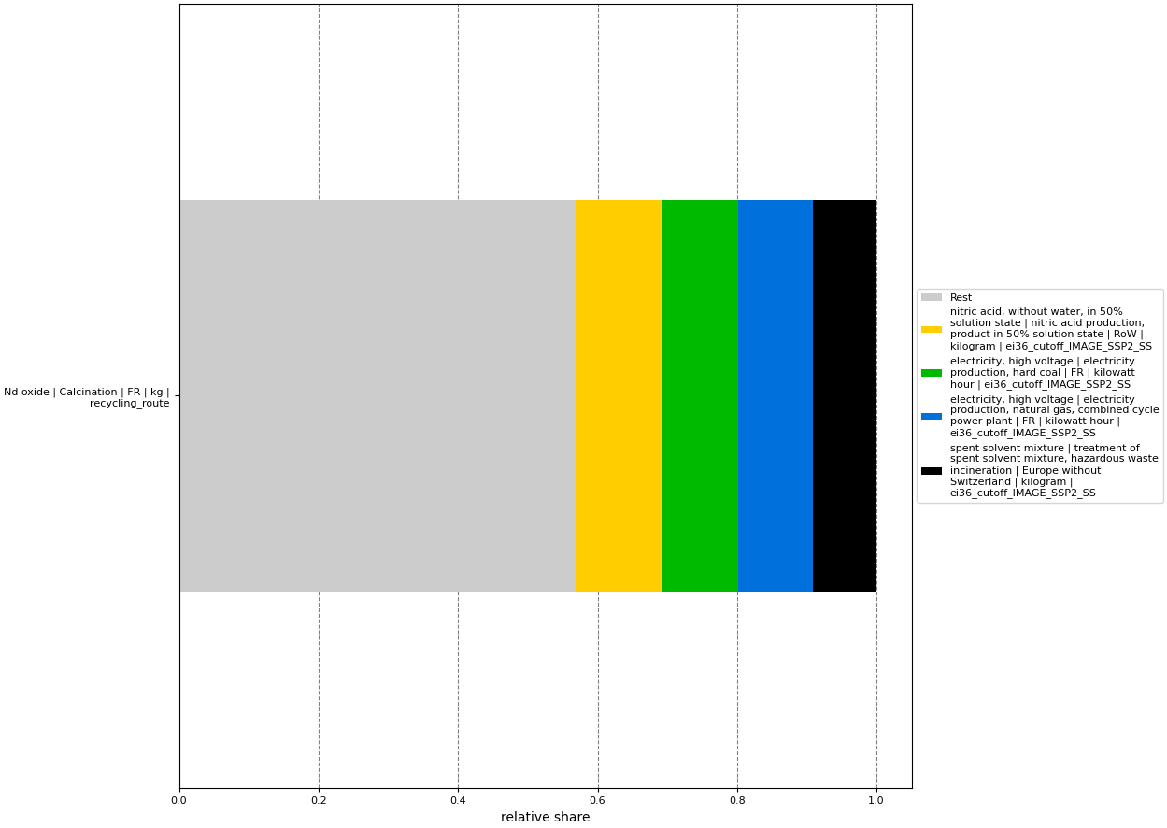

Figure C.2 Relative contribution analysis in freshwater and terrestrial acidification (%). Category indicator: 0,77 mol H+ eq. Top 4 contributors are shown in the figure. Source: author’s image.

Figure C.3 Relative contribution analysis in freshwater ecotoxicity (%). Category indicator: 31,66 CTU. Top 4 contributors are shown in the figure. Source: author’s image.

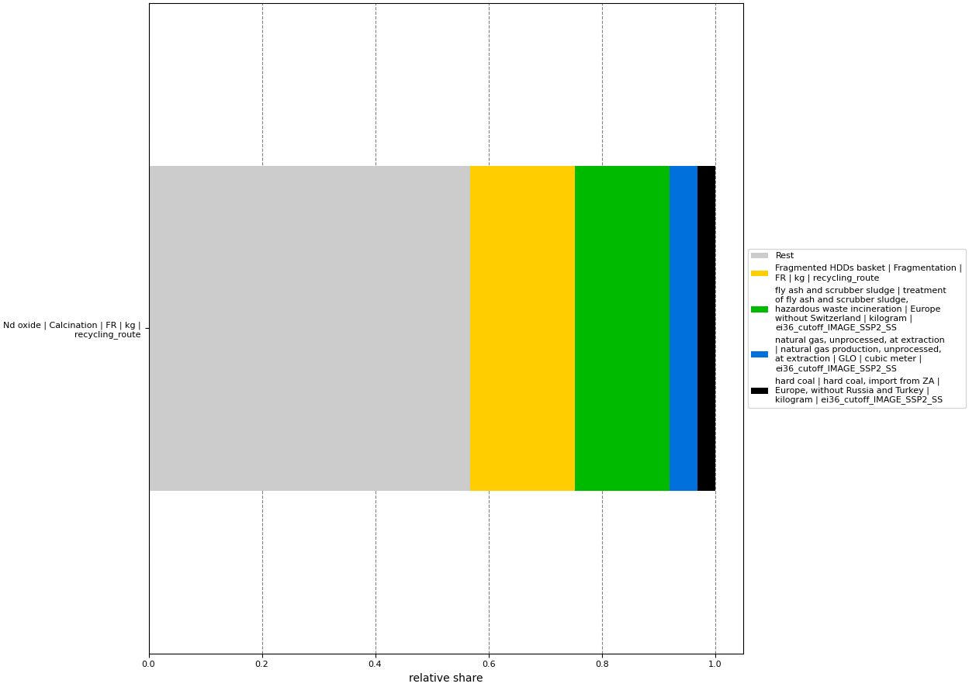

Figure .4 Relative contribution analysis in freshwater eutrophication (%). Category indicator: 0,01 kg P eq. Top 4 contributors are shown in the figure. Source: author’s image.

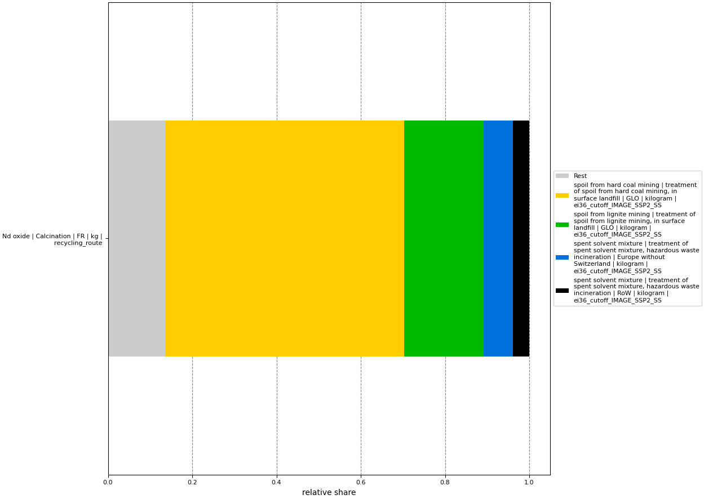

Figure C.5 Relative contribution analysis in marine eutrophication (%). Category indicator: 0,23 kg N eq. Top 4 contributors are shown in the figure. Source: author’s image.

Figure C.6 Relative contribution analysis in terrestrial eutrophication (%). Category indicator: 2,61 mol N eq. Top 4 contributors are shown in the figure. Source: author’s image.

Figure C.7 Relative contribution analysis in carcinogenic effects (%). Category indicator: 5,20 E-07 CTUh. Top 4 contributors are shown in the figure. Source: author’s image.

Figure C.8 Relative contribution analysis of foreground processes in non-carcinogenic effects (%). Category indicator: 5,31E-06 CTUh. Top 4 contributors are shown in the figure. Source: author’s image.

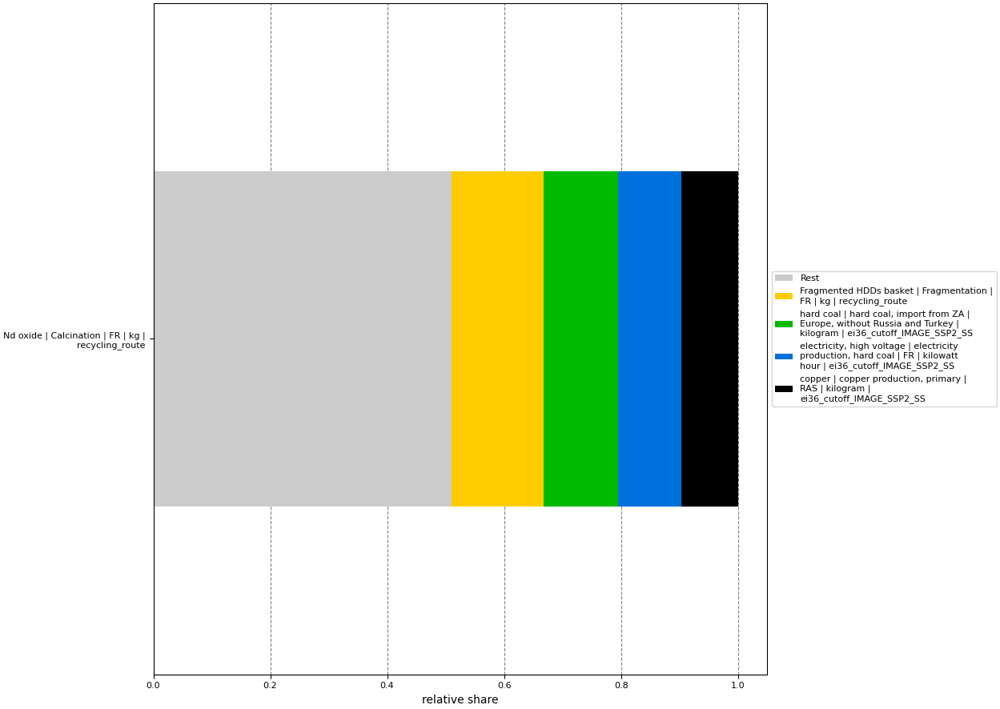

Figure C.9 Relative contribution analysis in ozone layer depletion (%). Category indicator: 8,05E-06 kg CFC-11. Top 4 contributors are shown in the figure. Source: author’s image.

Figure C.10 Relative contribution analysis in photochemical ozone creation (%). Category indicator: 0,64 kg NMVOC. Top 4 contributors are shown in the figure. Source: author’s image.

###### 

**Relative contribution analysis of the top 4 product system’s environmental flows to impact categories**

The values are relative to the category indicator result.

Figure D.1 Relative contribution analysis in climate change (%). Category indicator: 78,74 kg CO2 eq. Top 4 contributors are shown in the figure. Source: author’s image.

Figure D.2 Relative contribution analysis in freshwater and terrestrial acidification (%). Category indicator: 0,77 mol H+ eq. Top 4 contributors are shown in the figure. Source: author’s image.

Figure D.3 Relative contribution analysis in freshwater ecotoxicity (%). Category indicator: 31,66 CTU. Top 4 contributors are shown in the figure. Source: author’s image.

Figure D.4 Relative contribution analysis in freshwater eutrophication (%). Category indicator: 0,01 kg P eq. Top 4 contributors are shown in the figure. Source: author’s image.

Figure D.5 Relative contribution analysis in marine eutrophication (%). Category indicator: 0,23 kg N eq. Top 4 contributors are shown in the figure. Source: author’s image.

Figure D.6 Relative contribution analysis in terrestrial eutrophication (%). Category indicator: 2,61 mol N eq. Top 4 contributors are shown in the figure. Source: author’s image.

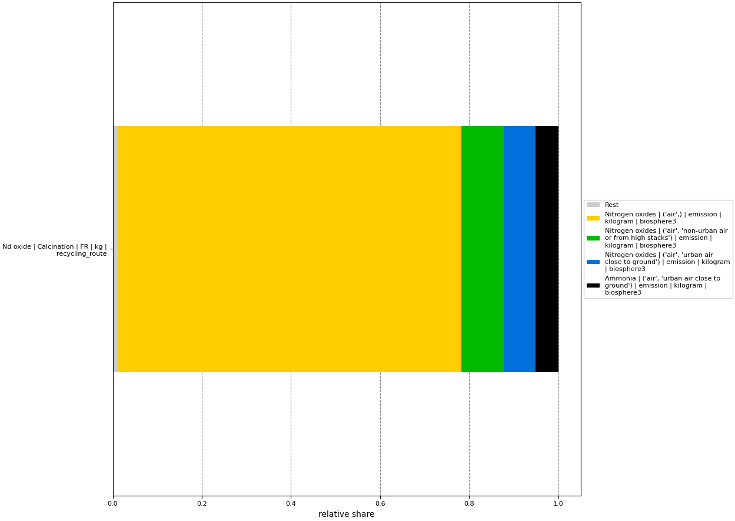

Figure D.7 Relative contribution analysis in carcinogenic effects (%). Category indicator: 5,20 E-07 CTUh. Top 4 contributors are shown in the figure. Source: author’s image.

Figure D.8 Relative contribution analysis of foreground processes in non-carcinogenic effects (%). Category indicator: 5,31E-06 CTUh. Top 4 contributors are shown in the figure. Source: author’s image.

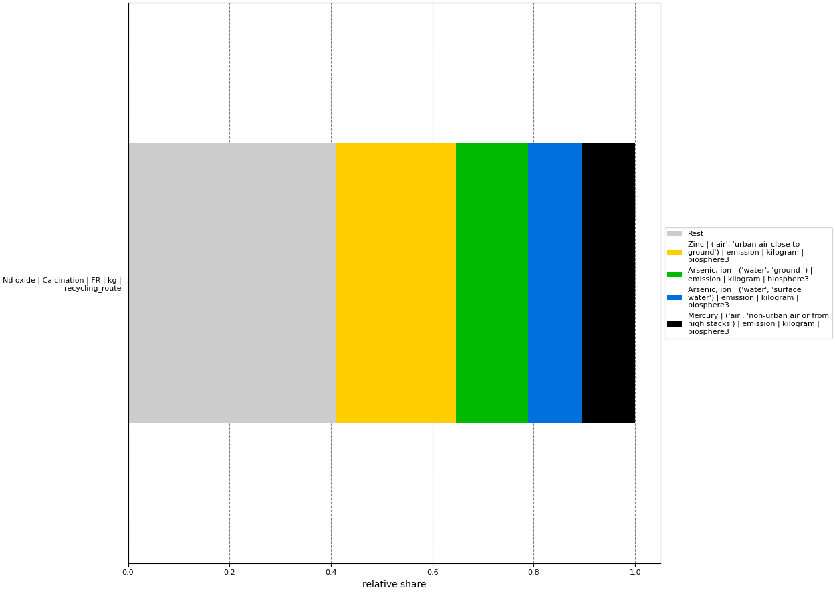

Figure D.9 Relative contribution analysis in ozone layer depletion (%). Category indicator: 8,05E-06 kg CFC-11. Top 4 contributors are shown in the figure. Source: author’s image.

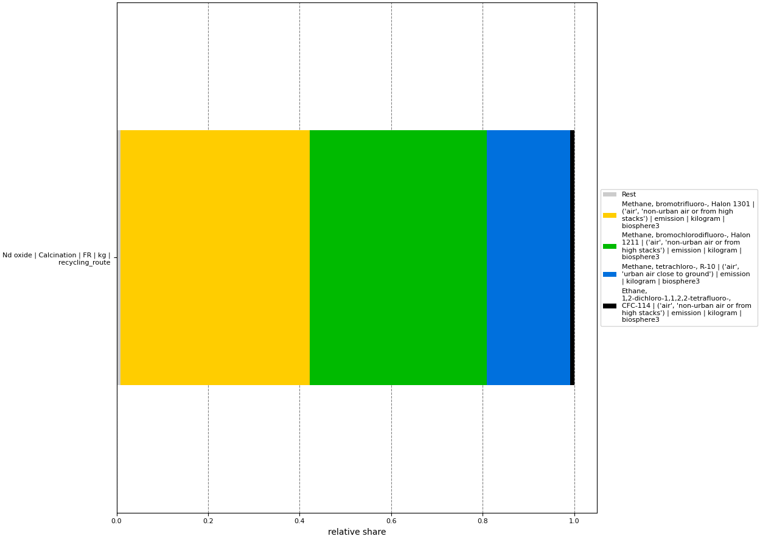

Figure D.10 Relative contribution analysis in photochemical ozone creation (%). Category indicator: 0,64 kg NMVOC. Top 4 contributors are shown in the figure. Source: author’s image.

###### 

**Additional information**

Table E.1 LCIA impact categories. Source: Fazio et al. (2019).

|  |  |  |  |  |
| --- | --- | --- | --- | --- |
| **Impact category** | **Category indicator** | **Characterization model** | **Characterization factor** | **Unit** |
| Climate change | Radiative forcing as Global Warming Potential | Baseline model of 100 years of the IPCC (based on IPCC 2013) | GWP100 | kg CO2 eq |
| Stratospheric ozone depletion | Ozone Depletion Potential | Steady-state ODPs as in (WMO 1999) | ODP | Kg CFC-11 eq |
| Human toxicity (cancer effects) | Comparative Toxic Unit for humans | USEtox model (Rosenbaum et al., 2008) | CTUh | CTUh |
| Human toxicity (non-cancer effects) | Comparative Toxic Unit for humans | USEtox model (Rosenbaum et al., 2008) | CTUh | CTUh |
| Ground-level photochemical ozone formation | Tropospheric ozone concentration increase | LOTOS-EUROS (Van Zelm et al, 2008) as applied in ReCiPe 2008 | NMVOC | Kg NMVOC eq |
| Acidification (land and water) | Accumulated Exceedance | Accumulated Exceedance (Seppala et al. 2006, Posch et al., 2008) | AE | Mol H+ eq |
| Eutrophication (terrestrial) | Accumulated Exceedance | Accumulated Exceedance (Seppala et al. 2006, Posch et al., 2008) | AE | Mol N eq |
| Eutrophication (aquatic freshwater) | Fraction of nutrients reaching freshwater end compartment (P) | EUTREND model (Struijs et al, 2009) as implemented in ReCiPe | P | Kg P eq |
| Eutrophication (aquatic marine) | Fraction of nutrients reaching marine end compartment (N) | EUTREND model (Struijs et al, 2009) as implemented in ReCiPe | N | Kg N eq |
| Ecotoxicity (freshwater) | Comparative Toxic Unit for ecosystems (CTUe) | USEtox model (Rosenbaum et al., 2008) | CTUe | CTUe |

Table E.2 Normalization factors for 2010 EU- 27 and robustness assessment. Source: Sala et al. (2015).

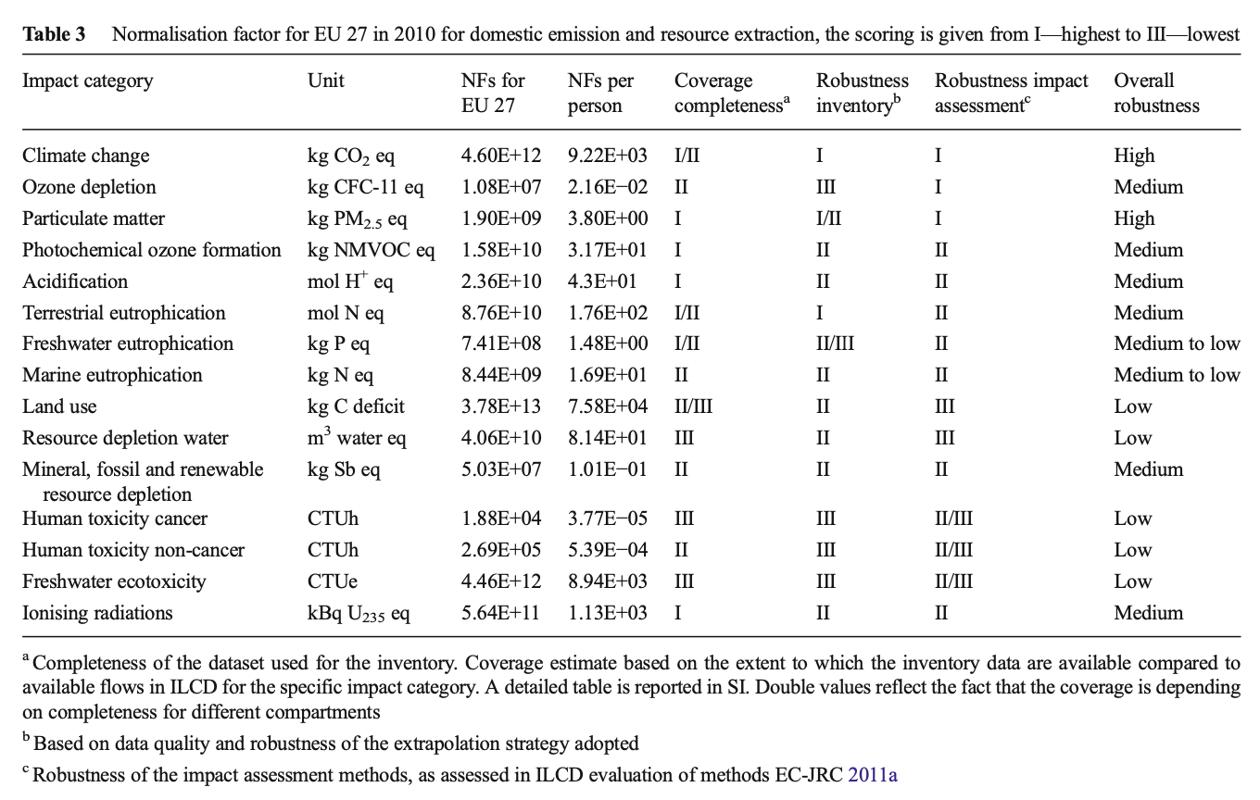

Figure E.1 Product system’s flowchart for sensitivity analysis with oxalic acid regeneration. Source: author’s image.

Table E.3 Environmental profile of the product system regenerating oxalic acid. FU: 1 kg of REO from EOL HDDs’ NdFeB magnets separated from e-waste at the plant’s gate. Source: author’s table.

|  |  |  |  |
| --- | --- | --- | --- |
| **Impact category** | **Original system** | **System regenerating oxalic acid** | **% change** |
| *Indicator results* |  |  |  |
| Climate change | 7,87E+01 kg CO2eq | 6,81E+01 kg CO2eq | -21 |
| Freshwater and terrestrial acidification | 7,67E-01 mol H+ eq | 4,83E-01 mol H+ eq | -37 |
| Freshwater ecotoxicity | 3,17E+01 CTU | 2,78E+01 CTU | -12 |
| Freshwater eutrophication | 1,45E-02 kg P eq | 1,26E-02 kg P eq | -13 |
| Marine eutrophication | 2,29E-01 kg N eq | 1,33E-01 kg N eq | -42 |
| Terrestrial eutrophication | 2,61E+00 mol N eq | 1,51E+00 mol N eq | -42 |
| Human health carcinogenic effects | 5,20E-07 CTUh | 4,65E-07 CTUh | -11 |
| Human health non-carcinogenic effects | 5,31E-06 CTUh | 4,66E-06 CTUh | -12 |
| Ozone layer depletion | 8,05E-06 kg CFC-11 | 6,72E-06 kg CFC-11 | -17 |
| Photochemical ozone creation | 6,43E-01 kg NMVOC- | 3,89E-01 kg NMVOC- | -39 |
| *Economic outflows not followed to system boundary* |  |  |  |
| Basket of coarse size fractions | 2,01E+05 kg |  |  |
| Basket of non-magnetic materials | 2,95E+03 kg |  |  |
| Cake | 5,68E+03 kg |  |  |

Table E.4 Environmental profile of the product system when using a general process for organic chemical production. FU: 1 kg of REO from EOL HDDs’ NdFeB magnets separated from e-waste at the plant’s gate. Source: author’s table.

|  |  |  |  |
| --- | --- | --- | --- |
| **Impact category** | **Original system** | **System approximating oxalic acid production by “chemical production, organic”** | **% change** |
| *Indicator results* |  |  |  |
| Climate change | 7,87E+01 kg CO2eq | 5,17E+01 kg CO2eq | -34 |
| Freshwater and terrestrial acidification | 7,67E-01 mol H+ eq | 1,96E-01 mol H+ eq | -74 |
| Freshwater ecotoxicity | 3,17E+01 CTU | 2,45E+01 CTU | -22 |
| Freshwater eutrophication | 1,45E-02 kg P eq | 1,18E-02 kg P eq | -19 |
| Marine eutrophication | 2,29E-01 kg N eq | 3,42E-02 kg N eq | -85 |
| Terrestrial eutrophication | 2,61E+00 mol N eq | 3,71E-01 mol N eq | -86 |
| Human health carcinogenic effects | 5,20E-07 CTUh | 4,27E-07 CTUh | -18 |
| Human health non-carcinogenic effects | 5,31E-06 CTUh | 4,04E-06 CTUh | -24 |
| Ozone layer depletion | 8,05E-06 kg CFC-11 | 5,42E-06 kg CFC-11 | -33 |
| Photochemical ozone creation | 6,43E-01 kg NMVOC- | 1,34E-01 kg NMVOC- | -79 |
| *Economic outflows not followed to system boundary* |  |  |  |
| Basket of coarse size fractions | 2,01E+05 kg |  |  |
| Basket of non-magnetic materials | 2,95E+03 kg |  |  |
| Cake | 4,55E+03 kg |  |  |

Table E.5 Environmental profile of the product system using allocation by mass. FU: 1 kg of REO from EOL HDDs’ NdFeB magnets separated from e-waste at the plant’s gate. Source: author’s table.

|  |  |  |  |
| --- | --- | --- | --- |
| **Impact category** | **Original system** | **System using allocation by mass** | **% change** |
| *Indicator results* |  |  |  |
| Climate change | 7,87E+01 kg CO2eq | 3,99E+01 kg CO2eq | -49 |
| Freshwater and terrestrial acidification | 7,67E-01 mol H+ eq | 3,59E-01 mol H+ eq | -53 |
| Freshwater ecotoxicity | 3,17E+01 CTU | 9,54E+00 CTU | -70 |
| Freshwater eutrophication | 1,45E-02 kg P eq | 6,68E-03 kg P eq | -54 |
| Marine eutrophication | 2,29E-01 kg N eq | 1,10E-01 kg N eq | -52 |
| Terrestrial eutrophication | 2,61E+00 mol N eq | 1,26E+00 mol N eq | -52 |
| Human health carcinogenic effects | 5,20E-07 CTUh | 1,87E-07 CTUh | -64 |
| Human health non-carcinogenic effects | 5,31E-06 CTUh | 2,00E-06 CTUh | -62 |
| Ozone layer depletion | 8,05E-06 kg CFC-11 | 3,77E-06 kg CFC-11 | -53 |
| Photochemical ozone creation | 6,43E-01 kg NMVOC- | 3,00E-01 kg NMVOC- | -53 |
| *Economic outflows not followed to system boundary* |  |  |  |
| Basket of coarse size fractions | 2,01E+05 kg |  |  |
| Basket of non-magnetic materials | 2,95E+03 kg |  |  |
| Cake | 4,55E+03 kg |  |  |

Table E.6 Environmental profile of the product system using minimum price for compound goods. FU: 1 kg of REO from EOL HDDs’ NdFeB magnets separated from e-waste at the plant’s gate. Source: author’s table.

|  |  |  |  |
| --- | --- | --- | --- |
| **Impact category** | **Original system** | **System using minimum price** | **% change** |
| *Indicator results* |  |  |  |
| Climate change | 7,87E+01 kg CO2eq | 1,87E+01 kg CO2eq | -76 |
| Freshwater and terrestrial acidification | 7,67E-01 mol H+ eq | 4,51E-02 mol H+ eq | -94 |
| Freshwater ecotoxicity | 3,17E+01 CTU | 2,75E+00 CTU | -91 |
| Freshwater eutrophication | 1,45E-02 kg P eq | 3,45E-03 kg P eq | -76 |
| Marine eutrophication | 2,29E-01 kg N eq | 9,28E-03 kg N eq | -96 |
| Terrestrial eutrophication | 2,61E+00 mol N eq | 9,50E-02 mol N eq | -96 |
| Human health carcinogenic effects | 5,20E-07 CTUh | 7,59E-08 CTUh | -85 |
| Human health non-carcinogenic effects | 5,31E-06 CTUh | 8,05E-07 CTUh | -85 |
| Ozone layer depletion | 8,05E-06 kg CFC-11 | 1,40E-06 kg CFC-11 | -83 |
| Photochemical ozone creation | 6,43E-01 kg NMVOC- | 2,73E-02 kg NMVOC- | -96 |
| *Economic outflows not followed to system boundary* |  |  |  |
| Basket of coarse size fractions | 2,01E+05 kg |  |  |
| Basket of non-magnetic materials | 2,95E+03 kg |  |  |
| Cake | 4,55E+03 kg |  |  |

Table E.7 Environmental profile of the product system using maximum price for compound goods. FU: 1 kg of REO from EOL HDDs’ NdFeB magnets separated from e-waste at the plant’s gate. Source: author’s table.

|  |  |  |  |
| --- | --- | --- | --- |
| **Impact category** | **Original system** | **System using maximum price** | **% change** |
| *Indicator results* |  |  |  |
| Climate change | 7,87E+01 kg CO2eq | 7,31E+01 kg CO2eq | -7 |
| Freshwater and terrestrial acidification | 7,67E-01 mol H+ eq | 7,37E-01 mol H+ eq | -4 |
| Freshwater ecotoxicity | 3,17E+01 CTU | 2,15E+01 CTU | -32 |
| Freshwater eutrophication | 1,45E-02 kg P eq | 1,28E-02 kg P eq | -11 |
| Marine eutrophication | 2,29E-01 kg N eq | 2,26E-01 kg N eq | -1 |
| Terrestrial eutrophication | 2,61E+00 mol N eq | 2,58E+00 mol N eq | -1 |
| Human health carcinogenic effects | 5,20E-07 CTUh | 3,98E-07 CTUh | -24 |
| Human health non-carcinogenic effects | 5,31E-06 CTUh | 4,16E-06 CTUh | -22 |
| Ozone layer depletion | 8,05E-06 kg CFC-11 | 7,85E-06 kg CFC-11 | -2 |
| Photochemical ozone creation | 6,43E-01 kg NMVOC- | 6,19E+01 kg NMVOC- | -4 |
| *Economic outflows not followed to system boundary* |  |  |  |
| Basket of coarse size fractions | 2,01E+05 kg |  |  |
| Basket of non-magnetic materials | 2,95E+03 kg |  |  |
| Cake | 4,55E+03 kg |  |  |

Figure . Most contributing environmental flows to NFs, per impact category. Source: Sala et al. (2015).

