© 2019 Manuscript version made available under CC-BY-NC-ND 4.0 license

[https://](NULL)creativecommons.org/licenses/by-nc-nd/4.0

Towards Comfortable Communication in Future Vehicles

Silvana Piroa, Iolanda Fiorilloa, Shabila Anjanib, Maxim Smuldersb, Alessandro Naddeoa*, Peter Vinkb

a Department of Industrial Engineering, University of Salerno,   
Via Ponte don Melillo, 1, 84084 Fisciano, Salerno, Italy

b Faculty of Industrial Design Engineering, Delft University of Technology,   
Landbergstraat 15, 2628CE Delft, The Netherlands

* Corresponding author. E-mail address: a.naddeo@unisa.it.

ABSTRACT

This research aims to study the effect of seat and/or backrest rotation on comfort and quality of conversation. Different sitting arrangements were tested to study the effect of the seat layout on: 1) (dis)comfort experience; 2) conversation quality and 3) postures. Two seats were arranged in different angles (0°, 45°, 90°, and 180°) at the same distance (1 meter) and participants were asked to talk to each other. The participants' postures were acquired by using cameras and markers on the participants' body. Questionnaires were used to rate the perceived (dis)comfort and quality of conversation. Results show that 90° configuration scored the best both in overall comfort and quality of conversation; while the 0° configuration scored the lowest in both ratings. A strong correlation was established between high comfort and good quality of conversation.

*Keywords*: Comfort; Communication; Sitting arrangement, Quality of Conversation

# Introduction

While travelling in trains, airplanes or future autonomous driving cars passengers perform various activities. The most mentioned are sleeping, listening to music, reading, talking and doing nothing (Greghi et al., 2012; Groenesteijn et al., 2014; Kamp et al., 2011; Lille et al., 2016). There are indications that the trend for travelling in groups is rising. In 2017 more than 28% of the passengers at Schiphol airport travelled with more than one accompanying passenger (Homburg, 2017). Young people are the driver of this trend, as millennials (born 1980s-2000s) are found to be more keen on social interaction than older business travellers (“CWT Connected Traveler Study,” 2017): 58% of millennials prefer to travel with others, in contrast, only 29% of the Baby Boomers (born 1940s-1960s) prefer to travel in groups. This implies that the need for conversation during travel will probably increase.

However, it is often hard to interact with anyone in the plane or in the car, even though some vehicles, such as autonomous driving cars, already allow their passengers to have more time for conversation (Lille et al., 2016).

Furthermore, improving aircraft passenger’s comfort requires knowledge about their perception and eliciting conditions (Ahmadpour et al. 2014).

This paper focuses on the comfortable communication model (Dumur et al., 2004) where comfort means that passengers can behave socially, that people travelling together can talk to each other, and can interact with their neighbours in a comfortable way, so they can have the sensation that all passengers form a group sharing a common experience.

During a social interaction, people surround themselves with a bubble of defined and organized space, which is internalized at an unconscious level (Hall, 1966). Respecting this space could improve the comfort during a social interaction. There have been studies on the distances between standing persons to facilitate communication. Hall (1966) stated there are four interpersonal distances important in social interactions (Figure 1): intimate (from 0 to 45cm) reserved for lovers, pets and family’s members; personal (from 45 cm to 1.2 m) reserved for friends; social (from 1.2m to 3.7m) reserved for strangers and newly formed group; and public (from 3.7m to 7.6m) for a large audience.

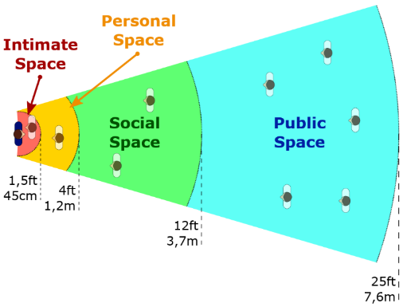

Figure 1: Four interpersonal distances during social interaction according to Hall, 1990

In addition, Sommer (1962) found that, during a social interaction, opposite seats are preferred to the side-by-side sitting at smaller distances.

Concerning the interpersonal communication that is the communication between one person and another (or others), both verbal and nonverbal communication, or body language, play a part in how one person understands another. The aim of this work is not to analyse the quality of communication, but the people’s perceived discomfort while they are engaged in a conversation in a tested configuration, thus through the conversation quality and postures analysis.

However, for the design of autonomous car and aircraft interiors information on seated positions for social interactions is needed.

A study from Nguyen (2016) indicated that the best sitting arrangement for communication and comfort was a L-shaped configuration.

In most vehicles, passengers sit aside and should turn their eyes, heads, shoulders, torso or whole body to be engaged in the conversation (Groenesteijn et al., 2014). But, rotating the body too much – especially for a prolonged amount of time ­– could cause discomfort. Regarding the neck, Naddeo et al. (2015) showed that the comfortable range of the head rotation is limited (Figure 2).

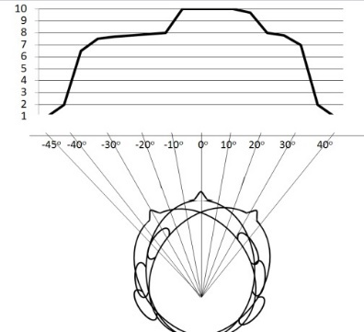

Figure 2: Comfort scores for different head rotations on a scale from 1-10 (10 is most comfortable) (Naddeo, 2017)

As concluded by Helander and Zhang (1997) and Zhang et al. (1996), sitting discomfort and comfort are based on different factors. Feelings of discomfort are associated with pain, tiredness, soreness and numbness, where comfort is associated with feelings of relaxation and well-being.

Different studies (Andreoni et al., 2001; Christensen and Nilsson, 1999) show that the most comfortable position corresponds to the neutral position of the joints or resting body, called Rest Posture. In the Rest Posture human muscles are relaxed or at minimum strain level, that minimizes muscle activity, strain in the ligaments and optimizes the comfort perception (Galinsky et al., 2000). It would be ideal if seats and/or backrests could rotate to facilitate the conversation and to ensure the highest comfort.

Despite this background, there is no research regarding the (dis)comfort and quality of conversation while sitting in different angles towards each other.

Therefore, the aim of this study is to find the best configuration to improve the quality of conversation, improve postural comfort and reduce discomfort. The output of this research could be a basis for designing autonomous car, train and aircraft interiors.

The research question is: *What is the effect of seat layout on: 1) (dis)comfort experience; 2) conversation quality and 3) postures?*

# Method

To answer this research question the effect of four different sitting arrangements on quality of conversation, perceived (dis)comfort and taken posture was studied. For each sitting arrangement, two seats were placed in different angles (0°, 45°, 90°, and 180°) to each other at a distance of 1 meter, that is in the personal space suitable for friends during social interaction (Hall, 1966). This distance was set up considering the centre of each seat as a reference point (Figure 3).

The experiment was done in a classroom at Delft University of Technology where 18 office chairs were set up using rulers, measuring tapes, goniometers and markers on the floor. The room was divided into 4 zones; each representing a configuration (0°, 45°, 90° and 180°).

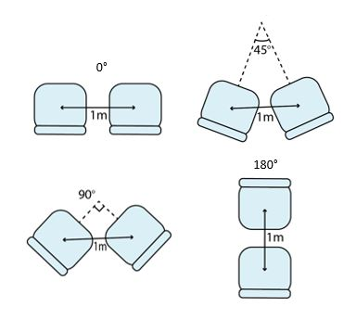

Figure 3: Seating arrangements examined

Thirty-six healthy participants, randomly recruited among students of TU Delft, 14 females and 22 males, took part in this study. Table 1 represents the demographic data of the participants.

Table 1: Demographics of the samples (n=36)

|  |  |  |  |
| --- | --- | --- | --- |
|  | Range | Mean | SD |
| Age (years) | 21-28 | 22,86 | 1,74 |
| Height (cm) | 160-195 | 177,10 | 9,53 |
| Weight (kg) | 53-110 | 71,08 | 11,49 |

All participants belong to the millennial age group (“CWT Connected Traveler Study,” 2017). It is assumed that the participants in this test are categorized as acquaintances, since most knew each other before the experiment.

The participants were divided in 9 groups of 4 persons. Of each group two were sitting-participants and the other two were observers, switching roles after each session. The order of the experiment was determined using a Latin square scheme (Fisher, 1992) to minimize the order effect.

During the experiment, the observers took pictures from three different views (top view, lateral view and frontal view) at three different moments in the experiment (start, middle and end) to capture information about postural angles. The pictures were analysed through Kinovea® software to collect postural angles.

## Protocol

Each subject was given a written experiment protocol and asked to sign an informed consent prior to the experiment. After that, the instructions of the experiment were explained and the participants were divided into groups of 4 persons. In each group two people were asked to sit for 10 minutes and talk about a given topic previously discussed in the classroom:

* the paper of Molenbroek et al. (2017)
* chapter 4 of the book “Aircraft interior comfort and design” (Vink and Brauer, 2011)

The given topic was meant to make the sitting-participants feel at ease in having the conversation (Sommer, 1962). At the end of the 10-minute conversation, the participants were asked to complete the questionnaire on the (dis)comfort and quality of conversation.

The two observers watched the sitting participants and took pictures (at the beginning, minute 4:30 until 5, and minute 9:30 until 10). The pictures were taken from the front-, side-, and top-view of each person. At the end of the 10-minute conversation, the observer rated the overall comfort and quality of conversation of the sitting participant. After 15 minutes (10 minutes in a seats configuration and 5 minutes to complete the questionnaire) each participant in each group changed his/her role from sitting to observer and vice versa. After 30 minutes, each group went to a different sitting configuration. Figure 4 shows the protocol of the experiment in a timeline.

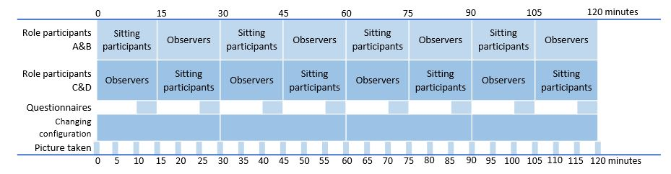

Figure 4: Protocol of experiment plotted along the time axis

## Questionnaire

Questionnaires were used to evaluate each sitting arrangement (see Appendix). Each sitting participant was asked to rate the Localized Postural Discomfort (LPD) (Grinten, 1992) for their upper-body (eyes, neck, shoulder, trunk, lumbar spine, pelvic). A 7-point Likert scale was used to assess this discomfort (1 = No discomfort and 7 = Extremely discomfortable). The LPD instrument was meant to help the participant in answering during the experiment. The visual map helps to focus on the various body regions and the 7-point scale helps to give an immediate response, without losing the discomfort perception. Several authors, such as Hiemstra-van Mastrigt et al. (2015; 2016), Bouwens et al. (2018) ,Van Veen et al. (2015), used the LPD questionnaire to analyse discomfort perception.

To evaluate the quality of conversation, four questions (Figure 5) were included using a seven-point Likert scale (Joshi et al., 2015) (from 1 = Extremely Disagree to 7 = Extremely Agree). Those questions were meant to get an idea about the participants’ feelings during the social interaction in a specific configuration, focusing on if they felt at ease or not. An appropriate questionnaire model for this case had not been found in the literature.

Participants also had to give an overall rating for comfort (10-scale: 1 = No comfort and 10 = Extremely comfortable) and for quality of conversation (10-scale: 1 = Very bad and 10 = Very Good) for each configuration. At the end of the experiment, after experiencing all configurations, each participant was asked to choose which configuration they preferred, both for overall comfort and quality of conversation, and they were asked to add an argument for the choice.

Additionally, the observers were also asked to rate their impression of the overall comfort and the quality of conversation with a 10-point scale, to see whether people outside the conversation could correctly rate the comfort and conversation quality.

# Analysis

## Comfort and discomfort analysis

All questionnaire data and results from analysing the pictures were gathered and analysed using IBM® SPSS® Statistics version 24. A Wilcoxon signed ranked test was performed to compare results of the questionnaire for each participant and for each configuration. It was useful to understand if participants answered properly for each configuration. In this case, Wilcoxon is used to analyse comfort and discomfort as discomfort may be not normally distributed (Groenesteijn, 2015). With the Wilcoxon test the significance was determined at P=0.05 for each configuration.

## Posture analysis

In order to acquire the postural angles, the photos were processed using Kinovea® software. Analysis was made of the following upper limbs movements: head rotation, head bending, shoulder rotation, shoulder bending, trunk rotation, trunk bending and trunk flexion. Body rotation was analysed in the transverse plane, body flexion in the frontal plane and body bending in the sagittal plane. The angles found are defined as the angles between two segments: the first is the line passing corresponding body part in the Rest Posture (when the body leans back against the chair) and the second is the same line after the movement. And more specifically, for the shoulder rotation the line is the one between the acromion processes, while for the head rotation the line is the one passing the centre of the neck and the nose base. An example of the postural angle acquisition is shown in the Figure 5.

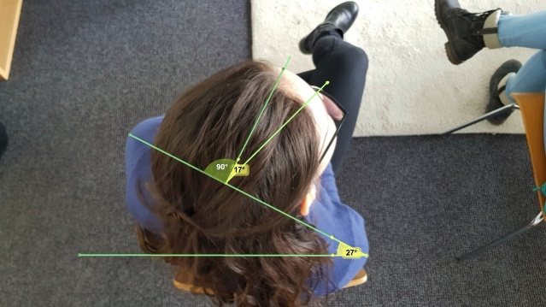

Figure 5: Example of neck and shoulders postural angle acquisition

# Results

## (Dis)comfort experience

|  |  |  |  |  |  |  |
| --- | --- | --- | --- | --- | --- | --- |
|  | Eyes | Neck | Shoulders | Upper back | Lower back | Buttock |
| 0° | 2,14 | 3,86 | 3,49 | 3,29 | 3,23 | 2,86 |
| 45° | 1,57 | 2,74 | 2,57 | 2,51 | 2,20 | 2,26 |
| 90° | 1,47 | 2,21 | 2,12 | 1,85 | 1,88 | 1,97 |
| 180° | 1,71 | 1,94 | 1,88 | 2,15 | 2,12 | 2,15 |
|  |  |  |  |  |  |  |

Table 2: Mean Values from LPD questionnaire, where 1 = no discomfort and 7 = extremely discomfortable.

Table 2 and Figure 6 show that the neck scored the highest values of discomfort for the 0˚, 45˚ and 90˚ configurations. The 0° configuration has the highest discomfort for all recorded body parts, followed by 45°, except for the eyes, which was the second most uncomfortable in the 180° configuration. In the questionnaires often the participants mentioned that the 180° configuration forced them to have eye to eye contact.

The 90° configuration showed the lowest discomfort, apart from the neck and the shoulders, where the 180˚ configuration scored less discomfort.

The recordings of the angles show that participants tend to rotate the neck and the shoulder to make the face-to-face contact.

Figure 6: Mean values from LPD questionnaire (* means significant differences between configurations)

## Conversation quality

Regarding the quality of conversation, a majority of the participants felt restricted in the social interaction in the 0° configuration. In the 180° configuration participants reported that they could easily understand each other in the conversation, but felt invaded in their personal space. The 90° configuration scored the highest value of “I feel at ease during the conversation”, meaning participants could feel more at ease during the conversation in this configuration than the others (Figure 7).

The 90° configuration scored the highest values both in overall comfort and quality of conversation, followed by 180°, 45° and 0° configurations (Figure 8), thus on the whole it could be the best configuration.

Figure 7: Results from questionnaire quality of conversation (1=extremely disagree, 7=extremely agree)

After sitting in each seat configuration, each participant was asked to choose their most preferred configuration (Figure 9). The majority of participants rated the 90° as the preferred configuration explaining that this configuration allows them to have a comfortable posture with less discomfort during the social interaction.

Figure 8: Mean Values of Overall comfort (1=no comfort, 10=extremely comfortable) and Quality of conversation (1=very bad, 10=very good)

Figure 9: Percentile of preferred configuration that participant rated

Table 3: Mean values of angles for the best sitting arrangement

|  |  |  |
| --- | --- | --- |
|  | Mean α or Mean β | Mean γ |
| 52.6° | 105.2° |
| 36° | 116.5° |
| 31.25° | 149.7° |

## Postures

The results of posture analysis show that for each configuration, with the exception of 180° configuration, the sitting participants rotated the upper part of their body. There were individual differences. In the 0° configuration the participants rotated or the shoulders (19%) or the neck (38%) or less the shoulder and more the neck or vice versa (43%).

Finally, the results of the mean values of the postural angles (α and β) are shown in Table 3.

α and β represent the rotation of neck and shoulders of participants, γ is the angle between the two participants recorded during the conversation (considering a triangle, having two angles at the basis, the third angle can be easily found and it represents the ideal configuration, where participants might be in Rest Posture).

Table 3 shows that increasing the angles of the sitting arrangement, the mean values of α and β decrease because the people need to rotate less their body parts to have an eye-to-eye contact.

## Correlations

To understand the correlation between the acquired data a statistical analysis was performed using SPSS. Pearson correlation coefficients were calculated to determine the strength of the relationships between all the variables.

Some relevant results were obtained from the correlations between the outcomes:

(** Correlation is significant at the 0.01 level)

1. There is a moderate correlation between the overall comfort and the quality of conversation (r=.542**);
2. There is a negative correlation between the angles regarding the neck rotation and shoulder rotation for the 0˚ configuration (r=-.503**) and a positive correlation for the 180° configuration (r=.694**);
3. There is a weak correlation between the postural angles and overall comfort and between postural angles and body discomfort.

## The effect of the quality of conversation to body part discomfort?

The absence of correlations between postural angles and discomfort and between postural angles and overall comfort could be caused by the relative weight of the quality of conversation on overall comfort.

In order to support the hypothesis, a sensitivity analysis was done by building a mathematical function in order to determine the impact of the variable “Quality of conversation” on the overall comfort.

The mathematical function has been built through the weighted means of data derived from postural comfort and quality of communication, it means defined as the linear combination of two factors: body part discomfort and quality of conversation.

$$Sensitivity Index=A*\left(body part discomfort\right)+B*(quality of conversation)$$

In which: $A+B=1$

|  |  |  |  |  |
| --- | --- | --- | --- | --- |
| **A** | 0.2 | 0.4 | 0.6 | 0.8 |
| **B** | 0.8 | 0.6 | 0.4 | 0.2 |

Table 4: Combination of A and B for the New Global Index.

The Sensitivity analysis consist of changing the factors assigning complementary values to the coefficients A and B (Table 4) to see what effect is produced on the sensitivity index.

A statistical analysis, with Pearson’s correlation coefficients, was performed to verify a possible correlation between the sensitivity index and the overall comfort. This analysis revealed that increasing B, thus increasing the weight of the quality of conversation, the sensitivity index shows a stronger correlation with the overall comfort for each configuration (Figure 10).

Figure 10: Sensitivity analysis for each configuration

# Discussion

Answering the research question, the results show that 90° is more preferred for both comfort and communication. This is in align with the study of Nguyen (2016) where the L-shaped configuration performed better than the Opposite (180˚) and Side-by- Side (0˚) set up. Maines (1979) describes that in the 180° configuration people felt uncomfortable as they are forced to face each other, which was affirmed in this study as well.

The 0° configuration scored the lowest in both comfort and quality of conversation since the sitting arrangement does not facilitate conversation and requires rotation of the body. This sitting configuration however, is most frequently used in cars, buses, trains and airplanes.

Thus, the 90° configuration represents the best compromise for a conversation, since it allows to have a comfortable posture with minimal discomfort and a good quality of conversation, while avoiding the forced eye-to-eye contact between neighbours.

However, the postural analysis shows that even in the highest scored configuration (90° configuration) participants have to rotate parts of their body, which could cause discomfort in the long run. Several studies show that discomfort increase over time (Sammonds et al., 2017; Vink et al., 2017; Hiemstra-van Mastrigt et al., 2016; Smulders et al., 2016). Further research is advised to look at long term effects and check the effect of angles in between the 90° and 180° configurations.

The strong correlation between the overall comfort and the quality of conversation confirms the studies by Helander and Zhang (1997) and Zhang et al. (1996); the quality of conversation, that is associated with the emotions, influences the overall comfort perceived by each participant while it doesn’t influence the LPD, that is associated with physical pain.

Furthermore, it confirms also the work of Ahmadpour (2014) which, in relation to passenger comfort, showed the importance of psychological and social experiences for creating comfort.

## Limitations of the setup

There are some limitations of this study that need to be acknowledged. Firstly, there are not literature studies on methods, tools, techniques to evaluate the quality of conversation. Then, the group of participants were homogeneous, as they were all young (21-28y) and most of them students. However, literature research showed that young people do travel more in groups. Thus, this sample might represent the group involved in this trend.

During the experiment the participants were asked only to talk about a given topic without defining precisely other conditions. This resulted in too many degrees of freedom for the participants, who sometimes assumed unexpected postures or used devices like books or mobile-phones during social interaction to substantiate their conversation. This aspect caused some problems with the pictures analysis, giving the possibility to analyse only pictures taken at minute 4:30 until 5. Therefore, it was not possible to have a deeper postural analysis, e.g. based on time. Future studies could consider a different method for postural acquisition to prevent these issues. On the other hand, this kind of freedom represents reality as well.

Furthermore, it was not possible to reproduce a realistic context during the experiment. The context was simulated in a classroom using normal office chairs. This also influences the validity of the experiment. It is advised to do the experiment again in a moving vehicle where the environment can be seen or in a restricted area of a cabin, using also seat belts to be nearer to cars or airplanes environment.

In addition, the distance of 1 meter theoretically is within the personal space between friends as presented in Figure 1. However, in reality most vehicles cannot afford to provide a 1-meter in-between seat allowance because the car size is usually limiting. Current vehicles have the side by side (0°) configuration to save space, thus a further analysis is required to save space and money with a more adequate distance.

# Conclusions

In most of the current vehicles, passengers travel side by side. There is a growing number of passengers travelling in groups (“CWT Connected Traveler Study,” 2017) and for these passengers the side by side configuration is not optimal.

The 90° sitting arrangement was found to be the most preferred for both comfort and quality of conversation, allowing to obtain a comfortable posture with minimal discomfort and a qualitative conversation without forced eye-contact. In interior design more attention is advised for using a similar configuration.

Regarding the (dis)comfort experience and conversation quality, the 0° configuration was found to score the lowest on both aspects and also was the least preferred of all arrangements.

Regarding the postures, it has been observed that for 0°, 45° and 90° configurations the participants needed to rotate their body to engage in a conversation. These postural angles may be used as guidelines for future interior and seat designs.

There was no correlation between (dis)comfort and local postural discomfort and postural angles, though it was found that there is a strong correlation between comfort and quality of conversation. A sensitivity analysis was performed and a new index was calculated as a linear weighted of the body postural discomfort and the quality of conversation. A strong correlation between the new index and the overall comfort was found in correspondence of the highest value of the quality conversation weight. This shows that the perceived overall comfort was strongly influenced by the quality of conversation the participants had.

**Acknowledgements**

We want to thank Mr B.J. Naagen for his help in setting up this study and MD students from IDE – TUDelft for helping us by taking part, as participants, in this study.

# References

Ahmadpour, N., Lindgaard, G., Robert, J.-M., Pownall, B., 2014. The thematic structure of passenger comfort experience and its relationship to the context features in the aircraft cabin. Ergonomics 57, 801–815. https://doi.org/10.1080/00140139.2014.899632

Andreoni, G., Rigotti, C., Baroni, G., Ferrigno, G., Colford, N.A.T., Pedotti, A., 2001. Quantitative analysis of neutral body posture in prolonged microgravity. Gait Posture 12, 235–242.

Bouwens, J.M.A., Fasulo, L., Hiemstra-van Mastrigt, S., Schultheis, U.W., Naddeo, A., Vink, P., 2018. Effect of in-seat exercising on comfort perception of airplane passengers. Appl. Ergon. 73, 7–12. https://doi.org/10.1016/j.apergo.2018.05.011

Christensen, H.W., Nilsson, N., 1999. The ability to reproduce the neutral zero position of the head. J. Manipulative Physiol. Ther. 22, 26–28. https://doi.org/https://doi.org/10.1016/S0161-4754(99)70102-8

CWT Connected Traveler Study [WWW Document], 2017. URL https://www.carlsonwagonlit.com/cn/en/news/news-releases/20171129-CWT-research--Millennials-like-to-travel-in-groups/

Dumur, E., Barnard, Y., Boy, G., 2004. Designing for comfort. Hum. Factors Des. 111–127.

Fisher, R.A., 1992. Statistical Methods for Research Workers, in: Kotz, S., Johnson, N.L. (Eds.), Breakthroughs in Statistics: Methodology and Distribution. Springer New York, New York, NY, pp. 66–70. https://doi.org/10.1007/978-1-4612-4380-9_6

Galinsky, T., Swanson, N., Sauter, S., J. Hurrell, J., M. Schleifer, L., 2000. A field study of supplementary rest breaks for data-entry operators. Ergonomics 43, 622–638.

Grinten, M.P., 1992. Development of a pratical method for measuring body part discomfort, in: S.K. (Ed) Advances in Industrial Egonomics and Safety IV. Taylor and Francis, London. pp. 331–318.

Groenesteijn, L., Hiemstra-van Mastrigt, S., Gallais, C., Blok, M., Kuijt-Evers, L., Vink, P., 2014. Activities, postures and comfort perception of train passengers as input for train seat design. Ergonomics 57, 1–12.

Hall, E.T., 1966. The hidden dimension. Doubleday, Garden City, N.Y.

Helander, M., Zhang, L., 1997. Field studies of comfort and discomfort in sitting. Ergonomics 40, 895–915.

Hiemstra-van Mastrigt, S., Kamp, I., van Veen, S.A.T., Vink, P., Bosch, T., 2015. The influence of active seating on car passengers’ perceived comfort and activity levels. Appl. Ergon. 47, 211–219. https://doi.org/10.1016/j.apergo.2014.10.004

Hiemstra-van Mastrigt, S., Meyenborg, I., Hoogenhout, M., 2016. The influence of activities and duration on comfort and discomfort development in time of aircraft passengers. Work 54, 1–7.

Homburg, B.A.P., 2017. Increasing passenger comfort during airside dwell-time. TU Delft. https://doi.org/uuid:ca3b8efc-9d47-4cc9-8bf6-833f7f891dd4

Joshi, A., Kale, S., Chandel, S., Pal, D., 2015. Likert Scale: Explored and Explained. Br. J. Appl. Sci. Technol. 7, 396–403.

Kamp, I., Kilincsoy, Ü., Vink, P., 2011. Chosen postures during specific sitting activities. Ergonomics 54, 1029–1042. https://doi.org/10.1080/00140139.2011.618230

Lille, C. de, Santema, S., Bouwens, J., Schultheis, U., Vink, P., 2016. Designing the cabin interior knowing high and low peaks in a passenger flight, in: AEGATS Conference, AEGATS2016_48.

M. Greghi, F., da Silva, T., B. J. Souza, G., Menegon, N., 2012. Contributions from the activity analysis to the products development project: Case study based on a project of innovation and comfort in aircraft’s cabins. Work 41, 55–60.

Maines, D.R., 1979. Mesostructure and Social Process. Contemp. Sociol. 8, 524–527.

Molenbroek, J.F.M., Albin, T.J., Vink, P., 2017. Thirty years of anthropometric changes relevant to the width and depth of transportation seating spaces, present and future. Appl. Ergon. 65, 130–138. https://doi.org/https://doi.org/10.1016/j.apergo.2017.06.003

Naddeo, A., Cappetti, N., D’Oria, C., 2015. Proposal of a new quantitative method for postural comfort evaluation. Int. J. Ind. Ergon. 48, 25–35. https://doi.org/https://doi.org/10.1016/j.ergon.2015.03.008

Nguyen, H., 2016. The influence of aircraft seats configurations on social interaction during a flight. TU Delft.

Sammonds, G.M., Fray, M.J., Mansfield, N.J., 2017. Effect of long term driving on driver discomfort and its relationship with seat fidgets and movements (SFMs). Appl. Ergon. 58, 119–127.

Smulders, M., Berghman, K., Koenraads, M., Kane, J.A., Krishna, K., Carter, T., Schultheis, U., 2016. Comfort and pressure distribution in a human contour shaped aircraft seat (developed with 3D scans of the human body). Work 54, 1–16.

Sommer, R., 1962. The Distance for Comfortable Conversation: A Further Study. Sociometry 25, 111.

Van Veen, S., Orlinskiy, V., Franz, M., Vink, P., 2015. Investigating Car Passenger Well-Being Related to a Seat Imposing Continuous Posture Variation. J. Ergon. https://doi.org/10.4172/2165-7556.1000140

Vink, P., Anjani, S., Smulders, M., Hiemstra-van Mastrigt, S., 2017. Comfort and discomfort effects over time: the sweetness of discomfort and the pleasure towards of the end.

Vink, P., Brauer, K., 2011. Aircraft interior comfort and design.

Zhang, L., Helander, M.G., Drury, C.G., 1996. Identifying Factors of Comfort and Discomfort in Sitting. Hum. Factors 38, 377–389. https://doi.org/10.1518/001872096778701962

# Appendix: Questionnaire of LPD and Quality of conversation

# 

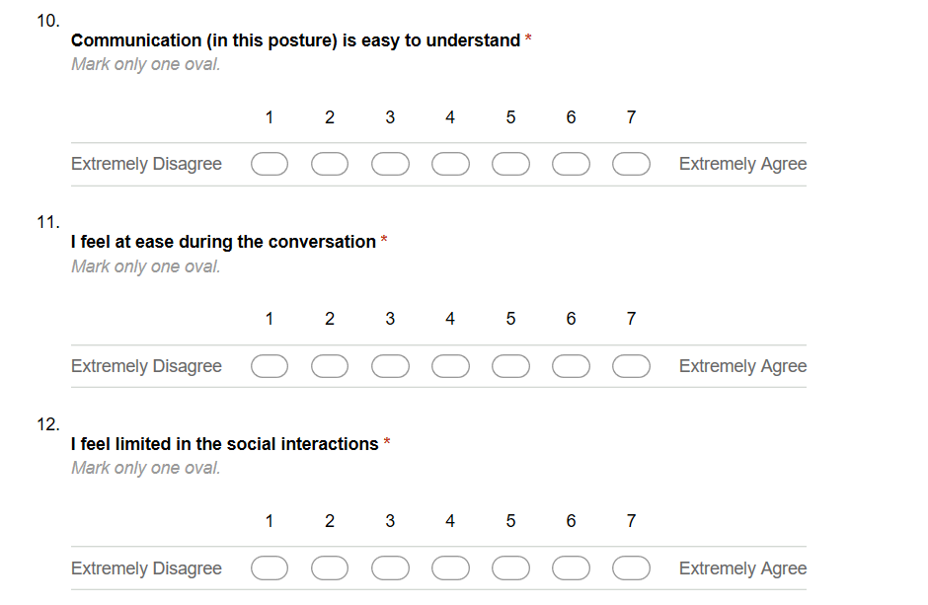

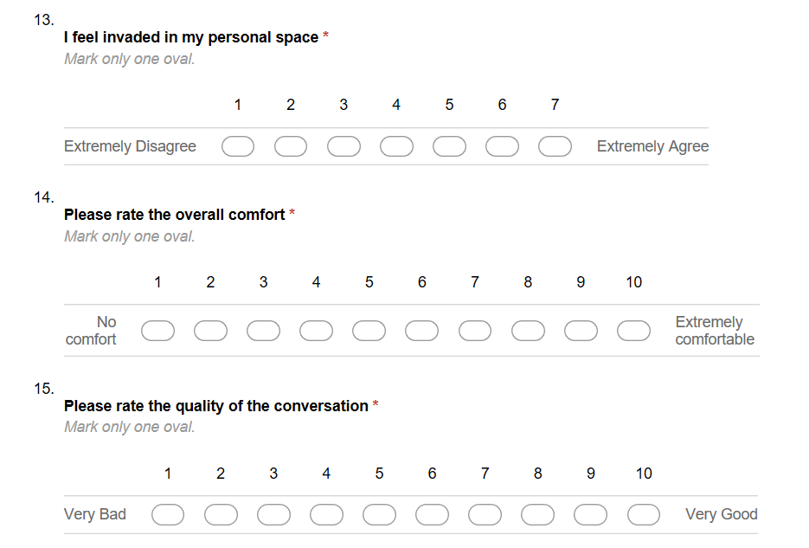

Part of questionnaire used for the experiment. Question 9 is the LPD, questions from 10 to 13 are about the quality of conversation, questions 14 and 15 about overall comfort and overall quality of conversation, respectively.