Graduation Plan
Master of Science in Architecture, Urbanism & Building Sciences
MSc Landscape Architecture 2023 - 2024
Wessel Koolhaas
Master of Science Architecture, Urbanism & Building Sciences

Graduation Plan

Submit your Graduation Plan to the Board of Examiners (Examencommissie-BK@tudelft.nl), your mentors and delegate of the Board of Examiners one week before the P2 date at the latest.

I Personal information
Full name | Wessel Koolhaas
Student number | 5882346

II Studio / Lab information
Name / Theme | FLOWSCAPES
Main mentor | Prof.ir. E.A.J. Luiten | Landscape Architecture
Second mentor | Ir. R.J. van der Veen | urbanism
Argumentation of choice of the LA graduation lab | I have an interest in exploring the fundamentals of landscape architecture. With this being probably my last study related design project for a while, do I like to be able to bring my skills to a more abstract, higher theoretical level during this graduation lab. With scale continuum being an interesting subject to explore, whilst giving a lot of freedom in choosing a site.

III Graduation project
Title of the project | The stream revived  Development of the river Aa catchment area to contribute to central-Brabant as a National Park.
Context and aim of the project
Location (region / area / site)
Problem statement
Research question(s)
Design assignment
Location
Noord Brabant, Van Gogh National Park, The Aa watershed

Problem statement
The Aa is a stream on the sandy grounds of North-Brabant. It flows form the higher ground of the Peelhorst, trough the cities of Helmond and Veghel, towards ‘s Hertogenbosch where it flows into the Meuse. What was once a free-flowing river, is now a canalized stream mainly used to provide water for agriculture in the summer and to discharge rainwater in the winter (Terra incognita, 2016) The intensive water management and high levels of nutrients of the Aa have diminished its natural and landscape qualities. This becomes especially clear when comparing the Aa to the Dommel, the stream directly west of the Aa. The Dommel is well known for its natural features and widely used for recreation. In the image below you can see the difference in use as an ecological area and corridor and the difference in water management, for example room for fluctuation. In the second image the difference in visibility of the stream in the landscape becomes clear. This shows how bringing the Aa ‘back to life’ is an interesting design assignment to see how the ecosystem and potential landscape quality of the Aa can be brought up to sufficient levels.

This improvement can happen in the context of the Van Gogh National Park (VGNP) as the Aa lies at the eastern edge of the proposed new National Park. VGNP in North-Brabant is the first really embracing the ideas of a National Park ‘nieuwe stijl’. Which are National Parks that include the surrounding farmland, and small towns and villages. This makes better cooperation possible between nature conservation and activities in nearby land. The surrounding landscape can help protect and strengthen the ecosystem, creating larger areas more resilient to changes and pressures (De Vries, et al. 2017).

The masterplan developed partly by West 8 for VGNP proposes to start with the streams and stream valleys of Mid-Brabant to create a coherent, connected, and recognizable landscape (masterplan VGNP, 2020). The problem is that not all streams are included from source to outlet, thereby leaving part of the ecosystem outside the national park. Moreover, not all streams have a sufficient ecological and landscape quality. This is also one of the reasons why VGNP has not yet been granted the status of a National Park with its latest application to become an official National Park (Adviescommissie Nationale Parken, 2021). This is partly due to the criterion nature conservation efforts outside the nature core of the Loonse en Drunense Duinen, but also the lack of a coherent landscape identity which ties the area of the National Park together. Everyone and everything in the region is allowed to join VGNP, no matter the current state of nature or landscape quality. VGNP then uses their platform to promote and improve the landscape.

The context of the VGNP makes redesigning the Aa a relevant exercise now.
With the goals of reintroducing natural processes and improving the ecological quality of the Aa, making the stream better visible in the landscape as part of a recognizable stream valley landscape of the VGNP, and improving leisure activities for both locals and visitors. The Aa can then become the eastern side of the Van Gogh National Park demarcating the gradient to the Peel area.

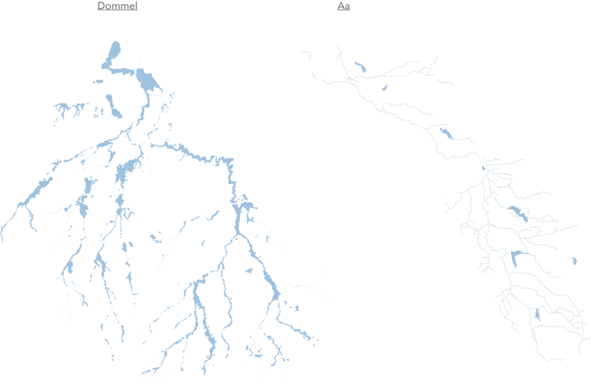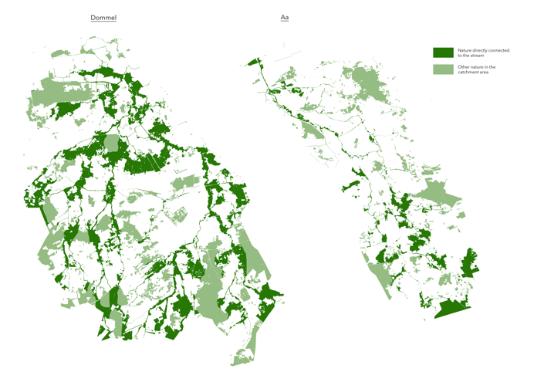

(Image 1; Comparing the Dommel and the Aa, Left: Floodable area, Right; Nature connected to the stream)
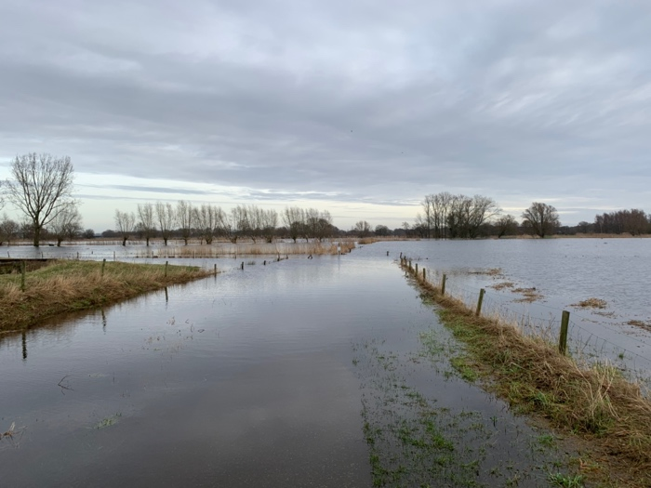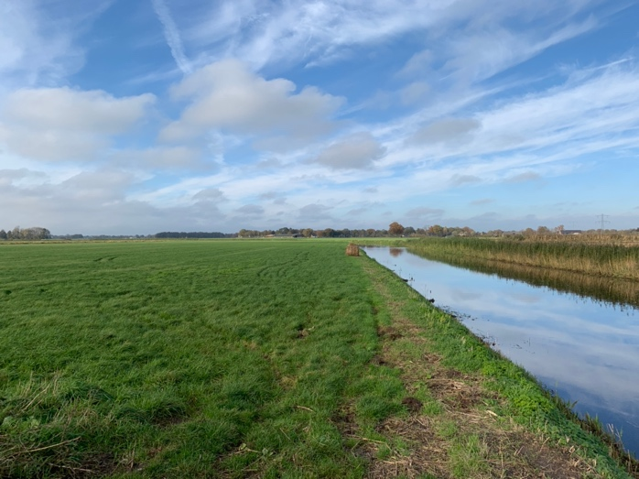
(Image 2; Left the Dommel and right the Aa)

Main Research Question:
How can the landscape development of the catchment area of the river Aa contribute to the quality and evidence of Central-Brabant as a National Park (nieuwe stijl)?

Sub Research Questions:
How can natural processes be integrated, and the ecosystem be strengthened in the Aa catchment area?

How to create a coherent landscape identity which makes the Aa catchment area recognizable and accessible for visitors and residents, as part of the Central-Brabant National Park?

Design assignment
The making of a landscape design for the lowland river Aa and its catchment area. In such a way that it develops into a natural area as part of a regional ecological network that is worthy of and supports the quality of a National Park. Create in this design a ‘language’ with landscape elements that make the National Park recognizable and accessible for residents and visitors. Illustrate how other types of land use, such as agriculture, housing, water management, can be integrated into this network.

IV Graduation process
Method description

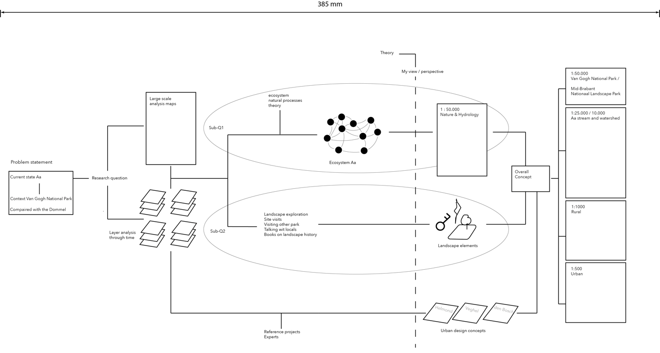The analysis starts with both large-scale mapping to understand the landscape, its layers and function. And small-scale research into the actors and processes that shape(d) the landscape over time.

To be able to answer the sub-questions, some more specific research is needed. For sub-question 1 theoretical research into ecosystems and natural processes will be taken up. With references on how to map them. With this knowledge I will map the ecosystem and natural processes relevant for and around the stream the Aa in Mid-Brabant, creating a web of relationships of the biotic and abiotic elements at play. When understanding the system, I can propose changes which support natural development. Then I will translate these into a landscape design. Using this knowledge, I can make large scale concept maps for the Aa and its watershed. The idea is to provide more space for a resilient ecosystem and natural processes.

For the second sub-question, on making a coherent landscape experience, I need to understand how people perceive landscapes and how landscape identity is created or shaped. Using this to then make a description, classification or designs of the landscape elements which do/can create a landscape identity in Mid-Brabant.

Reference projects will be collected and talks with experts and locals will be used for ideas on implementation and integration of design elements. These range from water management techniques, housing options, to agricultural methods. These can support and enrich the main design, but don’t form a basis for my design.

With the large-scale maps from the nature design concepts from sub-question 1 and the small-scale landscape identity elements from sub-question 2, I can start working on integration from both side of the scales towards a complete design concept, incorporating design principles form experts, locals, and references projects where possible.

From the complete design concept, I can start working on designs from different scales.

Literature and References
For the understanding of ecosystems and their landscape impacts there is plentiful scientific information: van Andel & Aronson, 2016, Bakker et al., 1979, Scheffer et al., 2012, Vos et al., 1982, and van Wierdum, 1979.
To help me create a standpoint and view on this topic and implementation I use inspioration from:Oorden van Onthouding (Feddes et al, ) and Adviesrapport Natuur- en landschapscriteria voor Nationale Parken van Wereldklasse (Vries et al., 2017)
Reference projects can be used for designing and visualization techniques.

For the designing of landscape identity elements, the two documents handleiding recreatieve poorten en entrees (Nationale Parken bureau, 2023) and Drentsche Aa landscape vision from Strootman Landscape Architects (landszine, 2010) are good starting points. Together with site visits to both central-Brabant and other national parks. I can catalogue and design elements that can create a recognizable landscape identity.

Besides the information needed for the two sub-questions some more general information is needed.
From the National Parks in New Stijl: the Leidraad and the Standaard form the Nationale Parken bureau.

Information from the Water Management Authority Aa en Maas in written documents, contact with a project leader, and from GIS data.

Site visits to both the project location and to reference projects and landscapes including other stream systems.

Finally, an understanding of ‘scale continuum’ and the four ‘landscape principles’ is needed. From which I can develop my own view on the subject and the use in designing. With books such as: recovering landscape by James Corner.

V Reflection on the project proposal
- What is the relation between your graduation topic, the lab topic, and your master track?
The strengthening and integration of nature into the landscape lies at the core of Landscape Architecture.
Using the Aa stream in the National Park gives me opportunities to both zoom in on smaller section of the stream for detailed design and allows me to zoom out towards the bigger National Park to see how ideas connect or can be repeated. Using the lens of scale continuum.

- What is the relevance of your graduation work in the larger social, professional and scientific context?
New attitudes towards nature are needed in The Netherlands and most of Europe. The relationship between our landscape use and nature is out of balance. Restoring this is a wicked problem, but small steps in ideas and examples do slowly move nature protection toward a better situation.

Bibliography
Adviescommissie nationale parken (2021). Advies aanvraag statustoewijzing
Nationaal Park Van Gogh i.o. Rijkesoverheid https://www.rijksoverheid.nl/documenten/kamerstukken/2021/06/24/advies-aanvraag-statustoewijzing-nationaal-park-van-gogh
Andel, J. van & Aronson, J. (2006). Restoration Ecology: The New Frontier, second edition. Wiley-Blackwell West Sussex.

Bakker, T., Klijn, J., & Van Zadelhoff, F. (1979). Duinen en duinvalleien : een landschapsecologische studie van het Nederlandse duingebied. https://repository.tno.nl/islandora/object/uuid%3Af95553e3-a67f-4102-ad5b-9e6ff1437461

Landzine (2010), Drentsche Aa Landscape Vision. Landzine. https://landezine.com/belvederes-drentsche-aa-by-strootman/

Nationale parken bureau (2021). Standaard en leidraad Natoinale parken nieuwe stijl. https://www.nationaleparkenbureau.nl/standaard+en+leidraad/default.aspx#folder=1818437
Nationale parken bureau (2013). Handreiking Recreatieve Poorten en Entrees Aanpak recreatieve poorten. https://www.nationaleparkenbureau.nl/documenten+en+verslagen/handlerdownloadfiles.ashx?idnv=2570557
Scheffer, M., Carpenter, S. R., Lenton, T. M., Bascompte, J., Brock, W. A., Dakos, V., Van De Koppel, J., Van De Leemput, I. A., Levin, S. A., Van Nes, E. H., Pascual, M., & Vandermeer, J. (2012). Anticipating critical transitions. Science, 338(6105), 344–348. https://doi.org/10.1126/science.1225244

Terra incognita (2016) De kracht van het Aa dal. Aaenmaas, https://www.aaenmaas.nl/publish/pages/1440/de-kracht-van-het-aa-dal-nov-2016.pdf

Vos, W., Harms, W., & Stortelder, A. (1982). Vooronderzoek naar landschapsecologische relaties tussen ecosystemen. Wageningen university and research. http://edepot.wur.nl/397302

De Vries, D., Schaminée, J., Schipper, P., & Tersteeg, J. (2017). Natuur- en landschapscriteria voor Nationale Parken van Wereldklasse – Naar Nederlandse natuur van internationale allure : Adviesrapport: Adviesrapport. Wageningen university and research. https://www.narcis.nl/publication/RecordID/oai%3Alibrary.wur.nl%3Awurpubs%2F516557

Van Wirdum G. (1979). dynamic aspects of trophic gradients in a mire complex. Proceedings of technology meeting 35, TNO. Den Haag, p. 66-82.

